**Jenkins_Tutourial**

**Jenkins is the CI/CD tool, developed on JAVA language**

* **Old Jenkins is called Hudson , introduced by** [Kohsuke Kawaguchi](https://en.wikipedia.org/wiki/Kohsuke_Kawaguchi) on January 29, 2011, creating the Jenkins project.
* He worked at [Sun Microsystems](https://en.wikipedia.org/wiki/Sun_Microsystems) on numerous projects for the Java, XML and Solaris ecosystems primary developer. Hudson was created in summer of 2004 and first released in February 2005.
* On February 1, 2011, Oracle said that they intended to continue development of Hudson, and considered Jenkins a fork rather than a renamed Jenkins and Hudson therefore continue as two independent projects,
* Jenkins is the pluggable tool , what are tools we can integrate those plug-in’s need to install plug-in’s.

**Note : Internet connectivity required for Jenkins practice (for plugins installations)**

**Jenkins for prerequisite setup:- jdk 1.8 install and set the classpath also.**

[**https://updates.jenkins-ci.org/download/war/**](https://updates.jenkins-ci.org/download/war/) **-> download any version Jenkins.war file **

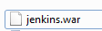

**Jenkins Install process1:-**

**Note:- If you install 2nd time – remove below folder.**

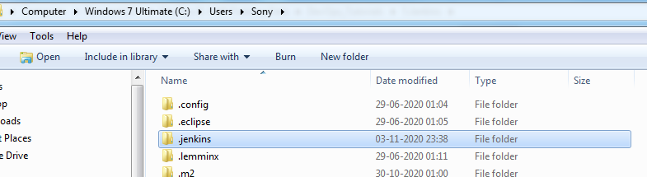

**1st time Jenkins install and running process :- bydefualt Jenkins port is 8080**

**Goto path :-** D:\DevOps & AWS Training Data\DevOps_Tutorials\5.Jenkins\2.100>**java -jar jenkins.war --httpPort=8282**

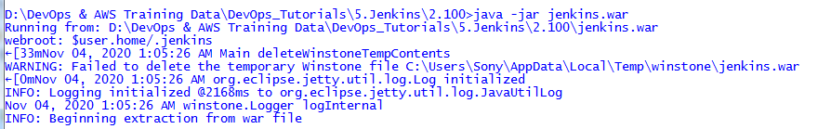

**Goto ur pc path and copy pwd.**

**Latest war:**

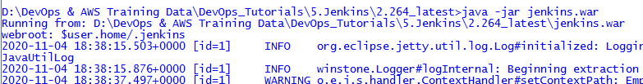

**1**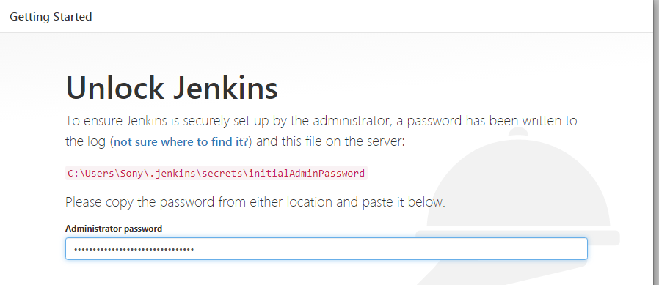

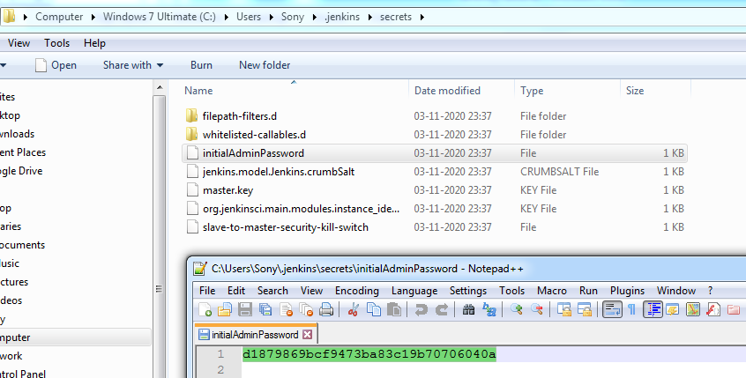

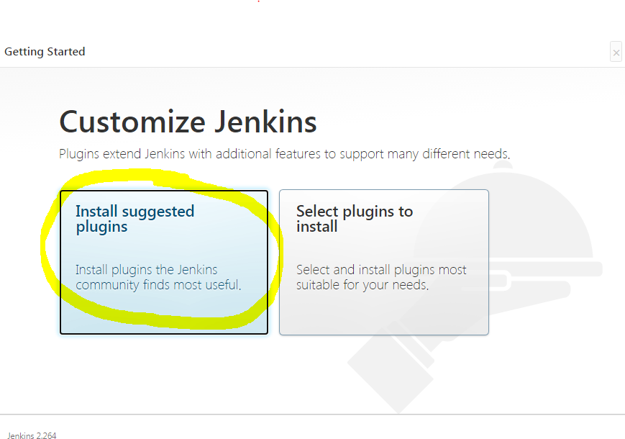

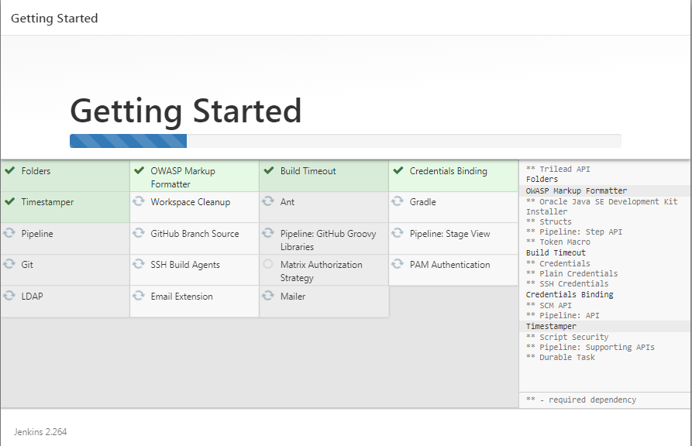

**Need to finish all above process.**

**I will not create any admin user i will continue as admin.**

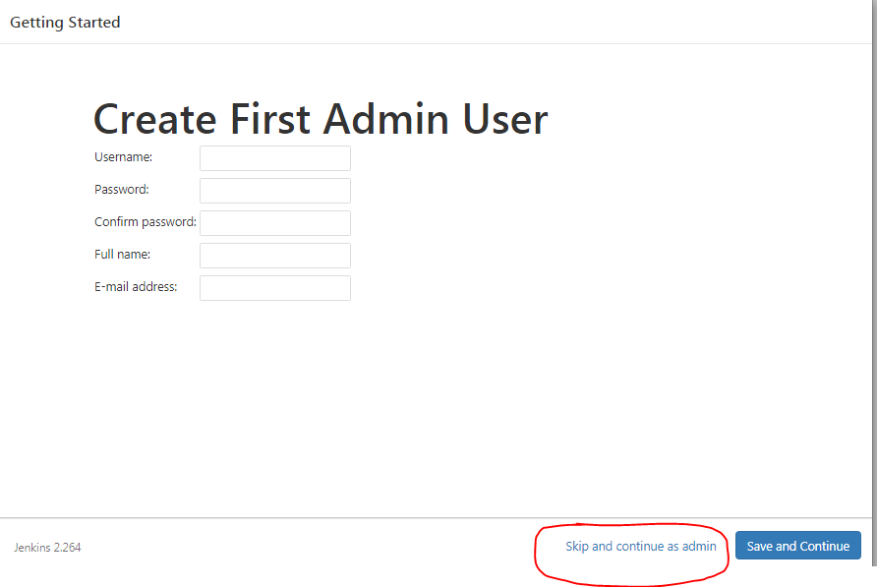

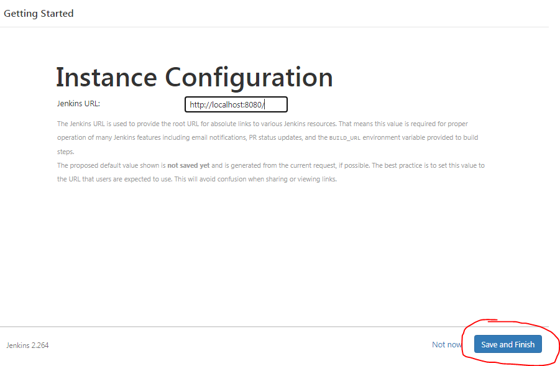

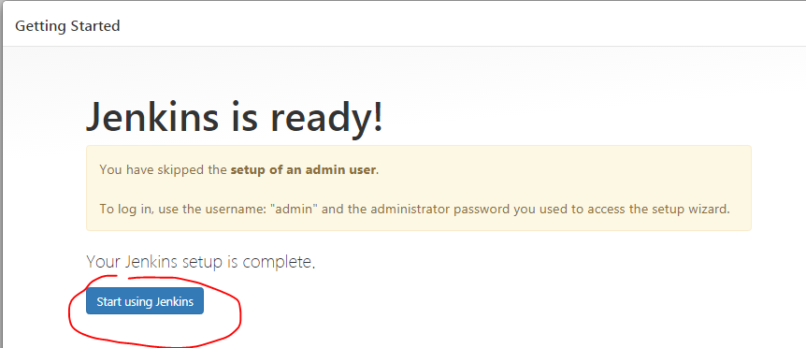

**Jenkins home page is open automatically, next logout**

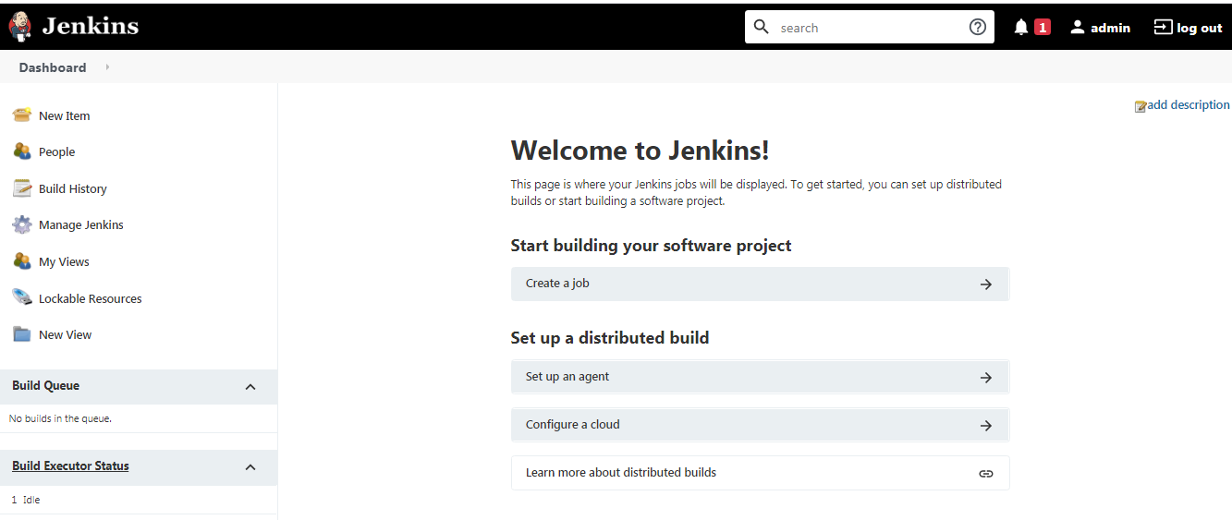

**By default admin pwd will get from below path file.**

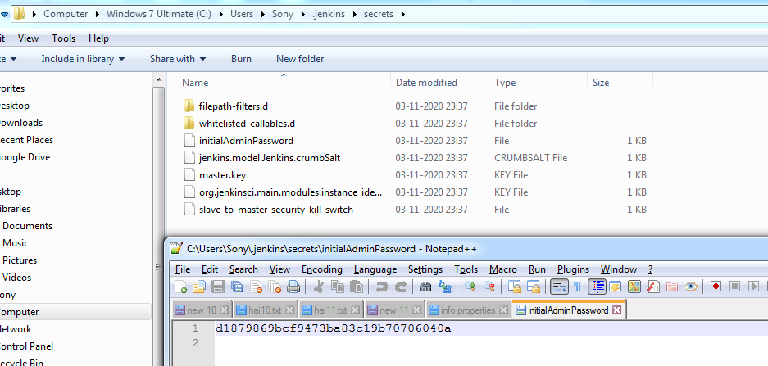

**Copy that pwd and Jenkins login as un: admin and paste that pwd.**

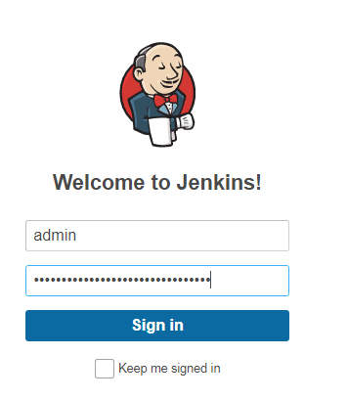

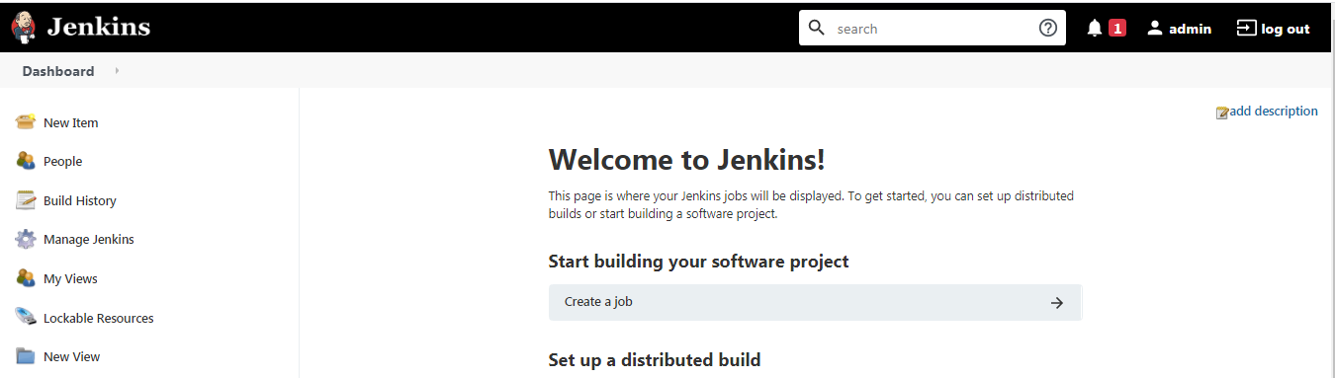

**Reset pwd:-**

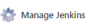

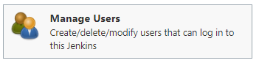

**Click**

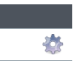

**Remove old pwd and enter ur own new pwd: admin@123 (by default un: admin)**

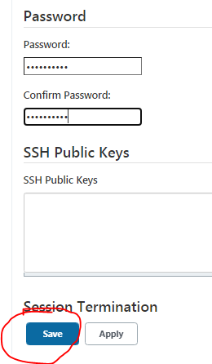

**Logout and login again with new pwd.**

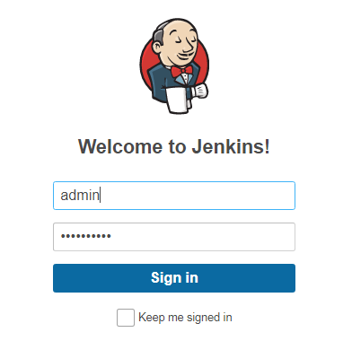

**Home page.**

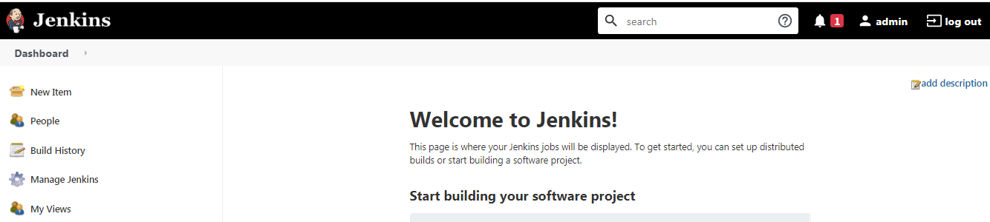

**Specific port to run Jenkins:-**

D:\DevOps & AWS Training Data\DevOps_Tutorials\5.Jenkins\2.264_latest>**java -jar jenkins.war --httpPort=8181**

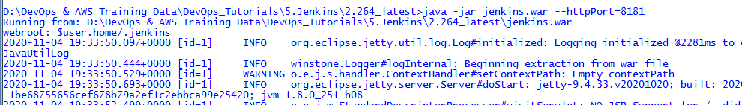

**home page.**

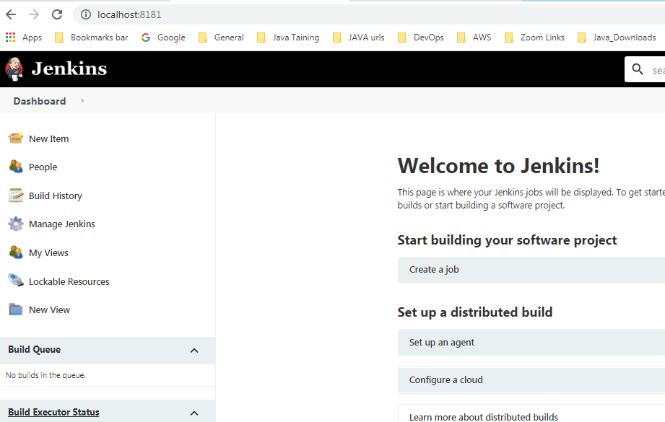

**Jenkins Install process2:-**

**Copy Jenkins war file into paste tomcat webapps folder.**

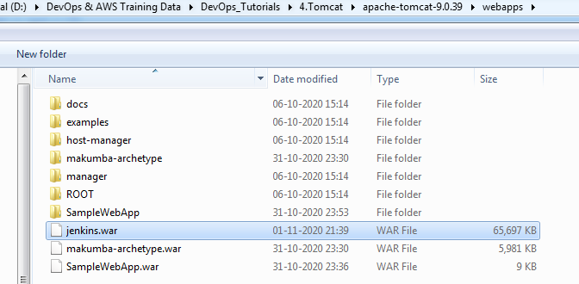

**Start tomcat startup batch file.**

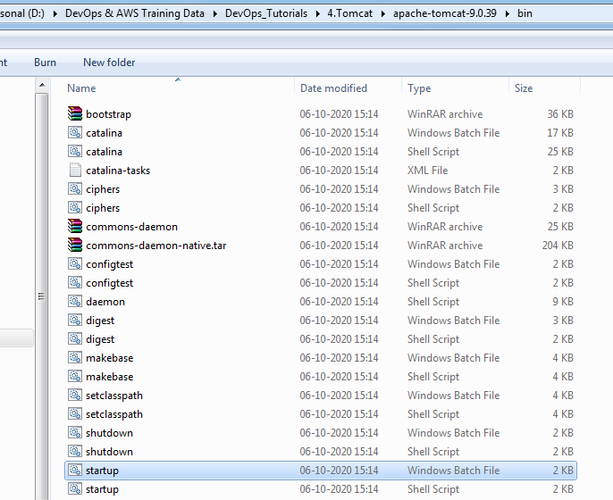

**Allow to access.**

**Open browser :-** [**http://localhost:8181/**](http://localhost:8181/)

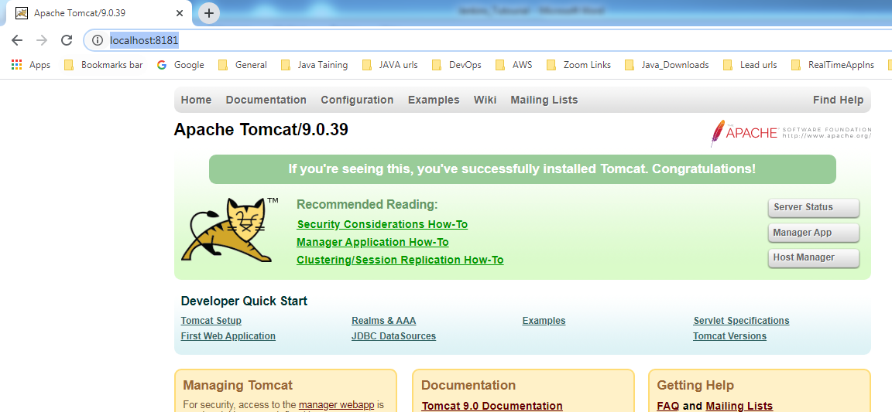

**Click App manger and enter un/pwd: tomcat/tomcat.**

**Open Jenkins link**

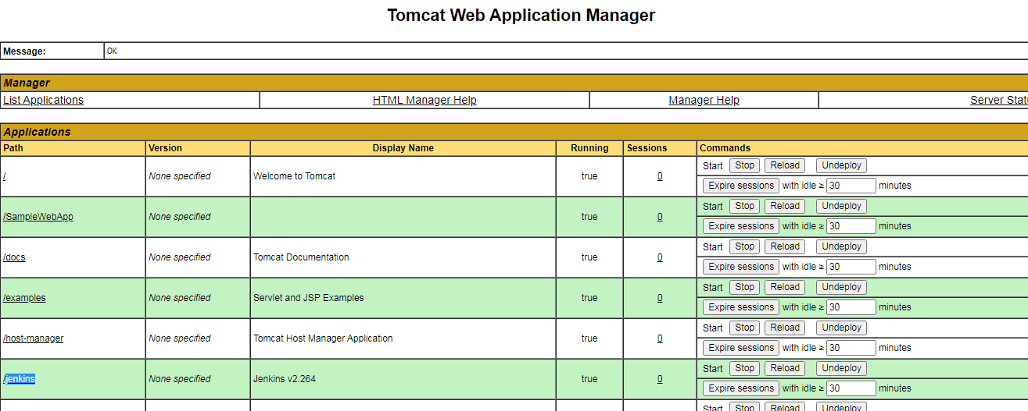

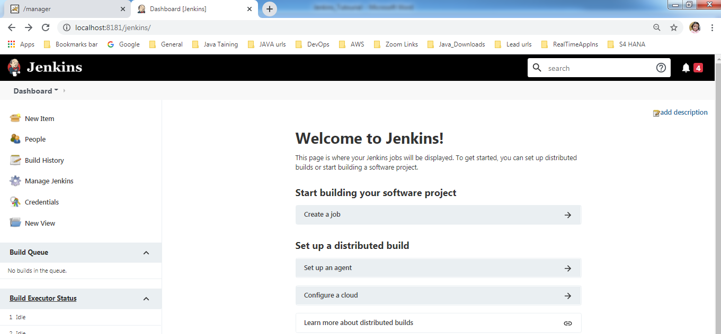

**Refer for more steps to install Jenkins : -** [**https://www.guru99.com/download-install-jenkins.html**](https://www.guru99.com/download-install-jenkins.html)

Create new job:- basic freestyle job.

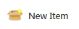

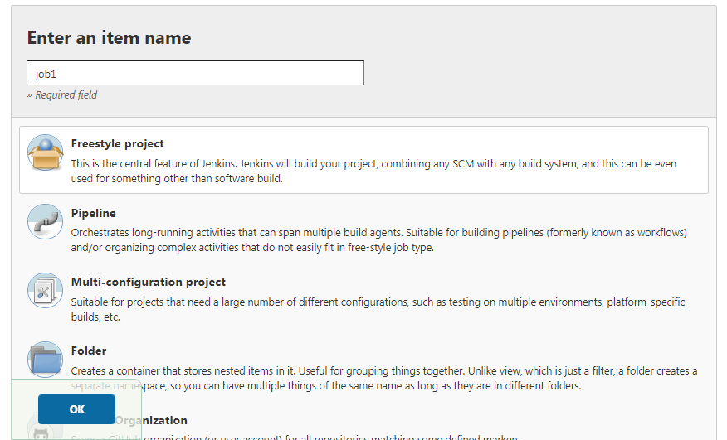

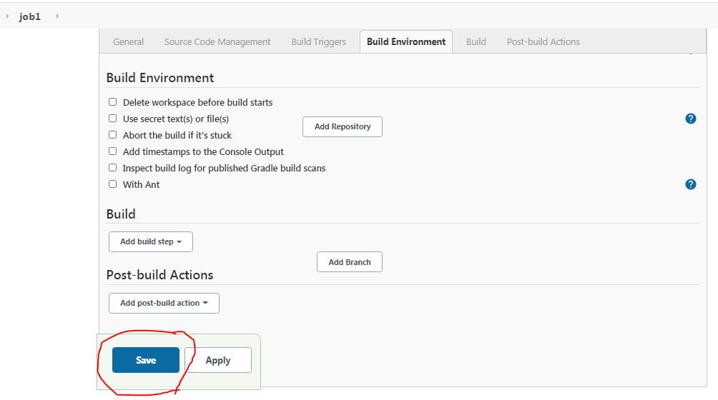

**Job1 created in dashboard.**

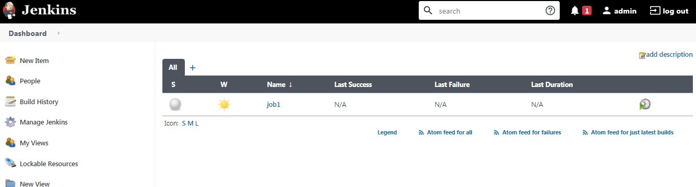

**Show all user details.**

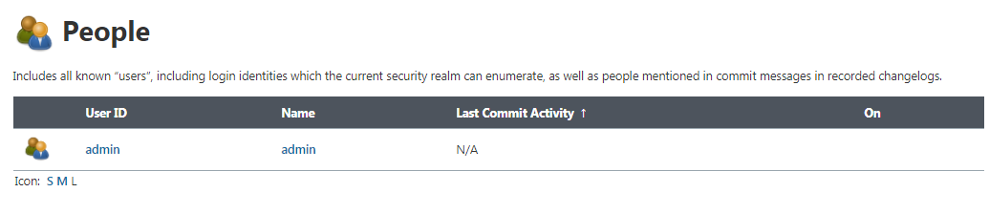

**Click build icon job will build it.**

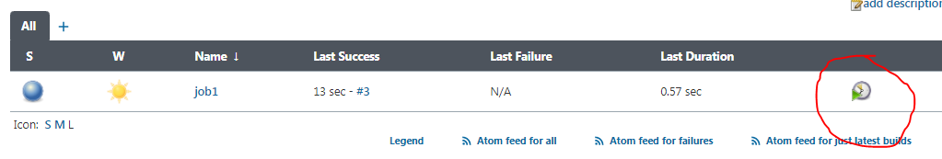

**Build history will show how many times job has builded.**

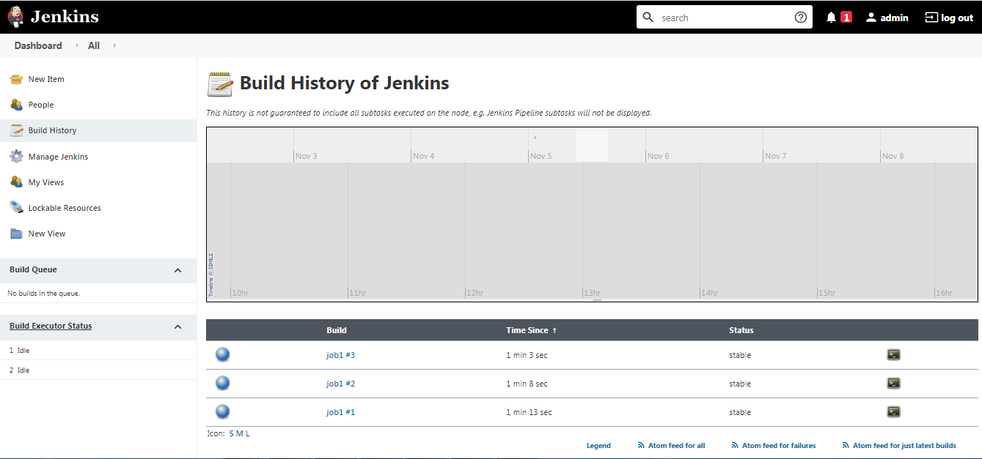

**Click - >Get all colors of jobs**



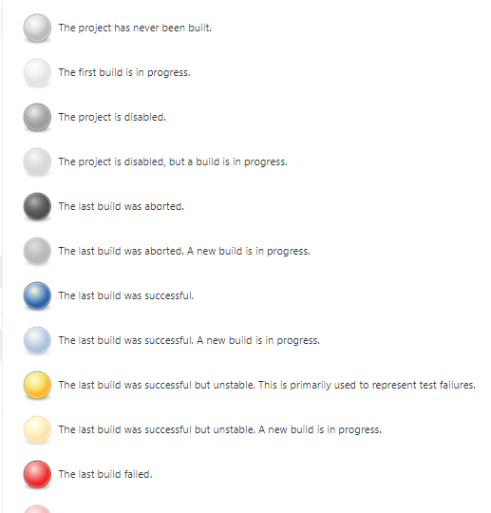

**Just change any size options of inside configure .**

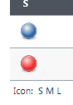

**Blue /Green– success**

**Red –failure**

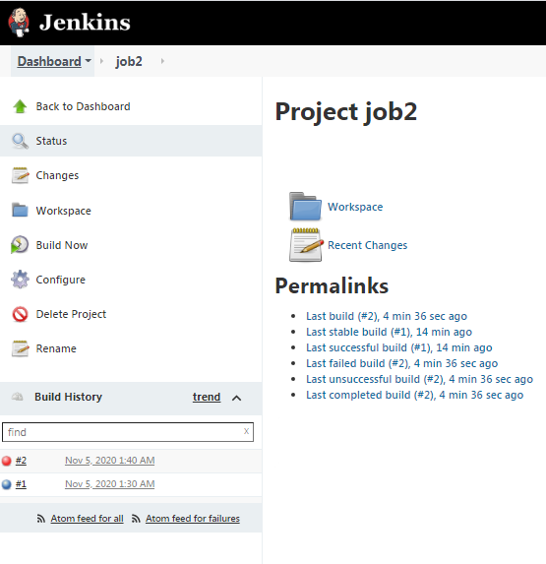

**All created jobs are stored in Workspace folder.**

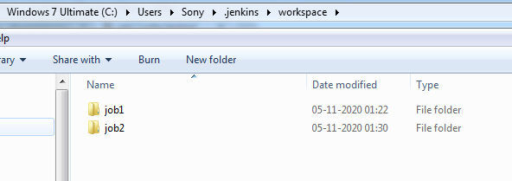

**Console output**

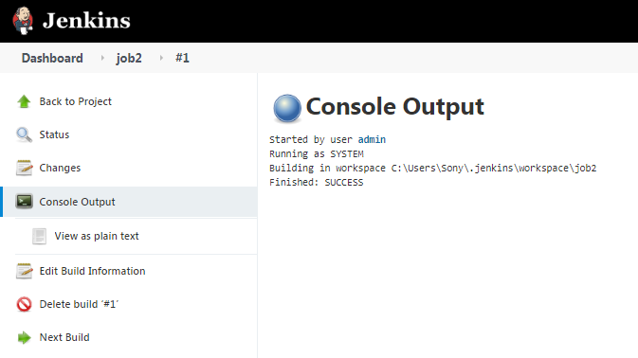

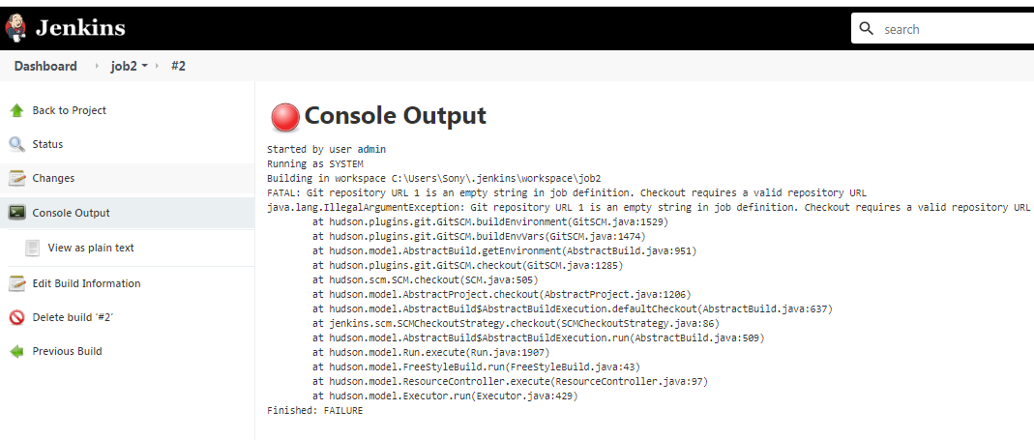

**Remove workspace**

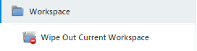

**Edit job**

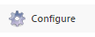

**Build the job**



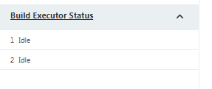

**If you run 5 jobs, build executer will build at a time 2 jobs and remaining 3 jobs will wait under build queue.**

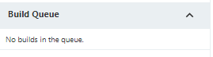



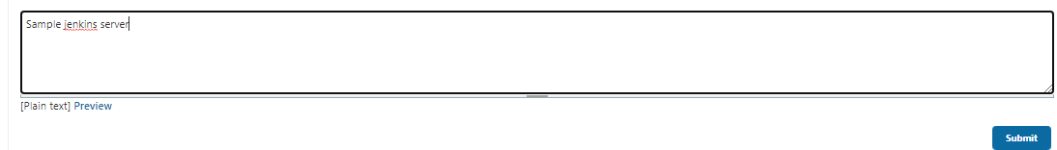

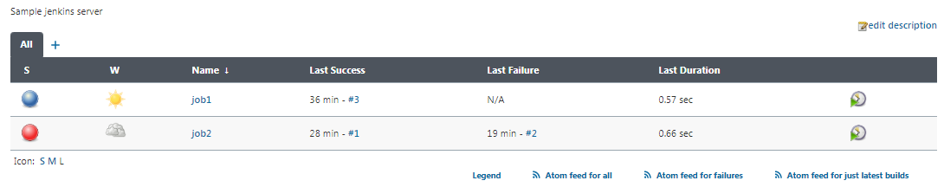

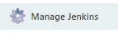

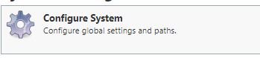

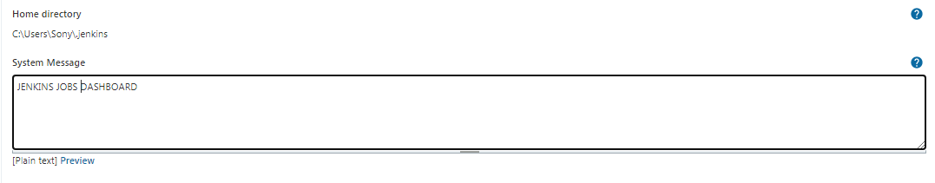

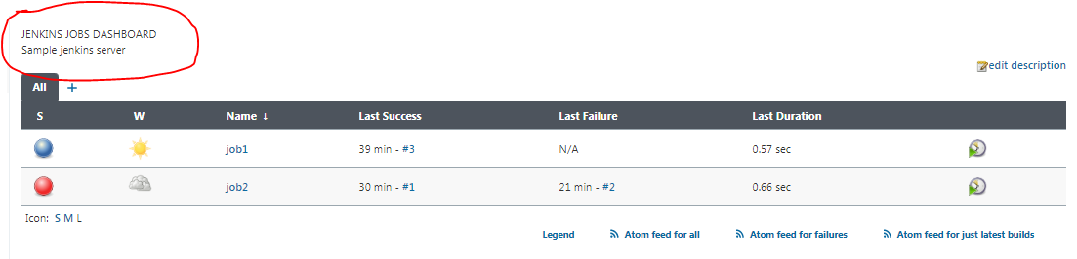

**Default build executers will increase.**

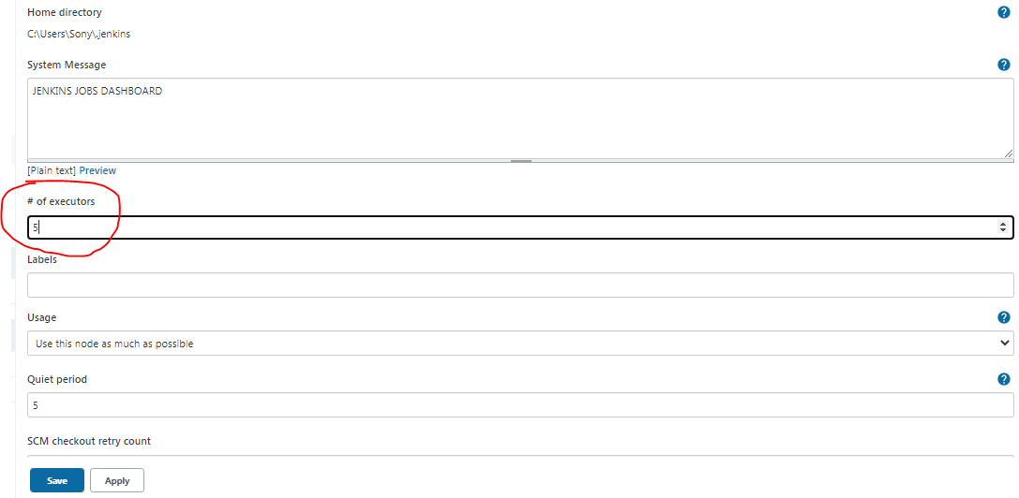

**Default build executers increase from 2 to 5. (at a time we can run 5 jobs)**

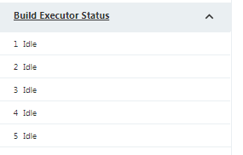

**node is used for load balancing purpose .**

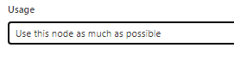

Quiet period -> while setup cron job, 2 jobs b/w gap period maintain time in default seconds .

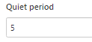

Every 2 mints once will check github url level any code changes happen or not.(POLL SCM)

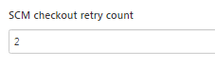

**For global variables configuration**

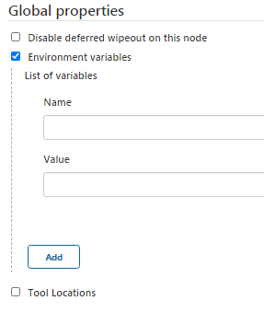

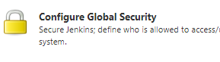

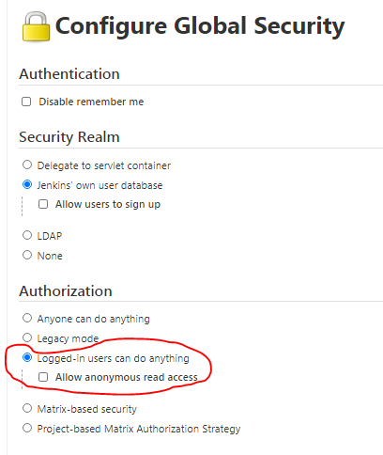

**Allow to create new user sign up option.**

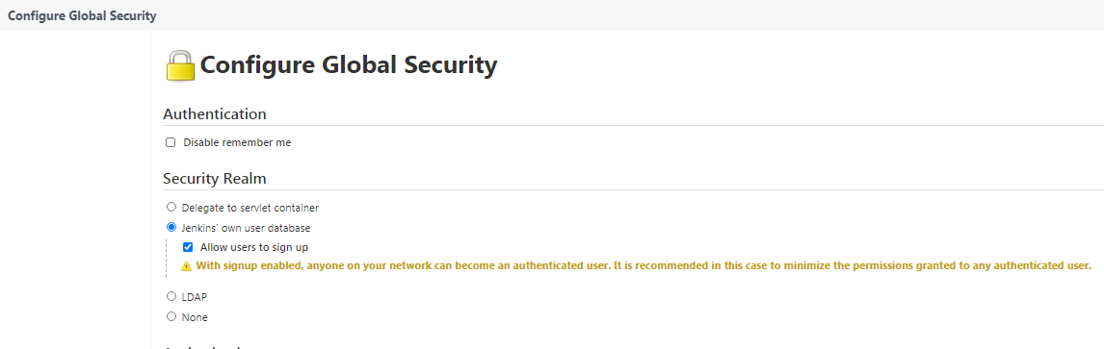

**Logout**

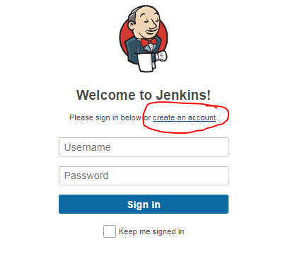

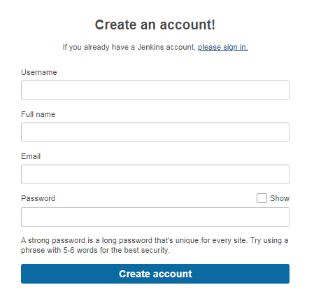

**Create new user and remove user:-**

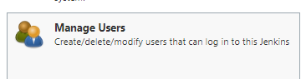

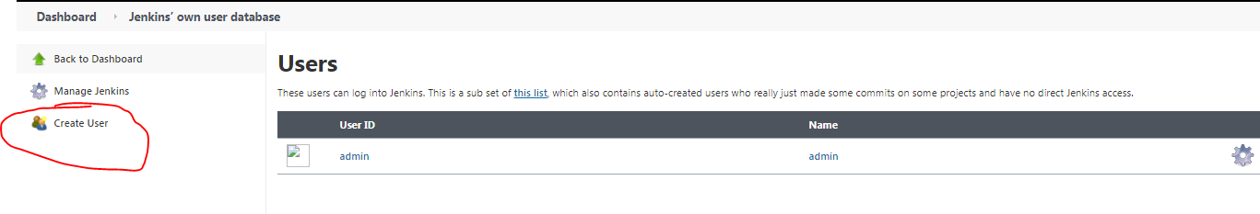

**Creating new user**

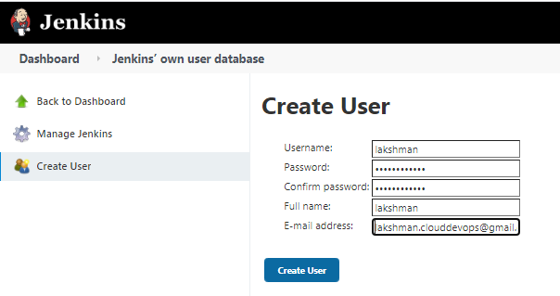

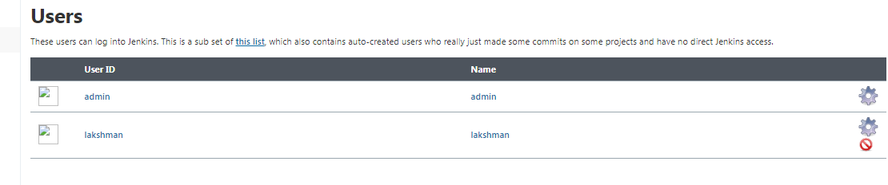

**Remove user click red circle then user will remove**

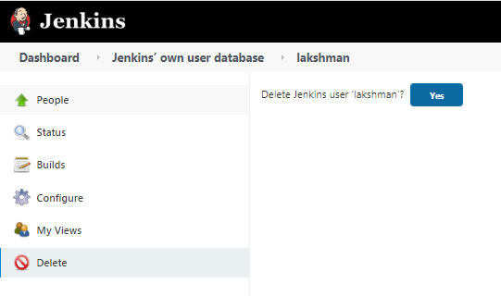

**Other users can do read access for all jobs**

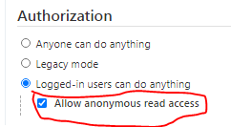

**Provide access to users.**

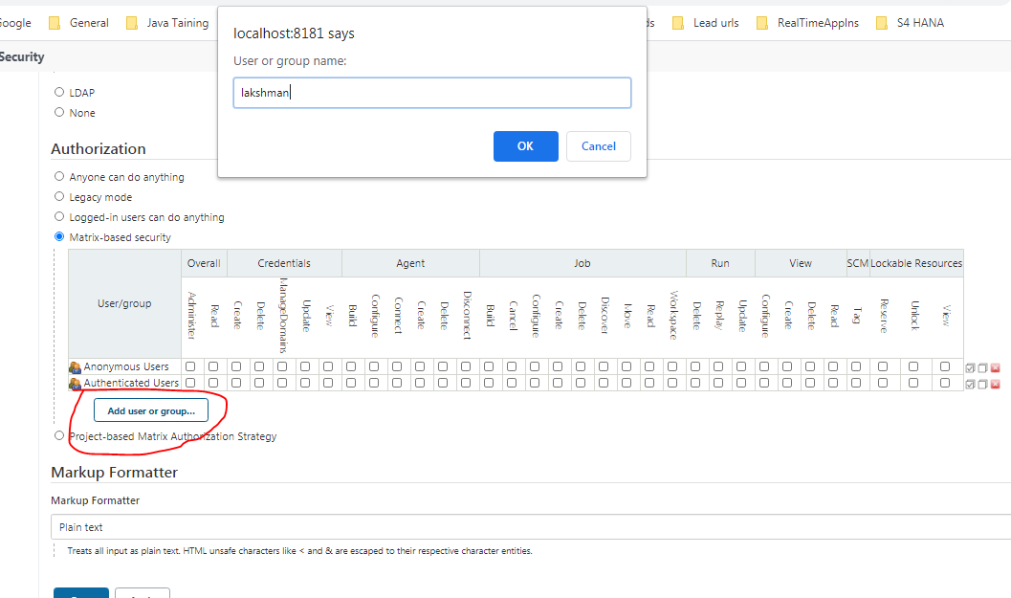

**Full permissions provided.**

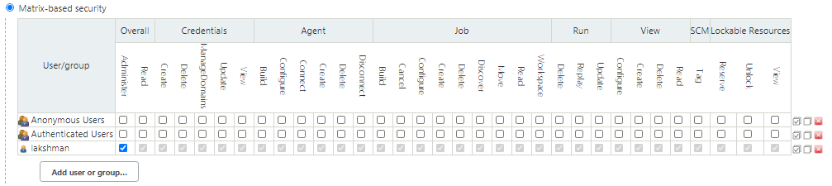

**Specific project based user can give permissions:-**

**Create user1 user2**

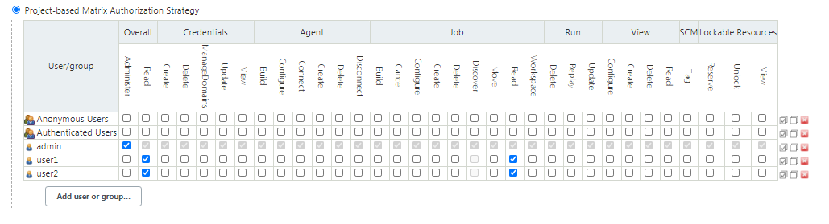

**Logout and login**

**Specific job based user can give permissions**

* **user1 can do only read and configure of this job**
* **user2 can do create,read,configure,build**

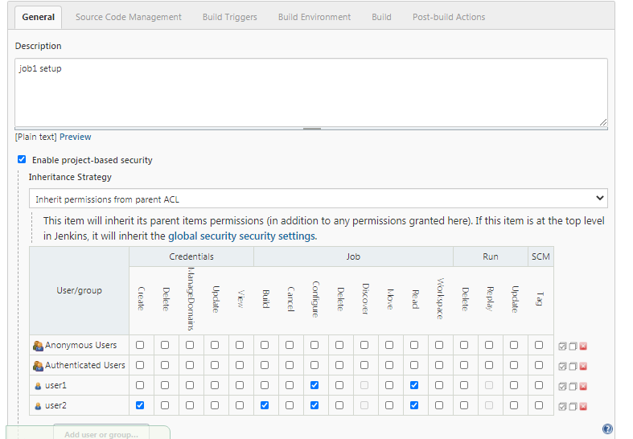

**Login User1 -> can do read and configure only**

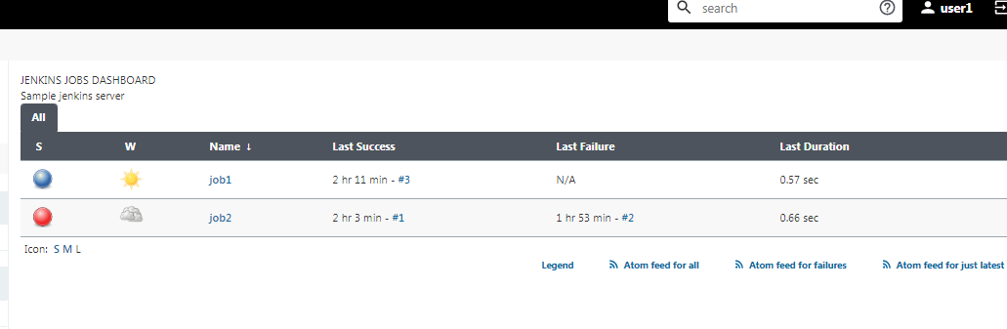

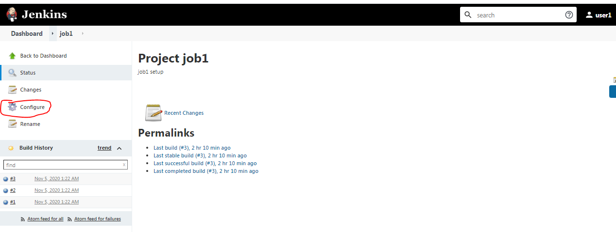

**Login User2-> can do read ,build,configure only**

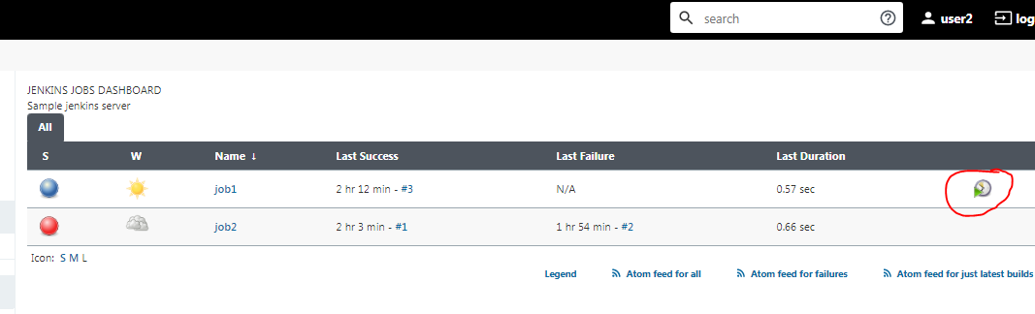

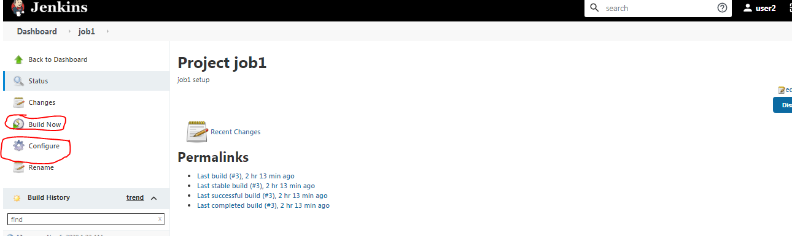

**If deleted jobs, How to take backup jobs:- For Jenkins version Migration we can follow below step.**

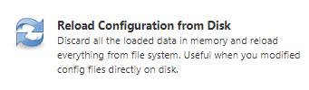

**Reload Configuration from Disk used to reload jobs from disk which are all took backup job.**

**Take backup jobs(cut those 2 jobs from .jenkins/jobs folder ) and keep into other bkp folder.**

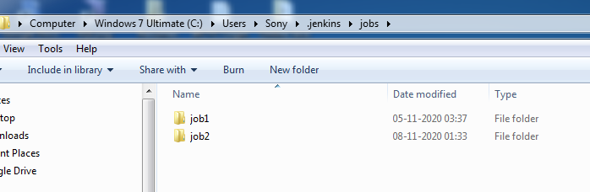

**Keep bkp folder**

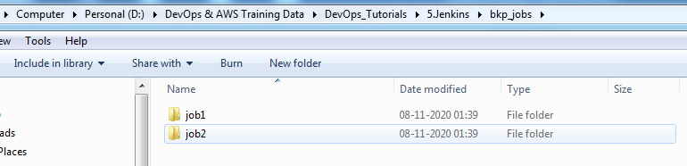

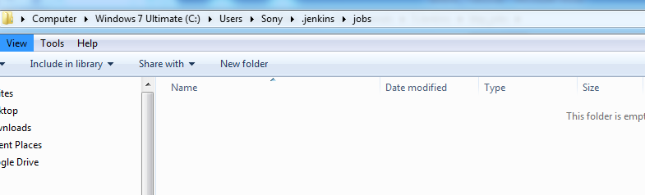

**Deleted the both jobs in jobs folder(job1 and job2) and delete both jobs in Jenkins dashboard also.**

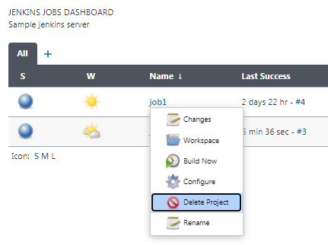

**Again paste those bkp jobs(job1,job2) into jobs folder of .Jenkins.**

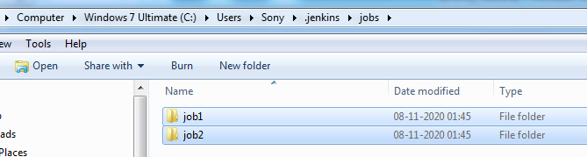

**Click**

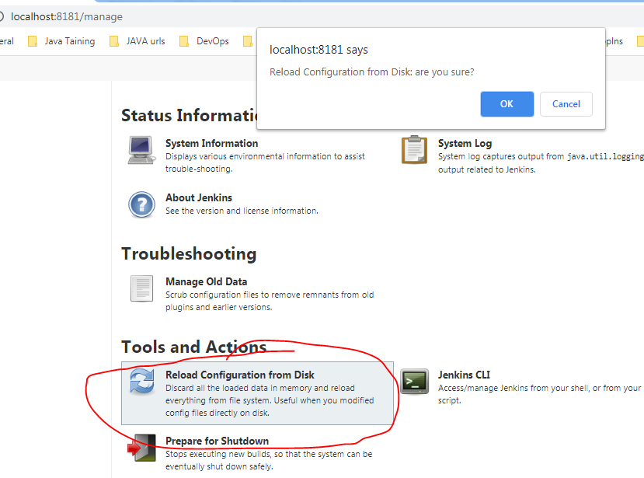

**Reloading**

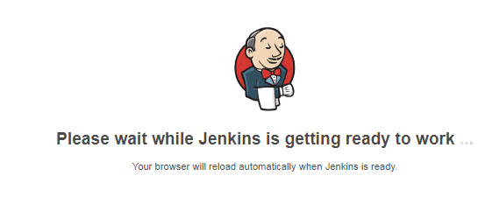

**Both jobs are back again.**

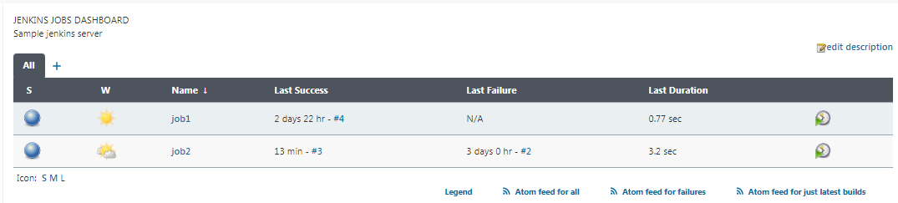

**Manage plugins -> used to install plugins and update plugins.**

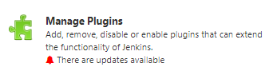

**Installed plugins -> already installed plugins**

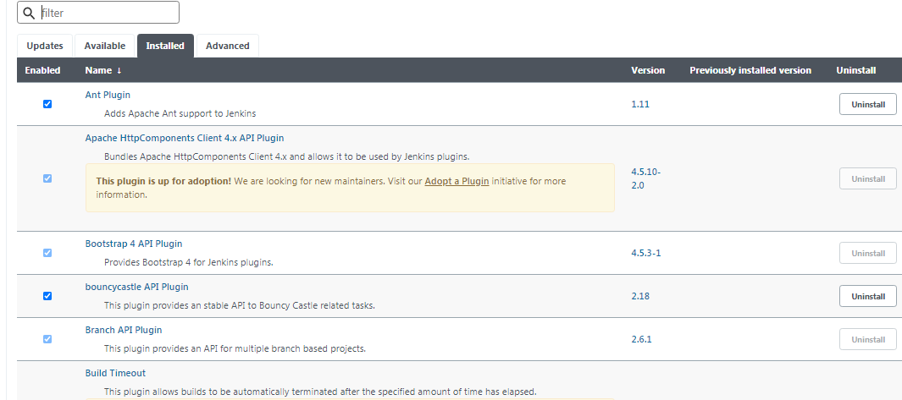

**Search specific plugin**

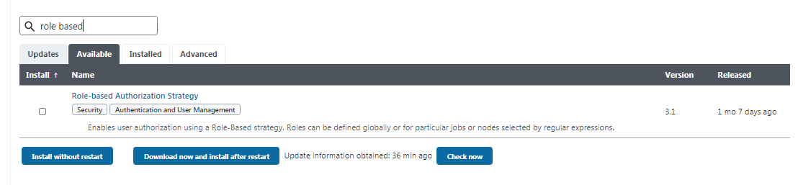

**Click that plugin -> it will open another tap of complete details of that plugin and usage.**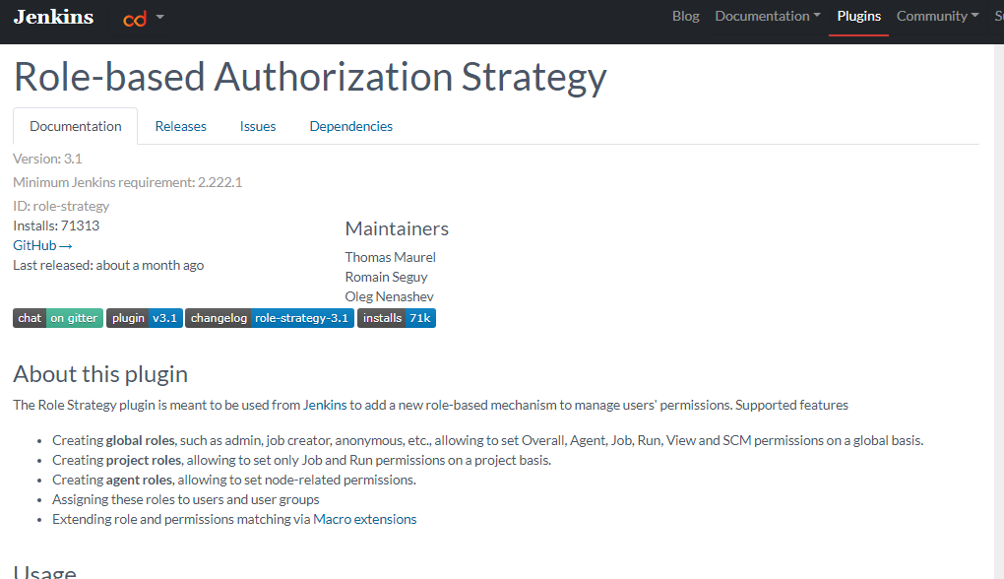

**Install without restart to install plugin**

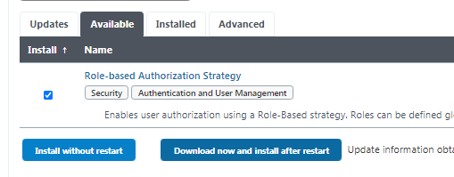

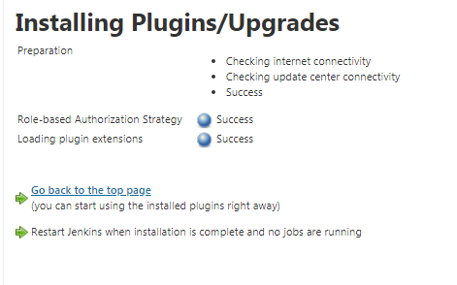

**Check that plugin related option enabled.**

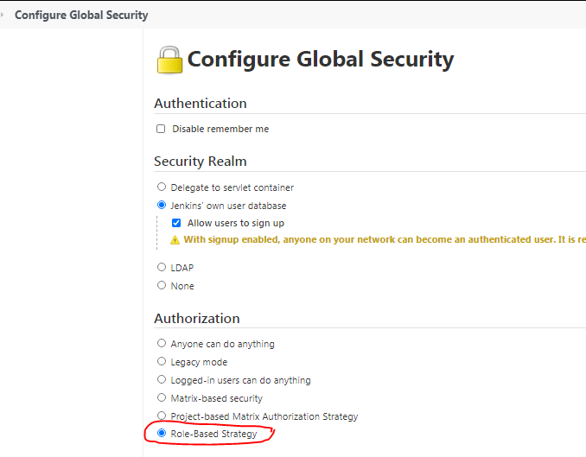

**How to un-install.**

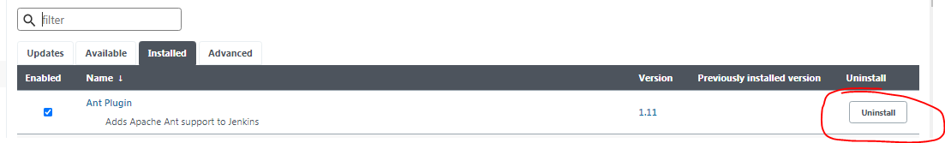

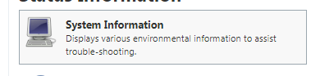

**All system related installed paths will show here**

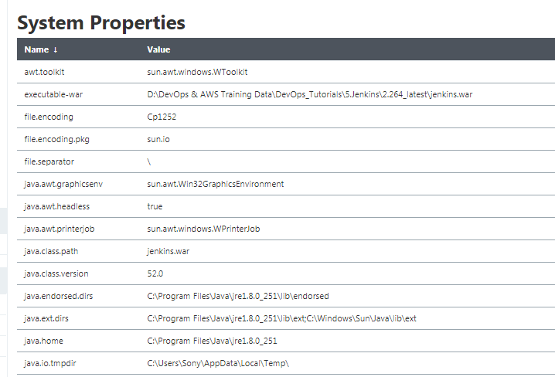

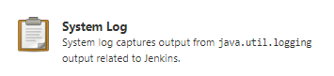

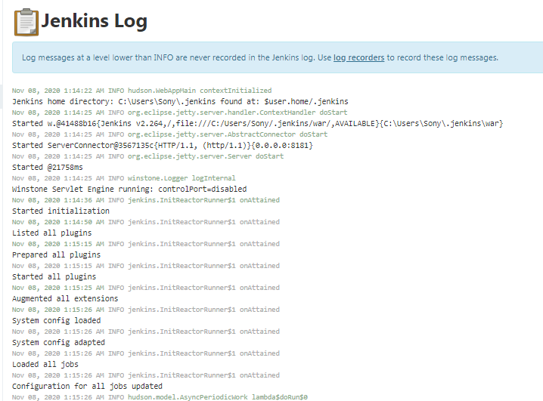

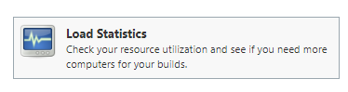

**Graphically it will show all running jobs flow**

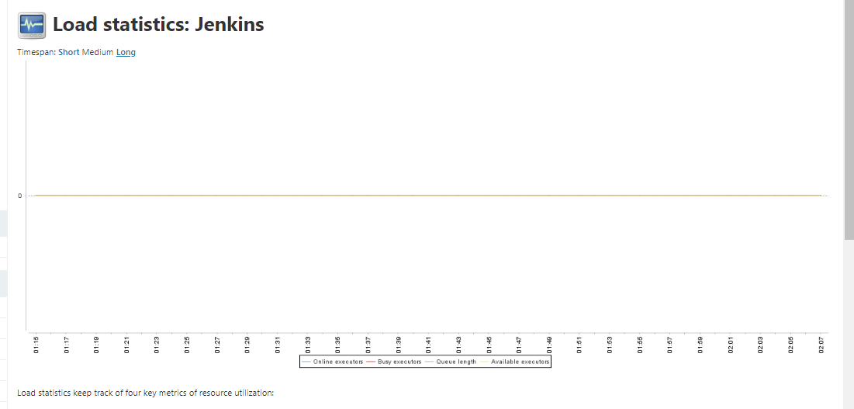

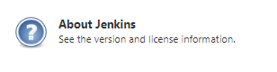

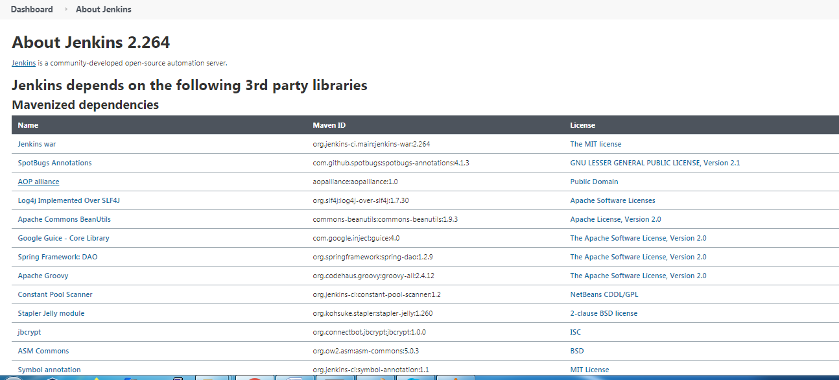

**Jenkins CLI -> Manage jenkins through cmnd prompt.**

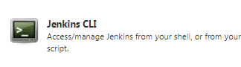

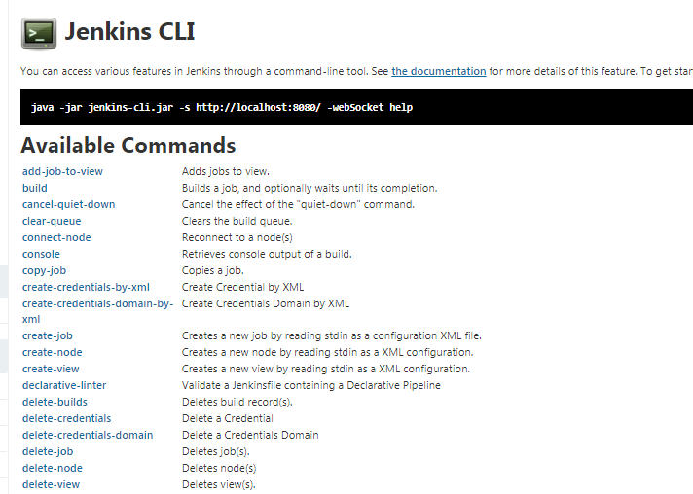

**How to create job.**

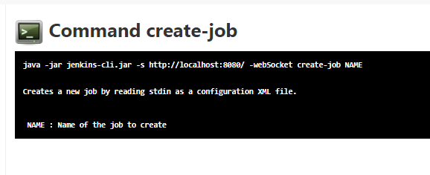

**Discard old builds -> manage builds**

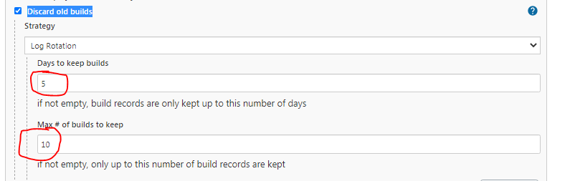

Days to keep builds -5 days will keep builds.

Max # of builds to keep – in 5 days will keep 10 builds and remaining will remove automatically.

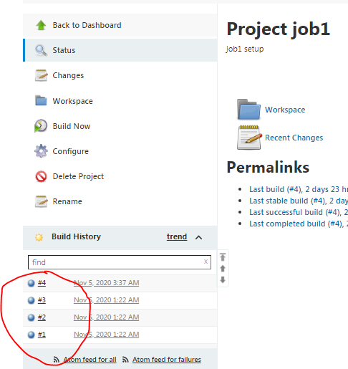

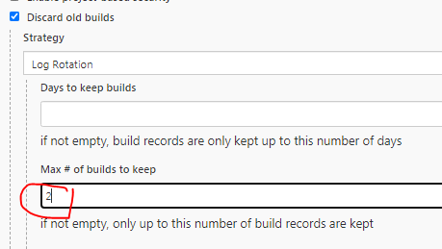

**Build again job1 -> only will keep latest 2 builds, remaining will remove(refresh to check)**

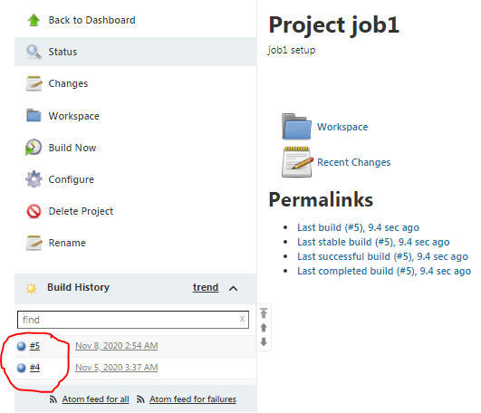

**How to pass parameters to job:-**

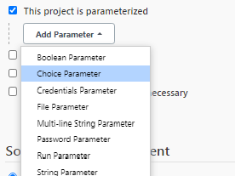

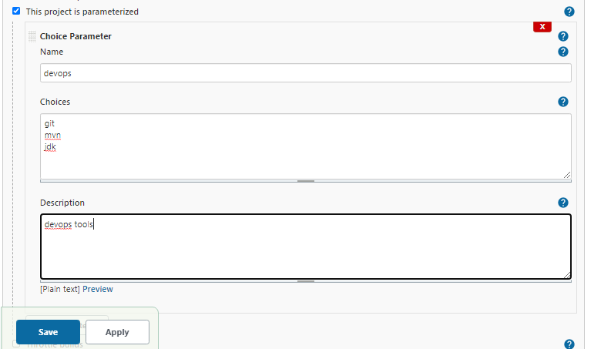

**Parameterized job**

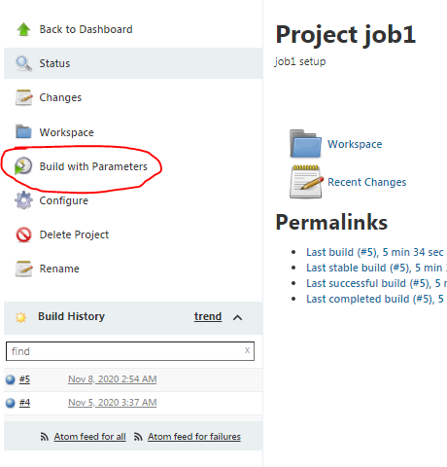

**Now we can build with parameter.**

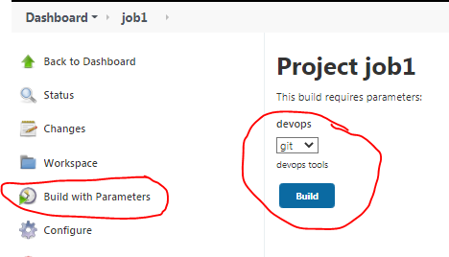

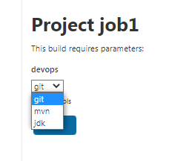

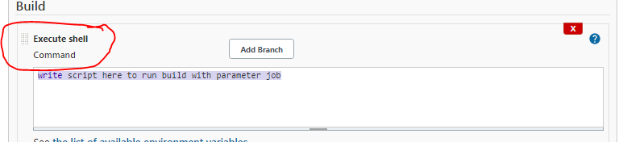

Disable this project-> temporarily disable the project by admin and other users cannot build this run.

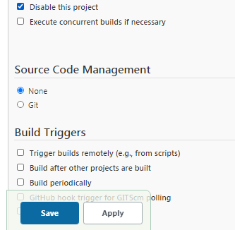

**Build option is disabled.**

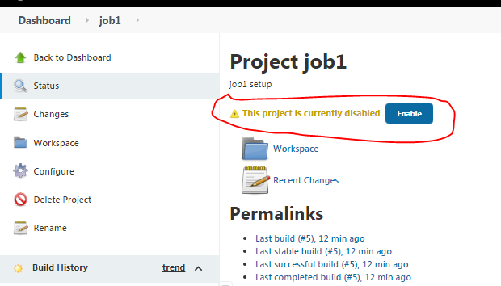

GitHub project-> configure GitHub url

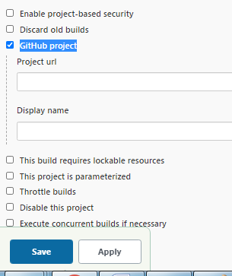

**Disable -Execute concurrent builds if necessary** -> diff no.of jobs can build in parallel.

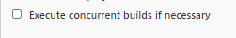

Both jobs i have builded, below 2 jobs are running in parallel .

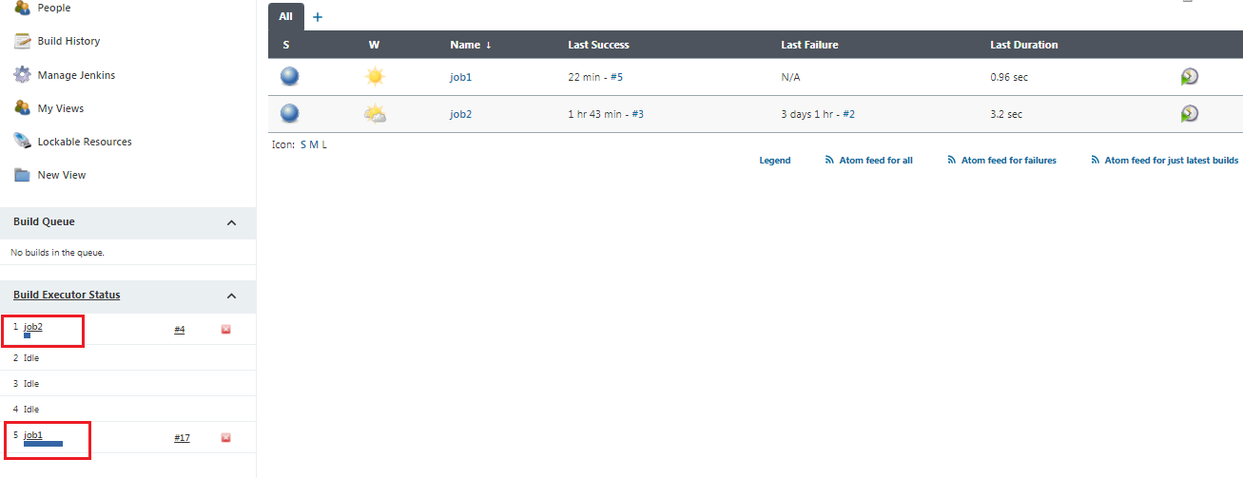

**Enable- Execute concurrent builds if necessary** -> same job no.of times we can build at a time **-RT**

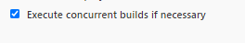

same job building no.of times

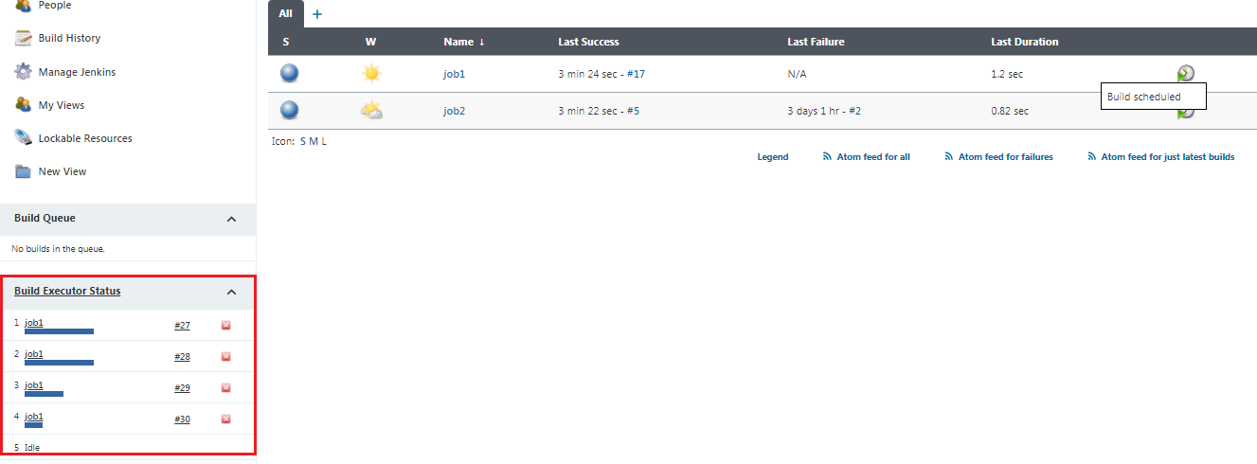

same job building no.of times and some of the jobs in queue

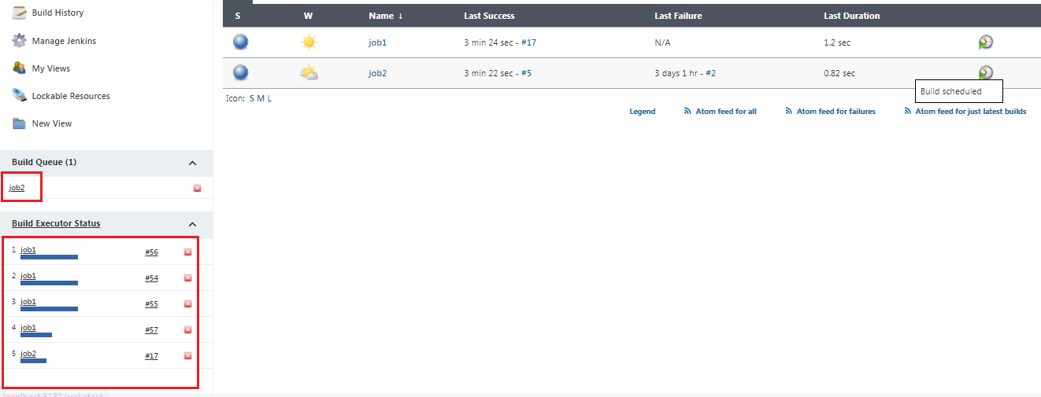

**Source Code Management -> configure github Repo details to build code.**

**Set JDK path setup:- first install jdk8 software in ur computer.**

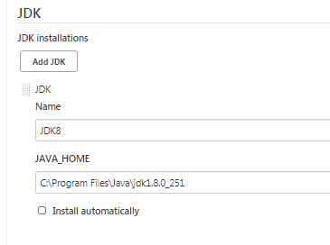

**Note:- if you select “install automatically” it will download from install from site.**

**First set git path.**



**C:\Program Files\Git\bin\git.exe**

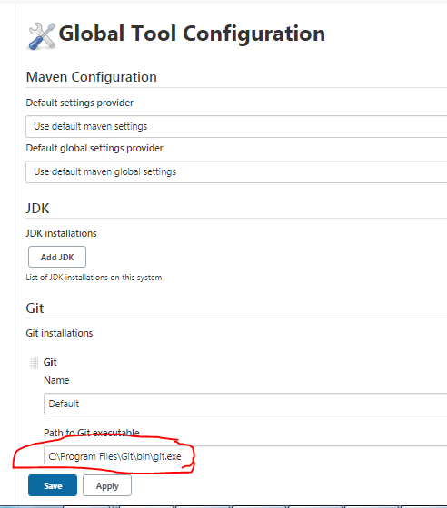

**Next set maven path.**

**D:\DevOps & AWS Training Data\DevOps_Tutorials\3.Maven\apache-maven-3.6.3**

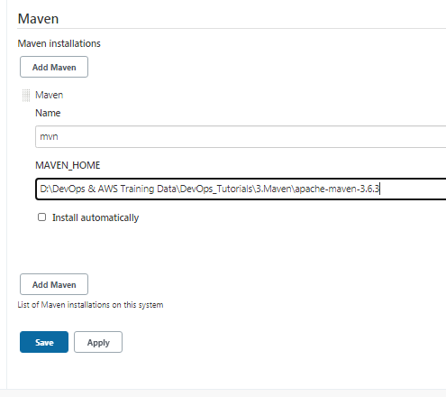

**Copy https github repo url and give same main branch in job1**

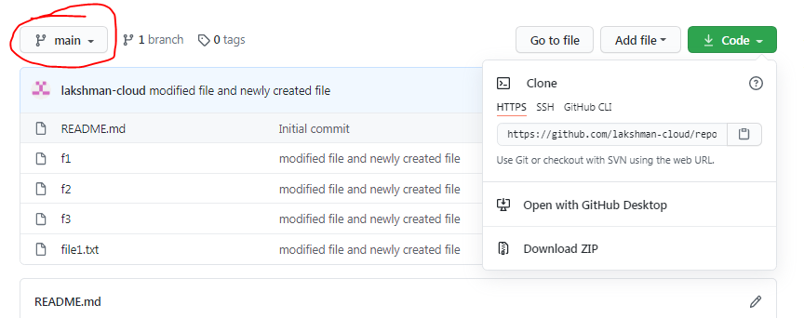

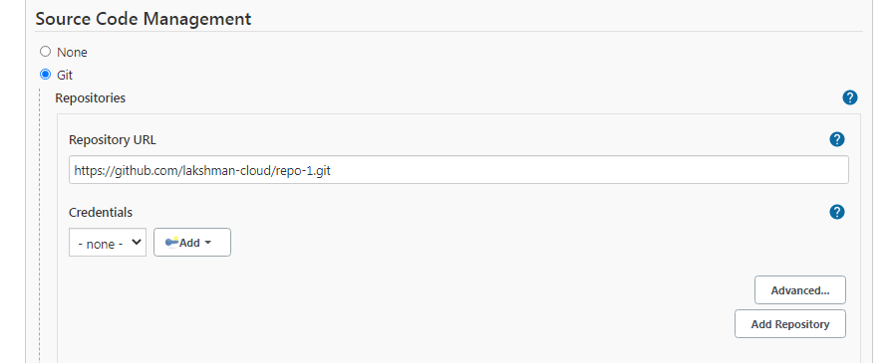

**Add ur github credentials (optional for public repos)**

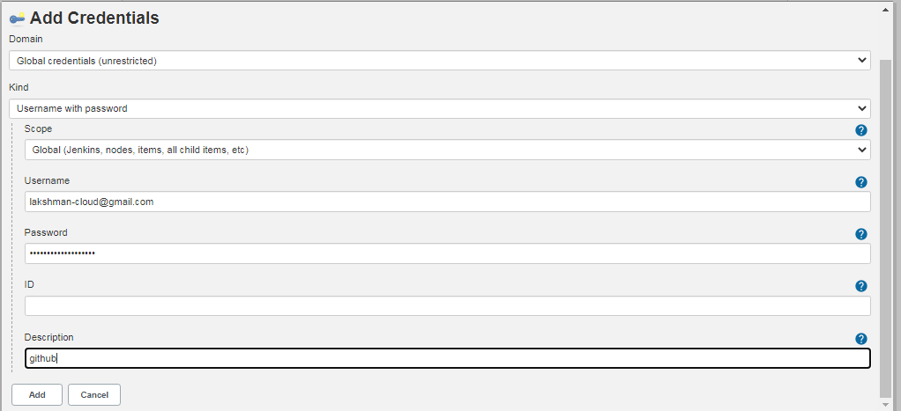

**Provide ur branch : main/master**

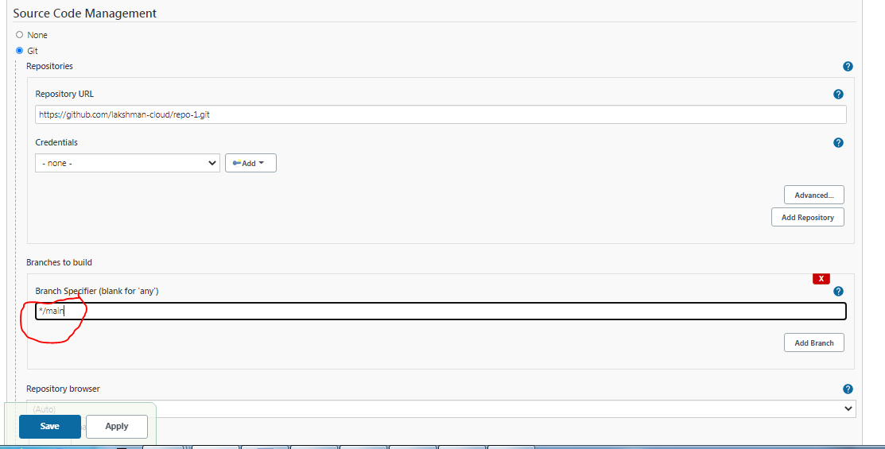

**Build the job -> open build console – build success**

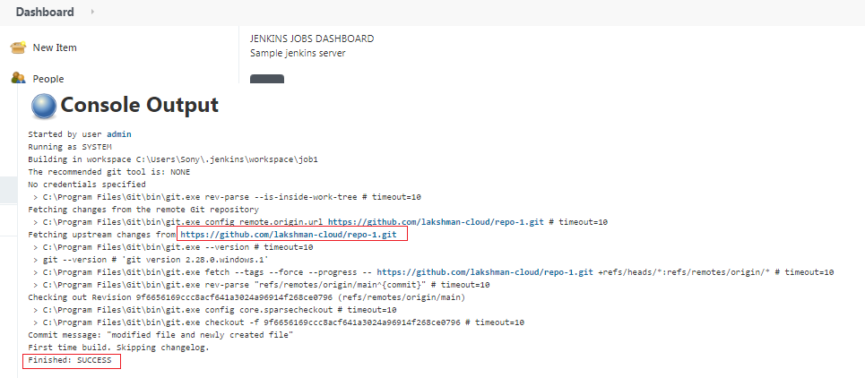

**Git hub code came to workspace**

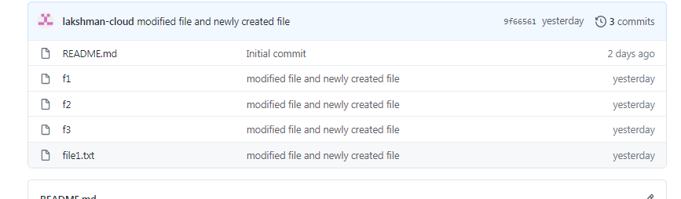

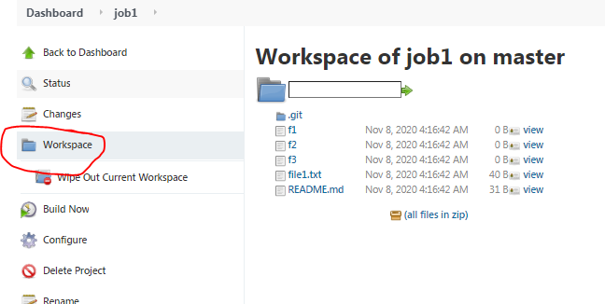

**Note:- wipe out current workspace means it will remove workspace data.**

**Created job3 job.**

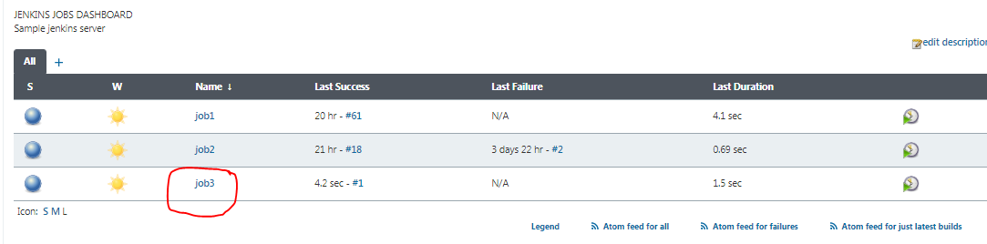

**Setup Upstream and Downstream jobs of Project Relationship in Jenkins:-**

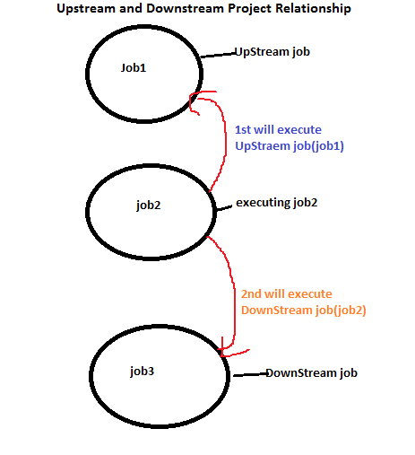

**Goto job2->configure ->build triggers->select job1(here job1 is Upstream )**

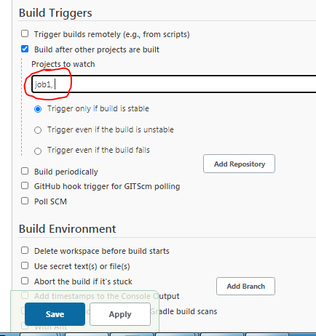

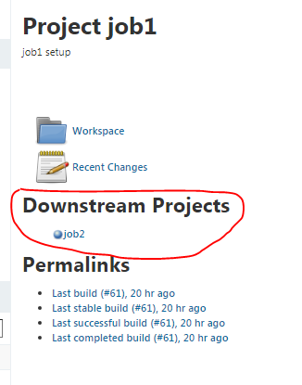

**Goto job3 ->configure ->build triggers->select job2(here job2 is Upstream )**

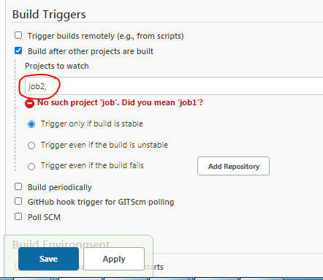

**UpStream project(job2) is configured for job3**

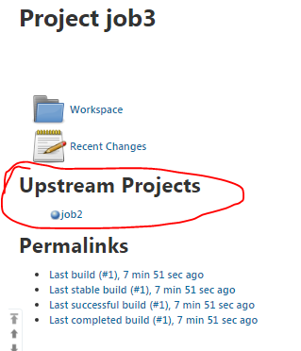

**Downstream project(job3) is configured for job2**

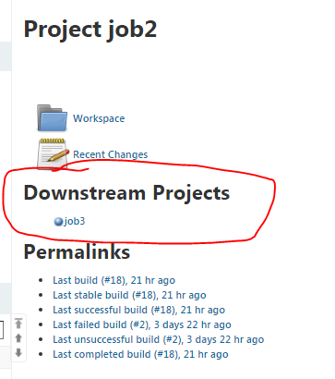

**Job2 having up and down streams.**

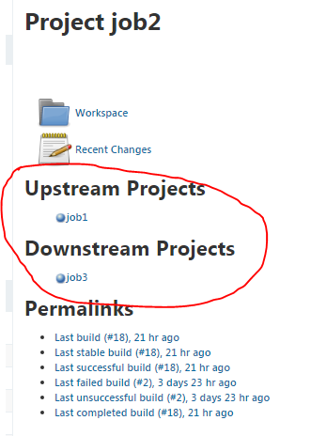

**Now we can build job1 -> remaining job2 and job3 also will build automatically.**

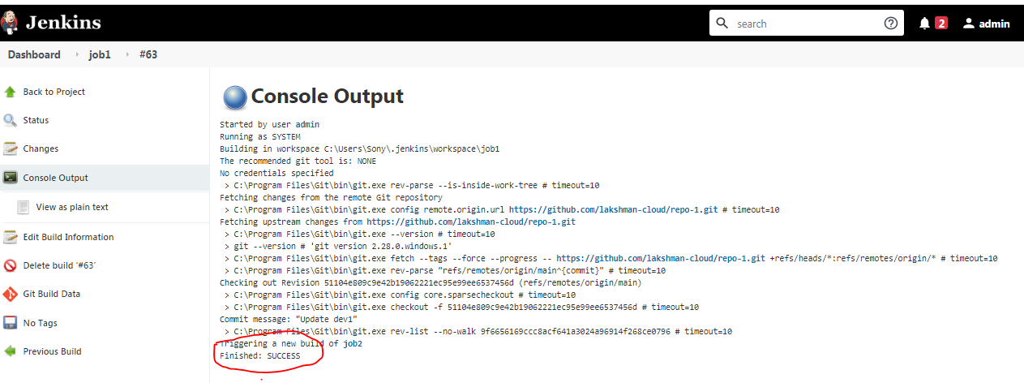

**Job1,job2,job3 ran the jobs.**

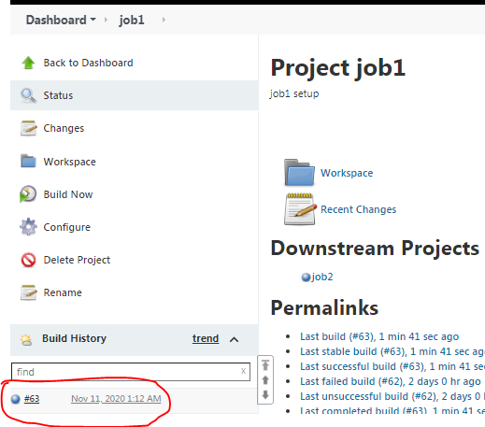

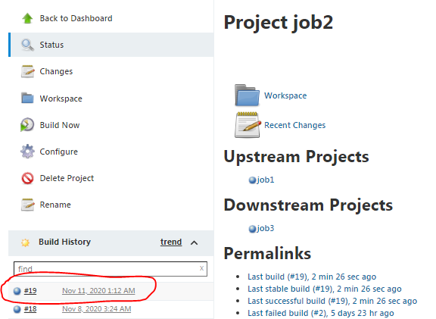

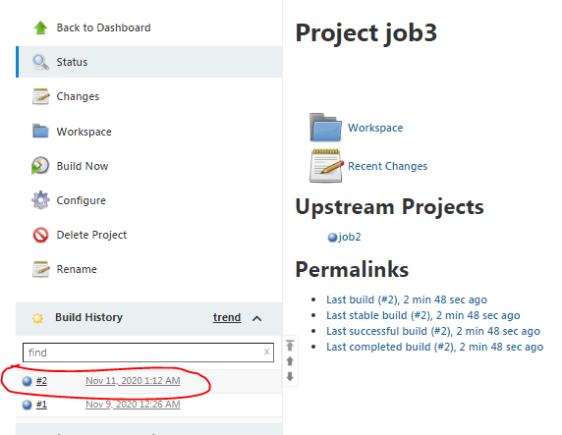

**Another way Down stream jobs setup:- once successfully build job2 , after build job3 also.**

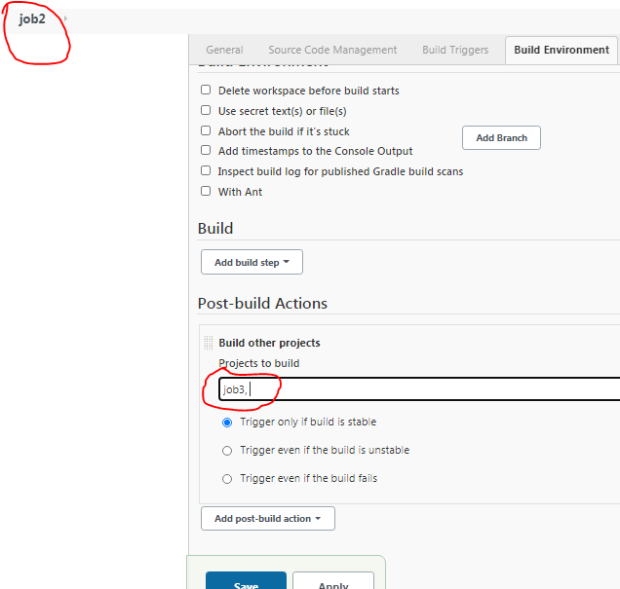

**3 jobs got build success**

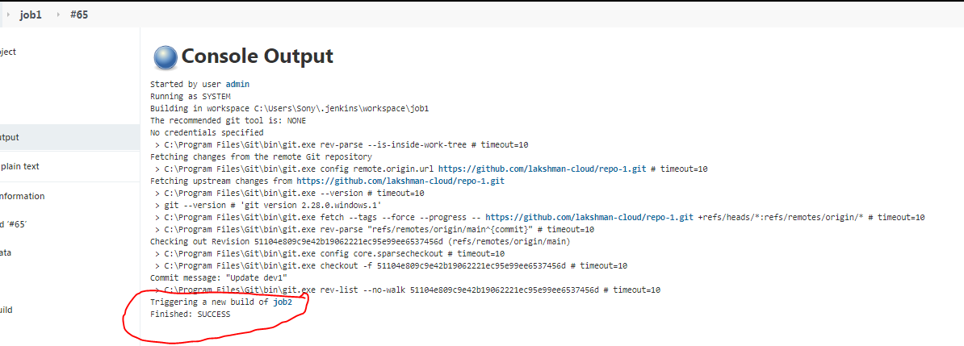

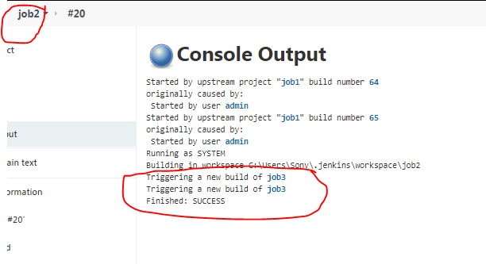

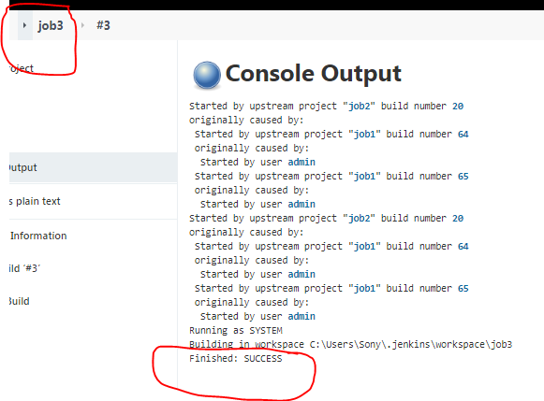

**New Job4 and job5 created.**

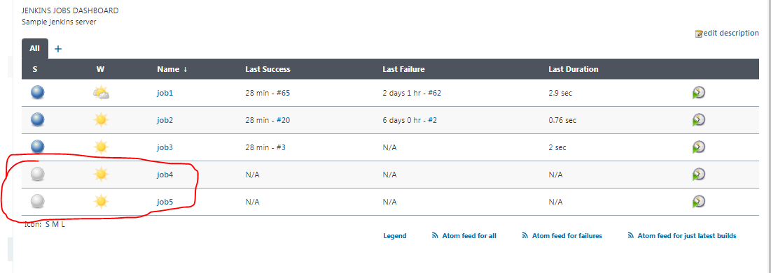

**Goto job3-> projects to build : job4,job5**

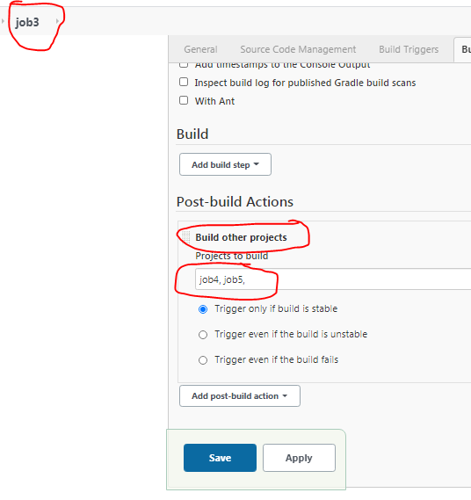

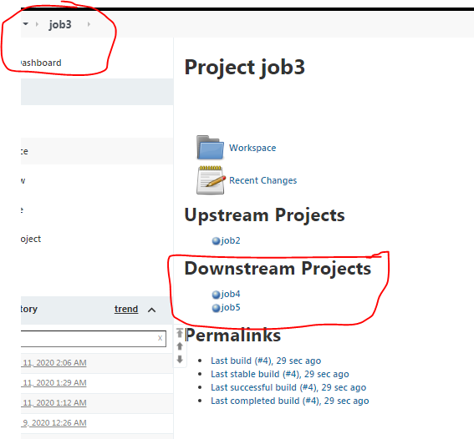

**Scenario 1:- if run job1 – will build job1, job2, job3, job4, job5->all jobs will run**

**Scenario 2:- if run job2 – will build job2, job3, job4, job5->job1 will not run, only downstream jobs will run, but not run up stream jobs.**

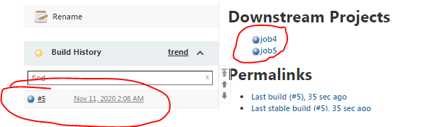

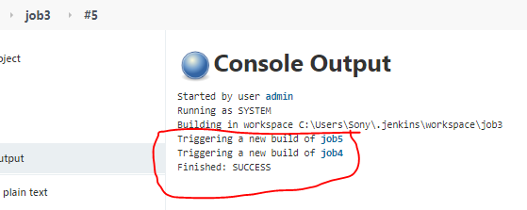

**Note: for one job we can create many dependency jobs.**

**Build Periodically:- use cron jobs setup**

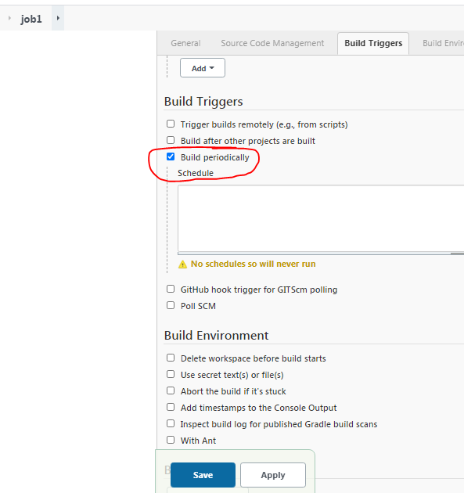

**Search crown tab formats**

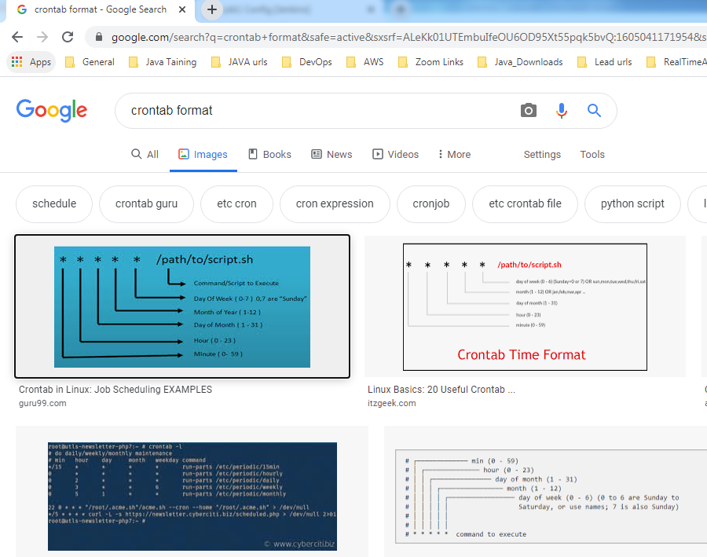

|  |  |
| --- | --- |
| **Cron Job** | **Command** |
| **Run Cron Job Every Minute** | ***\* * * * \**** |
| **Run Cron Job Every 30 Minutes** | ***30 * * * \**** |
| **Run Cron Job Every Hour** | ***0 * * * \**** |
| **Run Cron Job Every Day at Midnight** | ***0 0 * * \**** |
| **Run Cron Job at 2 am Every Day** | ***0 2 * * \**** |
| **Run Cron Job Every 1st of the Month** | ***0 0 1 * \**** |
| **Run Cron Job Every 15th of the Month** | ***0 0 15 * \**** |
| **Run Cron Job on December 1st – Midnight** | ***0 0 0 12 \**** |
| **Run Cron Job on Saturday at Midnight** | ***0 0 * * 6*** |

**27 –min, 02- hr,11-day,11-month,03- Wednesday . (**[**Nov 11, 2020 2:27 AM**](http://localhost:8181/job/job1/67/)**) , Eg: 22 19 10 06 04 (**[**Jun 10, 2021 7:22 PM**](http://localhost:8585/job/job1/29/) **)**

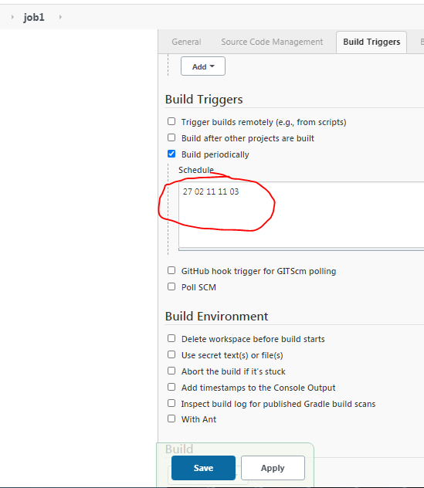

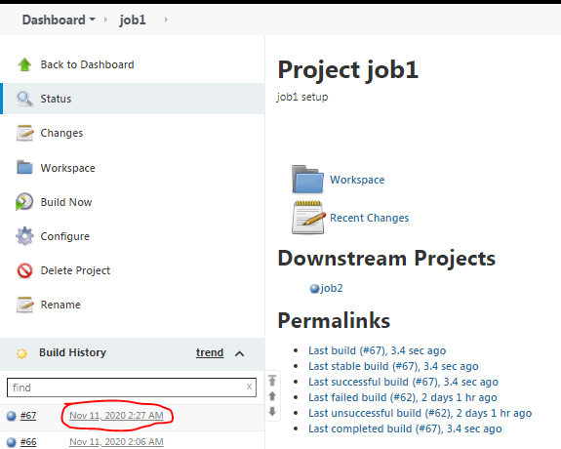

**Builded successfully 5 jobs automatically as per crown tab setup (**[**Nov 11, 2020 2:27 AM**](http://localhost:8181/job/job1/67/)**).**

**Verify in console ->manually build by admin**

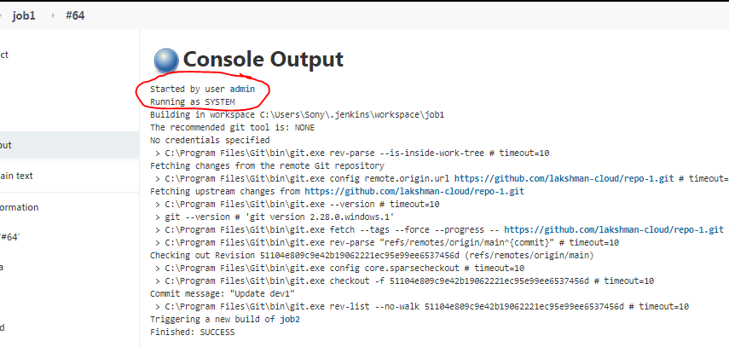

**Verify in console ->with UP and Down stream setup**

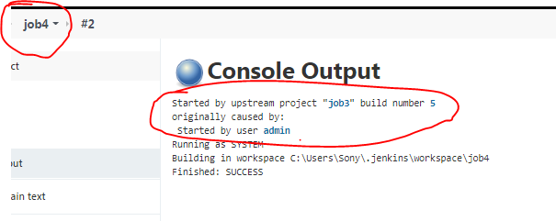

**Verify in console ->Started By timer**

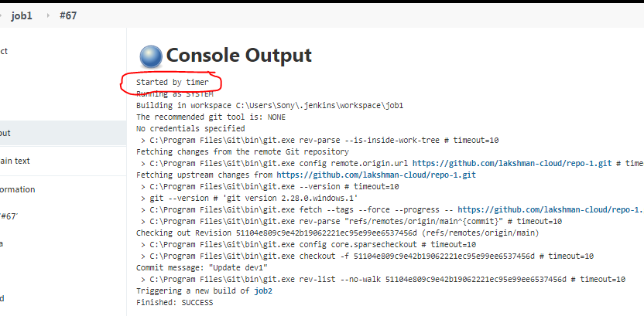

**If you give all stars -> every min,hr,day will trigger build.**

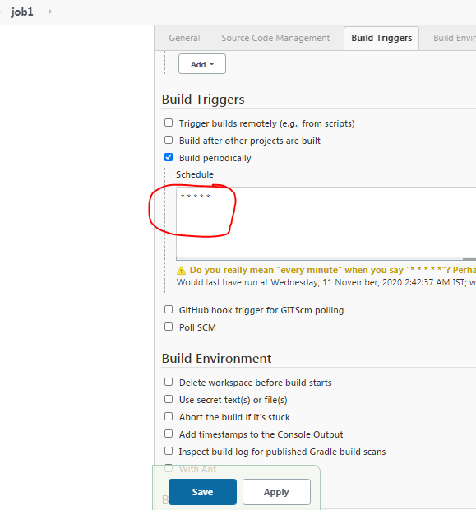

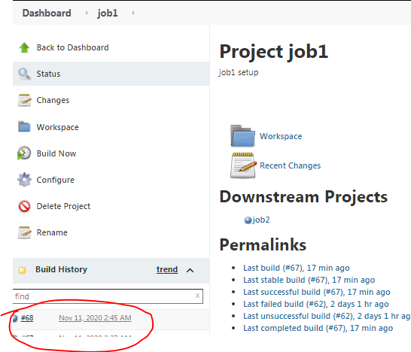

**Every min will build doing .**

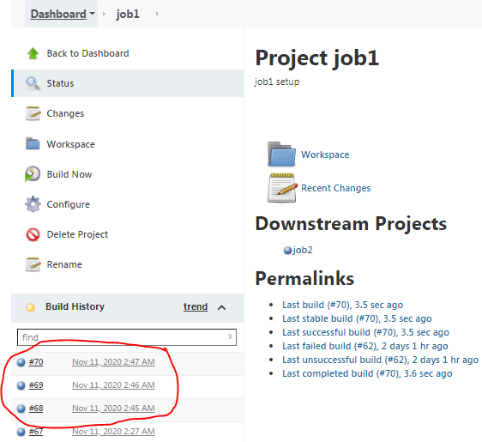

Poll SCM:- whenever code pushed into github repo, build will start and latest code will clone and build the poll SCM on based on crown tab format.

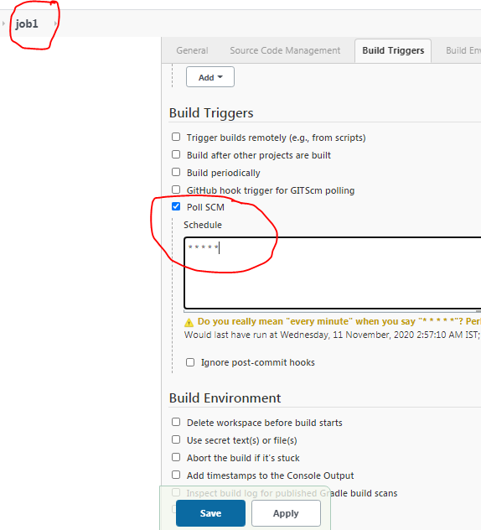

**Created one new file and add, commit ,push into repo-1 repo.**

**Create new folder and Clone the code from github.**

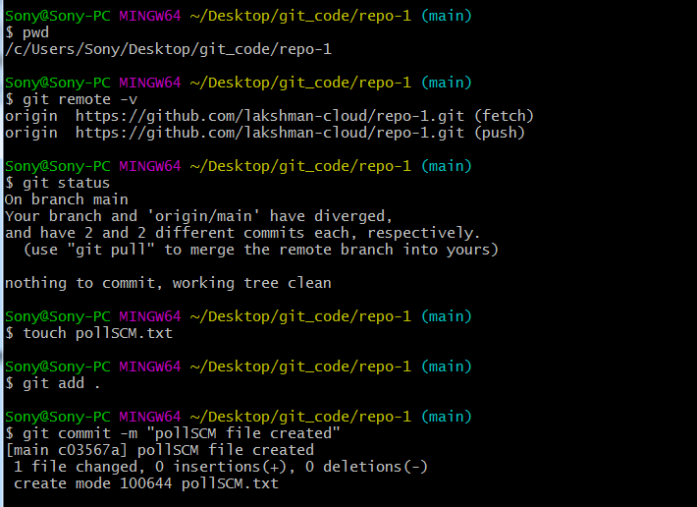

**If any error while pushing code , we need to pull the code and push again.**

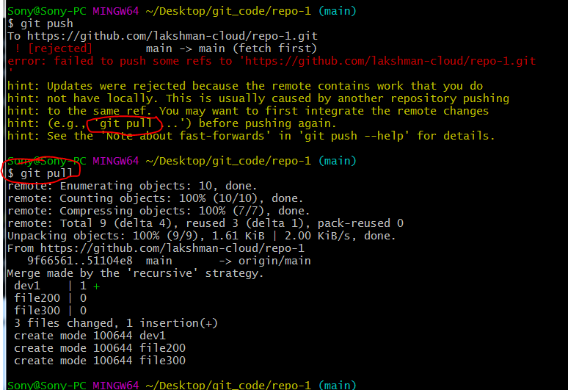

**Now push the code it will work.**

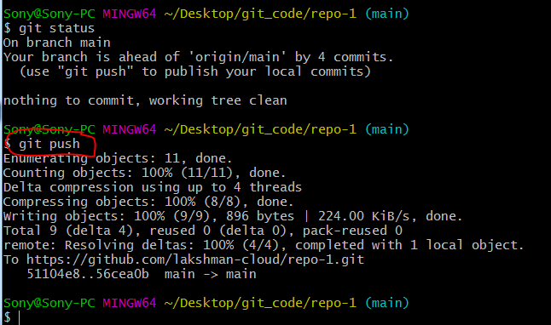

**Verify logs, Around 3 :14 i have pushed the code.**

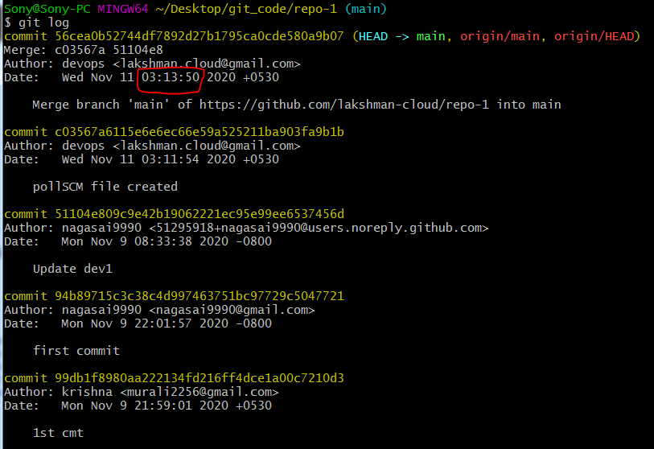

**Pushed code to github.**

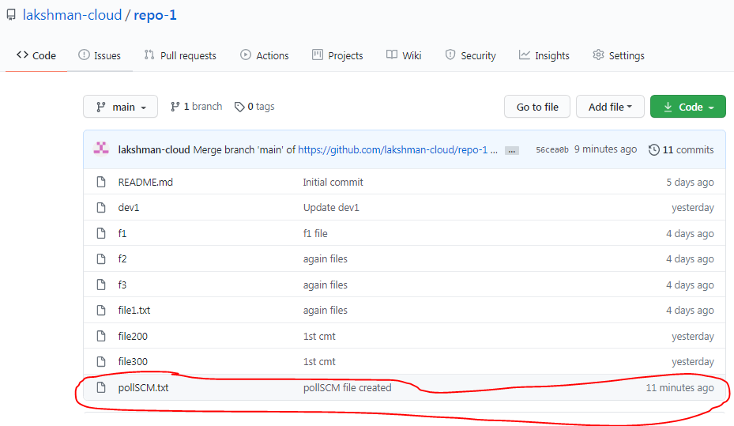

**Next minute -> 3:15 build done.**

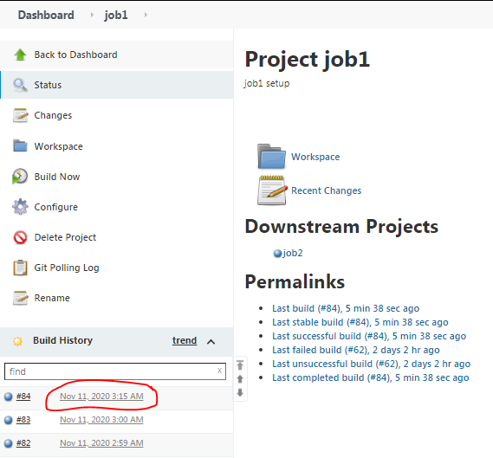

**Verify in console -> started by SCM**

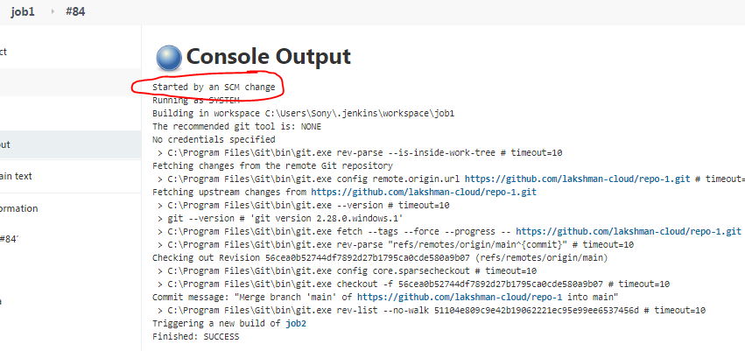

**Delete workspace before build starts -> before build workspace will remove.**

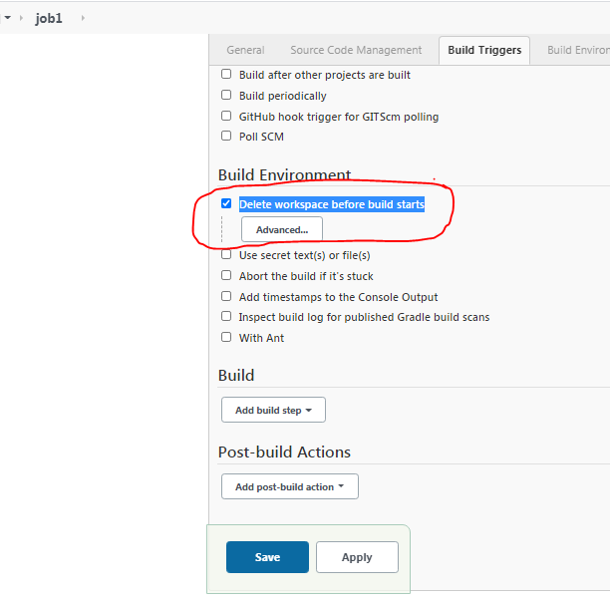

**Cleanup workspace and clone again fresh code.**

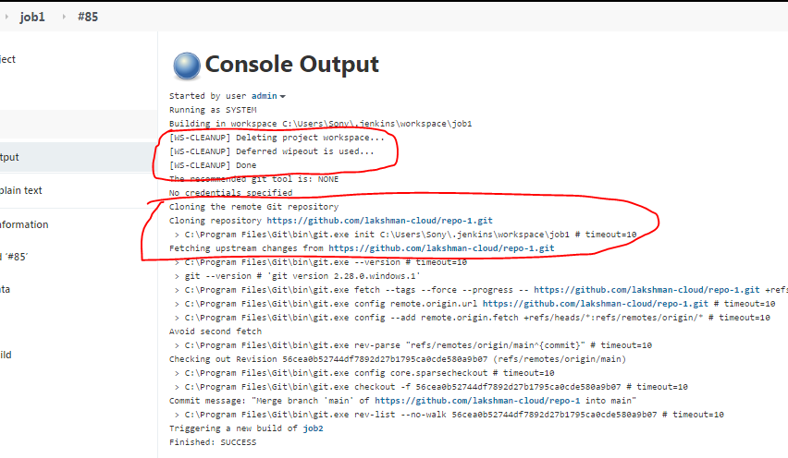

**Abort the build if it's stuck ->If any job struck, that job will kill after 2 mints.**

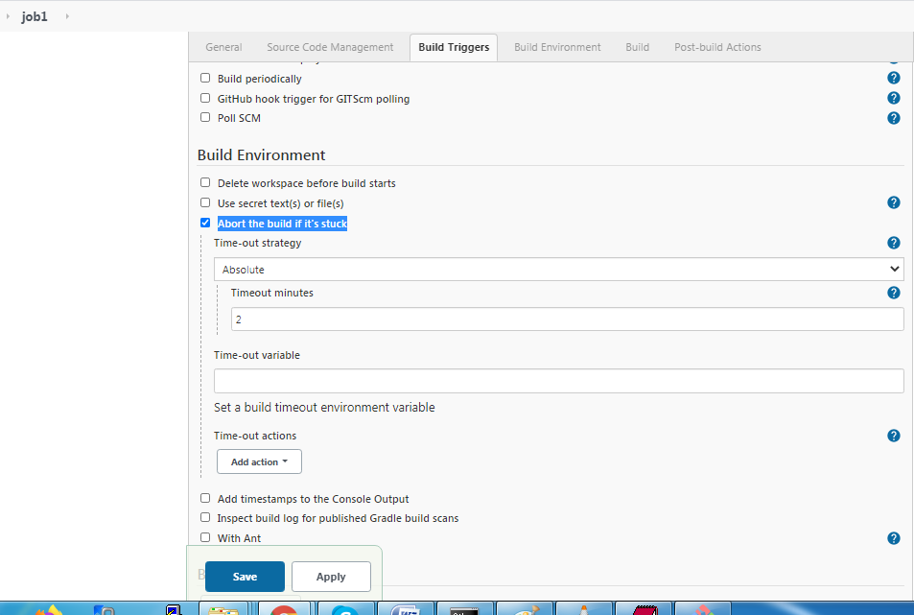

**Add timestamps to the Console Output -> time stamp will be shows in console for all events.**

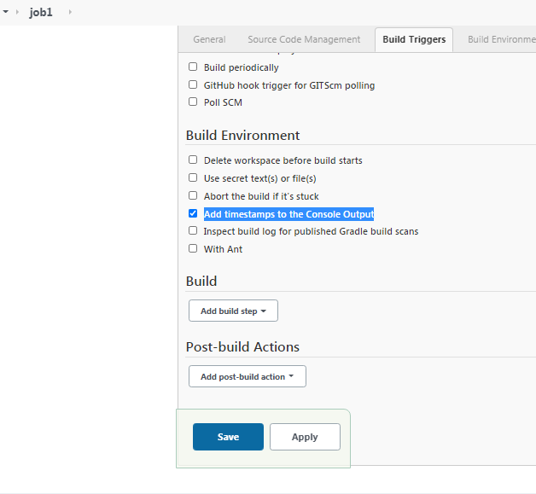

Build job1 ->open console

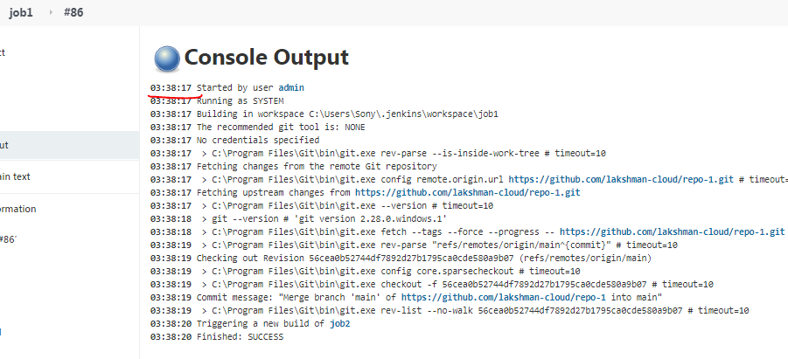

**Build Section:-**

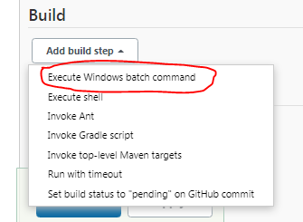

**Given windows cmnd dir to show all dir folders.**

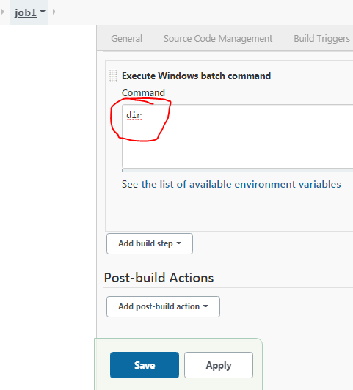

**Click Build now**

**Note: -your Jenkins is running in windows choose windows batch cmnd option**

**OR**

**your Jenkins is running in linux choose execute shell option.**

**It shows the all directories.**

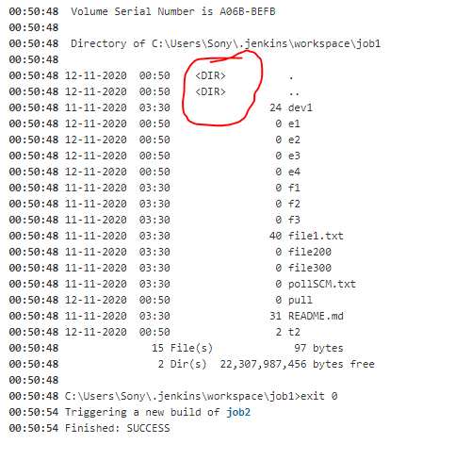

**Note: Push the maven project into github:- already in maven session we have generated maven web project**

**Create new repo in github.**

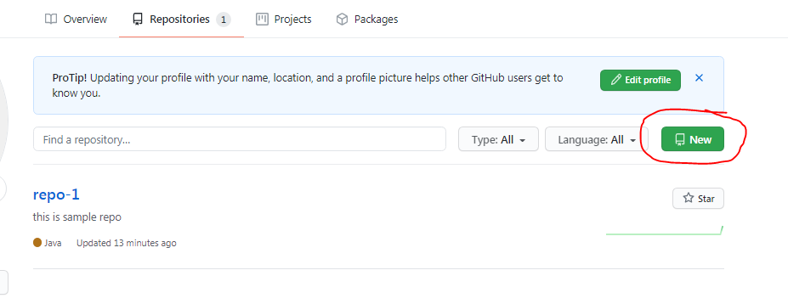

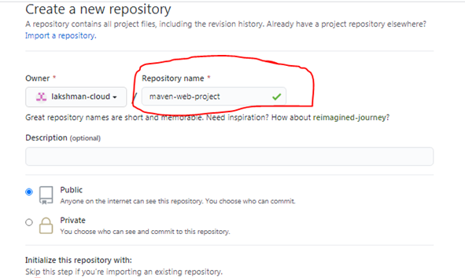

**No need to select read me file-> create repository.**

**Empty New project created.**

**Create new folder and Clone to local .**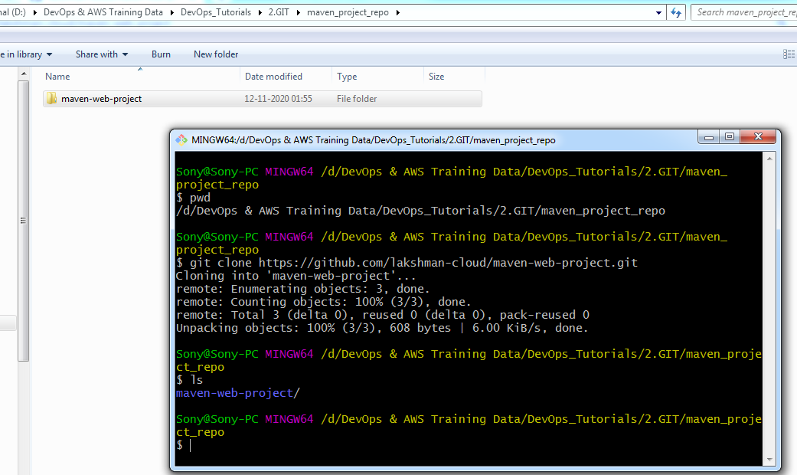

**Keep maven web project into that repo.**

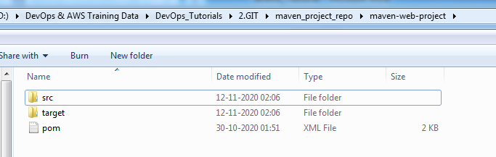

**Status**

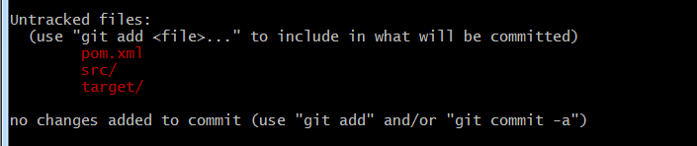

**Verify remote is up to and date.**

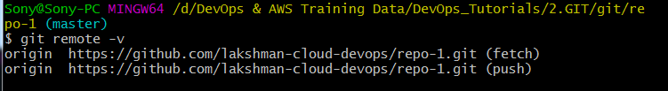

**Add and commit**

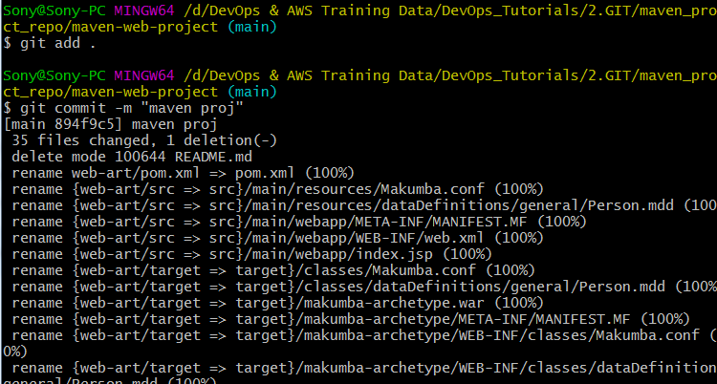

**If not pulled code , do it pull cmnd.**

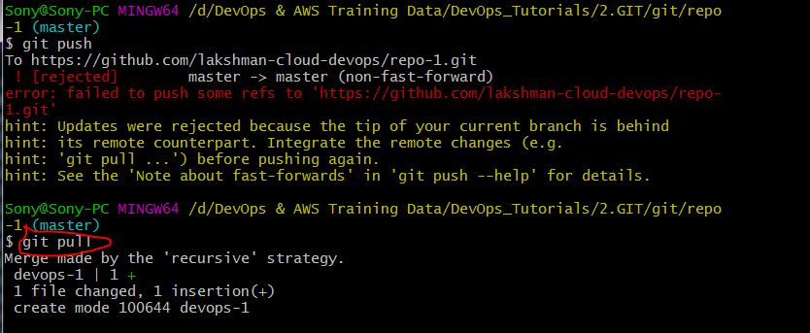

**Push the code.**

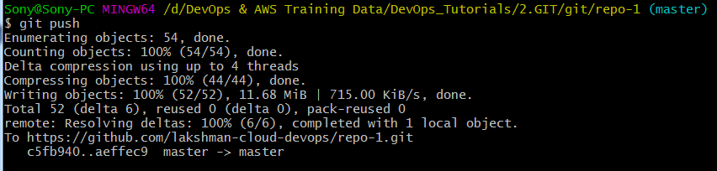

**Refresh github url.**

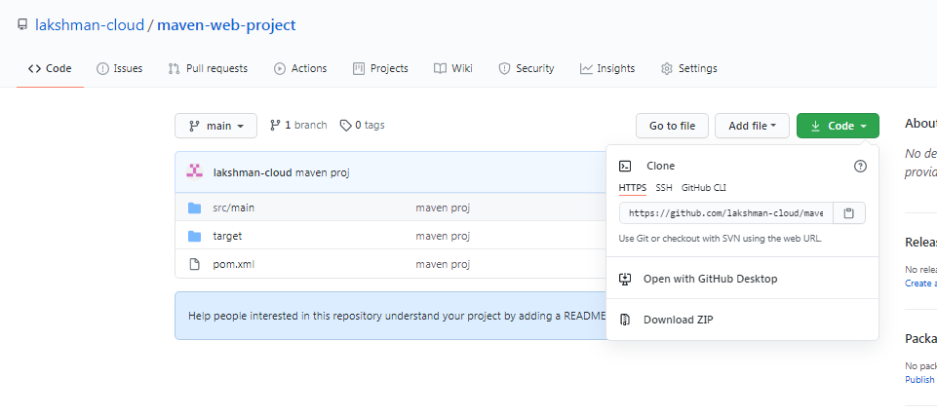

**Provide repository url**

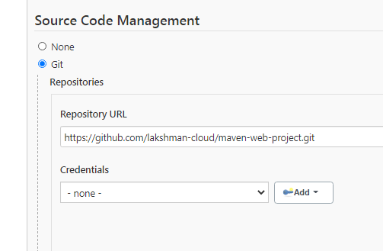

**Select maven version and Set maven goal in the job.**

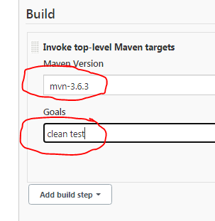

**Build Now -> maven build is success.**

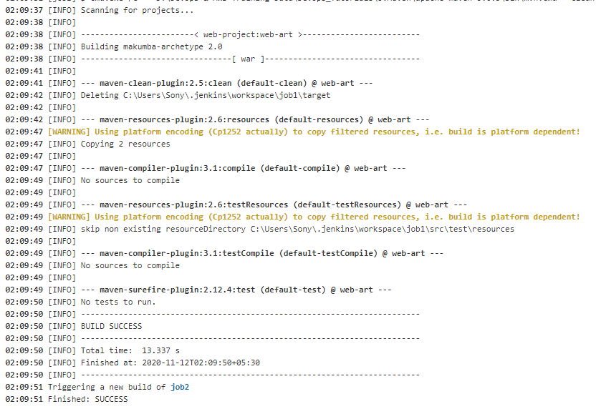

**Setup for executable file generation (war file).**

**Goal changed.**

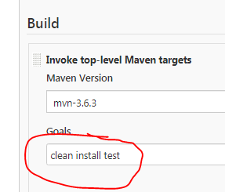

**Job Build now -> build success and war file created in specific dir.**

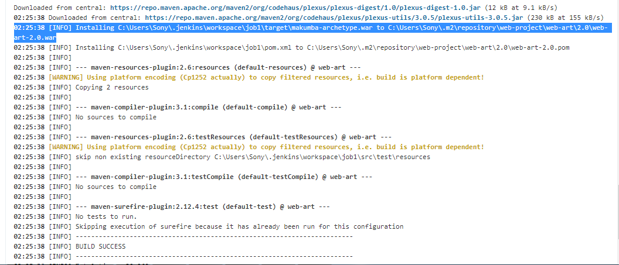

**Verify in job workspace.**

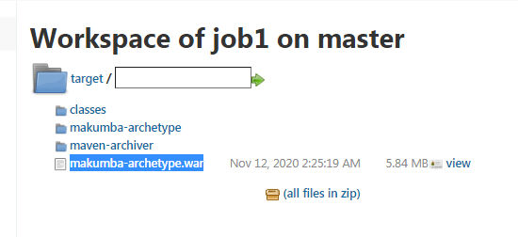

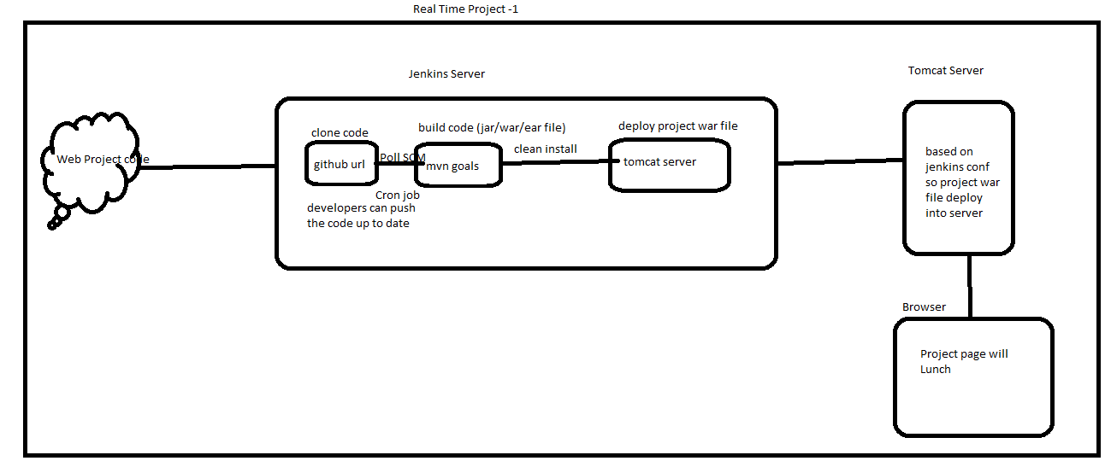

**Deploy war file into tomcat server:- In Windows**

**Start tomcat server in windows.**

Open tomcat users xml

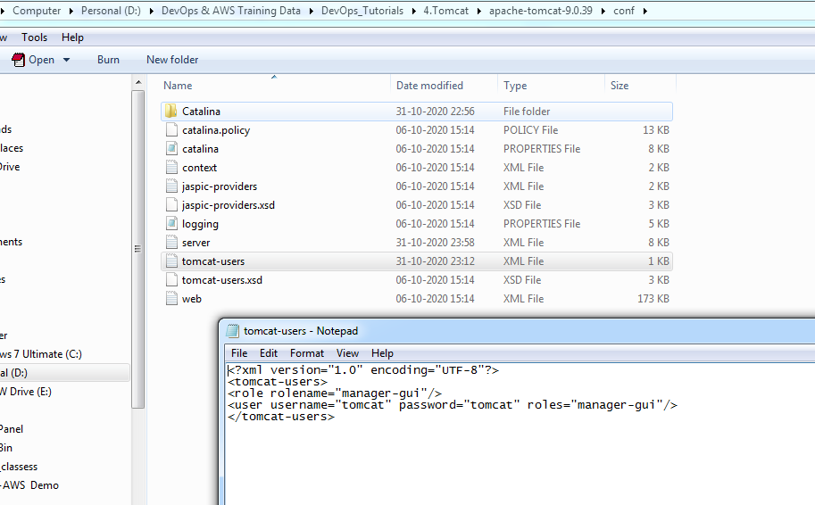

Add roles in tomcat users.xml file for all roles access.

manager-script, manager-admin, manager-status

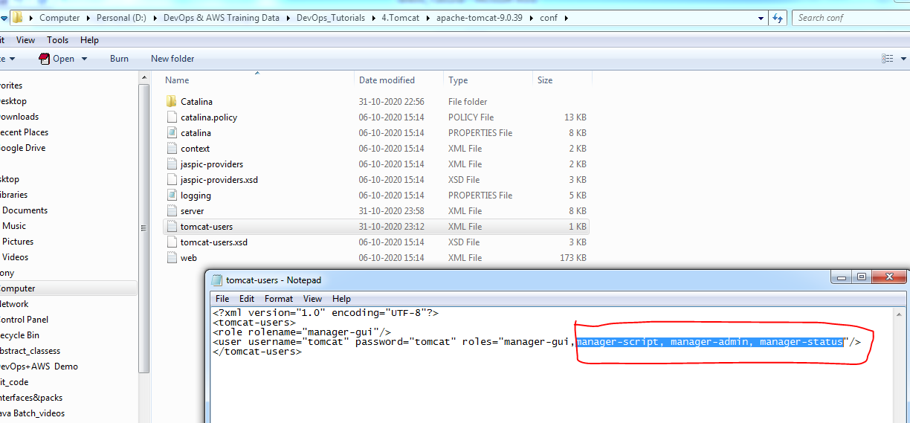

Start tomcat

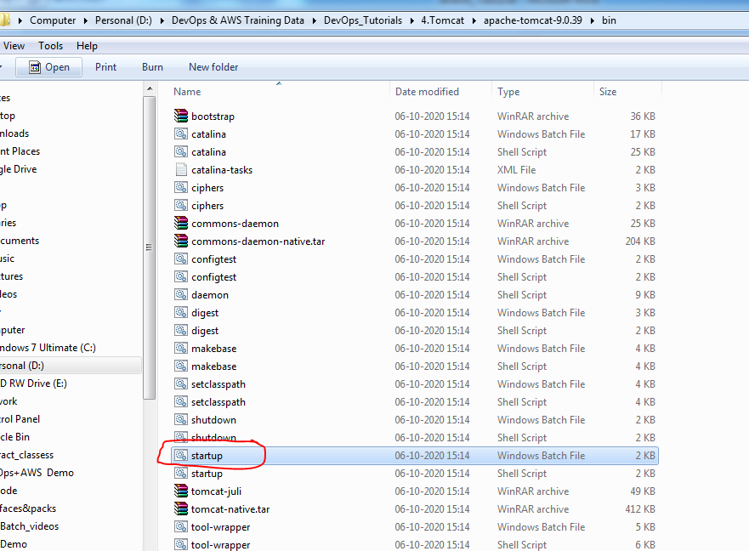

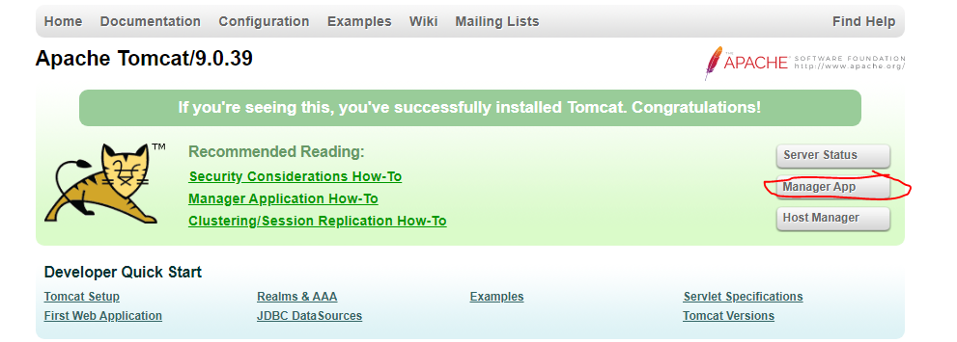

Un/pwd:- tomcat/tomcat

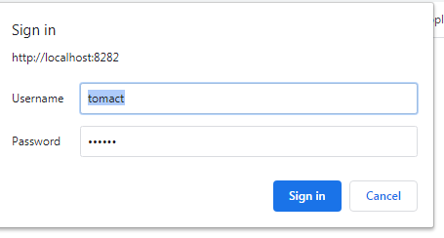

**Source Path->** **Copy war file path**

C:\Users\Sony\.jenkins\workspace\job1\target

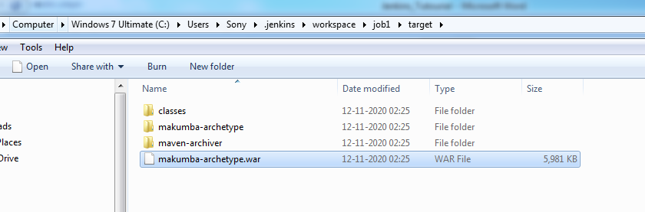

**Dest Path->** **tomcat webapps folder.**

D:\DevOps & AWS Training Data\DevOps_Tutorials\4.Tomcat\apache-tomcat-9.0.39\webapps

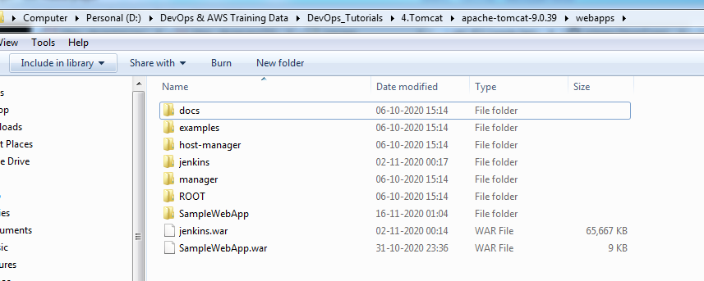

**Note:-if war exists, make sure remove war file in webapps folder before run the job1.**

**Above both paths give into job1 configure under builds :-**

COPY "C:\Jenkins_home\workspace\jenkins_job1\target\makumba-archetype.war" "E:\DevOps & AWS Training Data\DevOps_Tutorials\4.Tomcat\apache-tomcat-8.5.65\webapps"

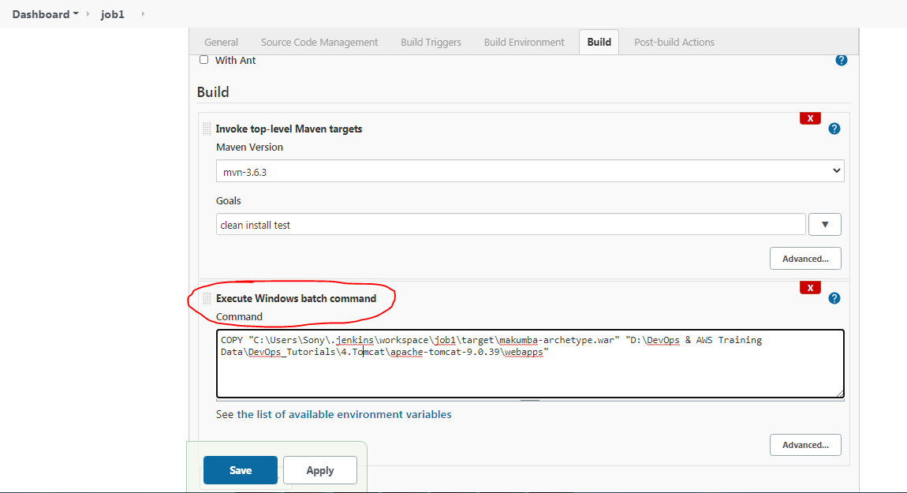

Job1 ->Build now.

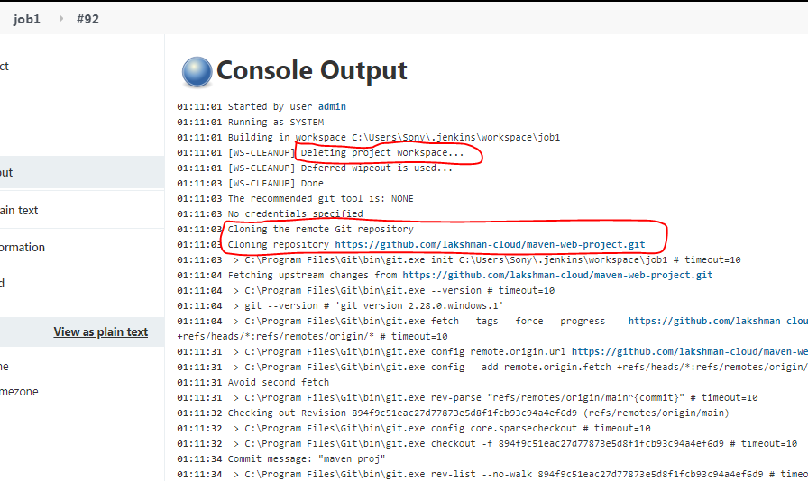

Copied war file deploy into tomcat webapps folder .

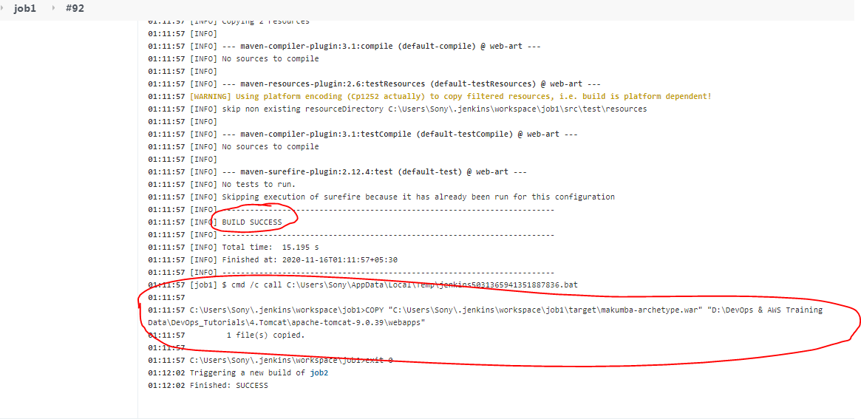

Refresh tomcat server browser and verify war file deployed or not and open war file project.

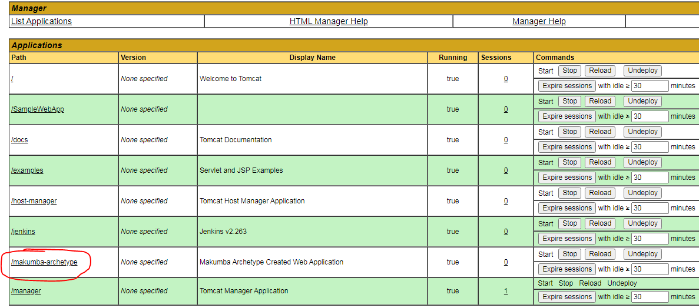

**Email –Configuration for job1:-**

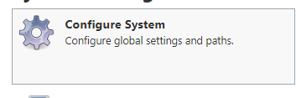

For example gmail configuration doing.

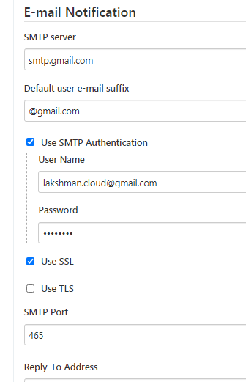

Note:- Here gmail pwd (personal pwd)

Try for testing-> click test configuration

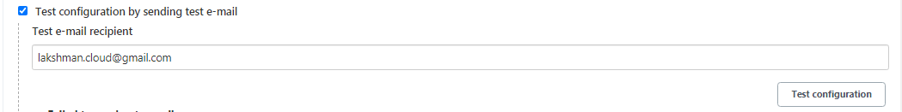

If you not get mail, gmail less secures apps access option is disabled .

**How to Enable gmail less secures apps access option:-**

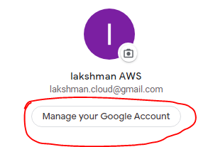

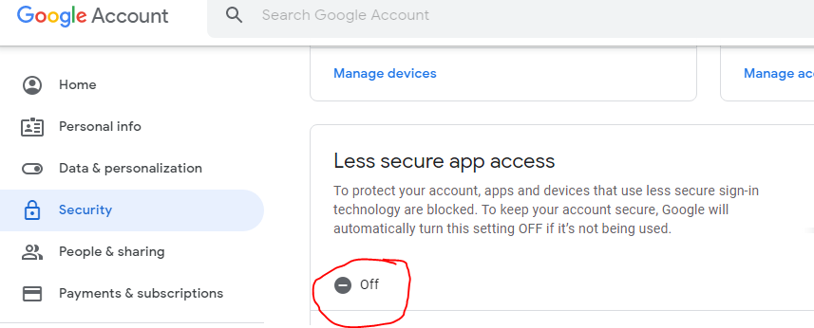

**Enable it -> on**

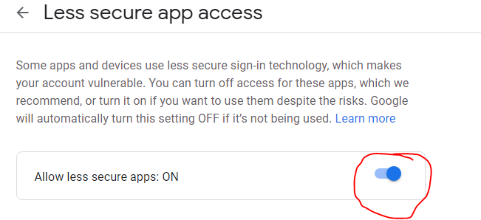**Enabled.**

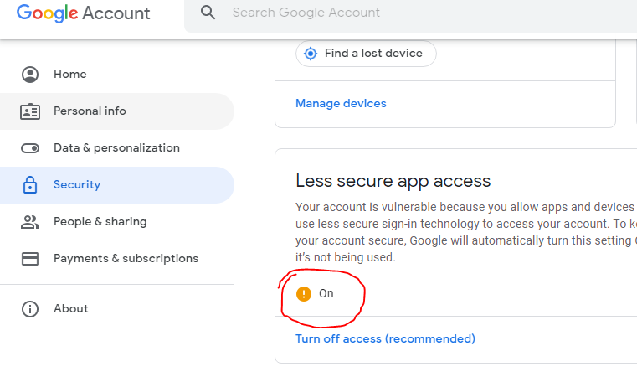

**Email was successfully sent**

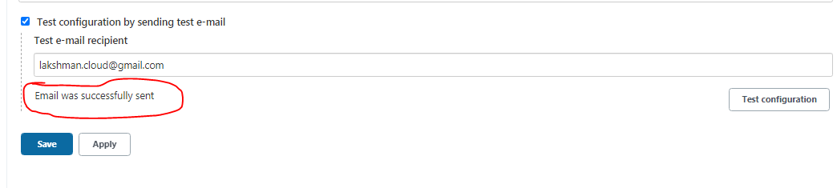

**Verify gmail inbox**

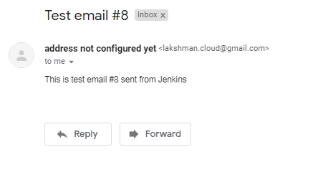

**Goto job1 configure .**

**Provide email id for every unstable build: - only mail will trigger when ever build is failure.**

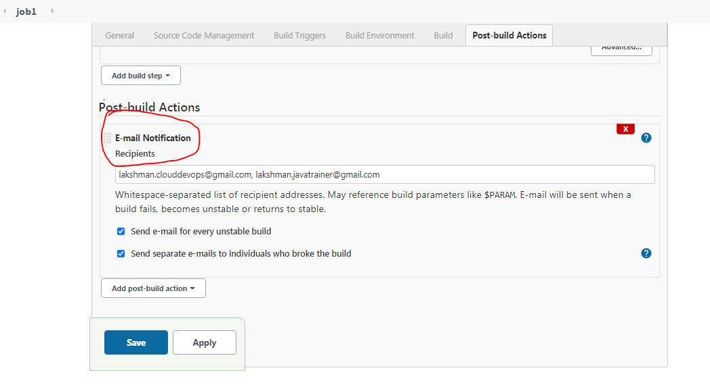

**Given wrong git hub url for build failure.**

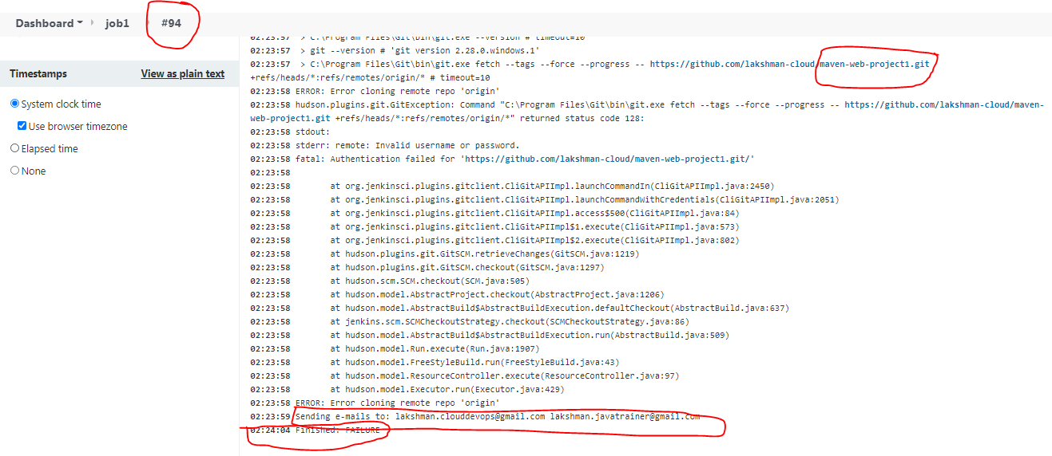

**You will get build failure mail, verify gmail for same Build No.**

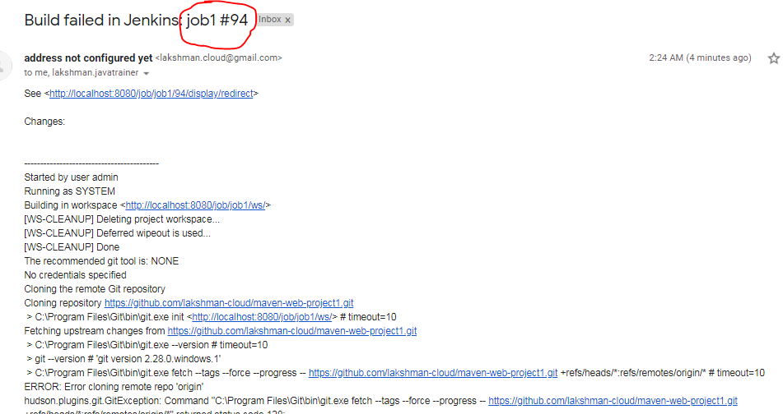

**For next success build for one more mail will trigger:- build back to normal mail.**

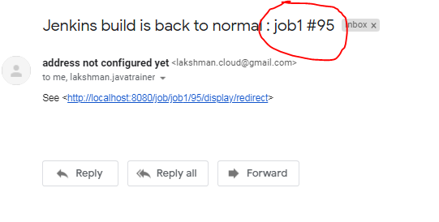

**Editable Email Notification:-**

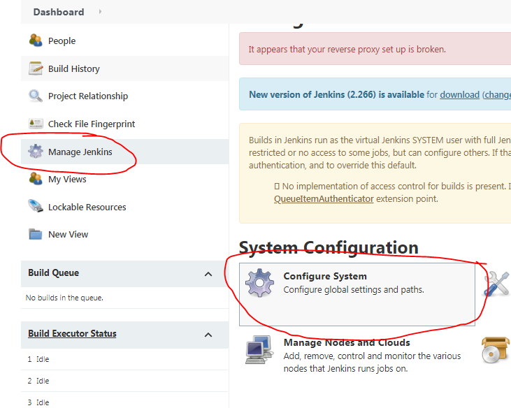

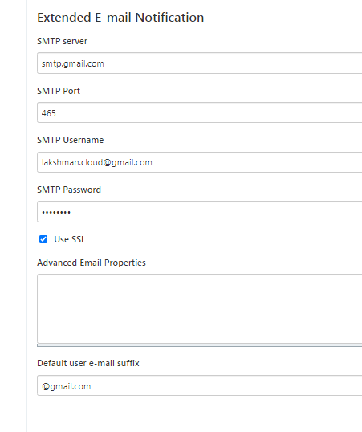

**Goto job1-configure.**

**Cancel previous email-notification setup under post build.**

**Setup for editable email notification.**

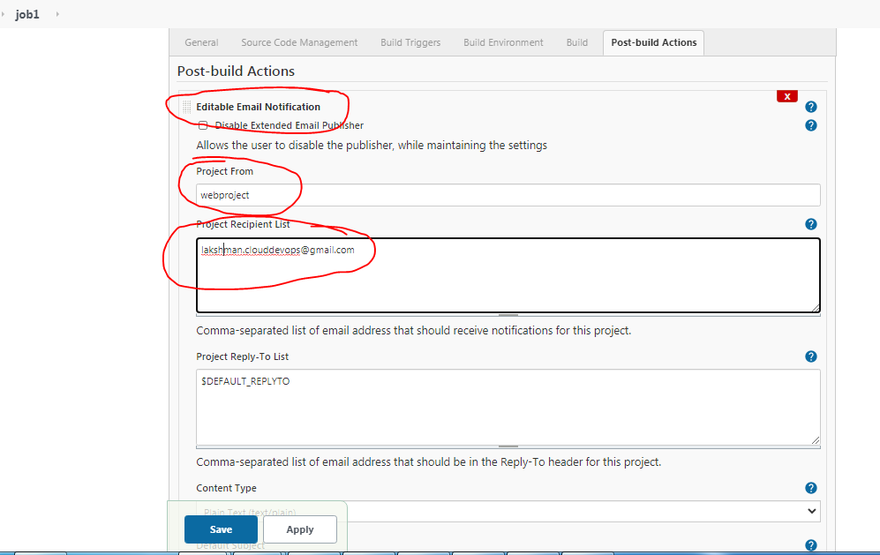

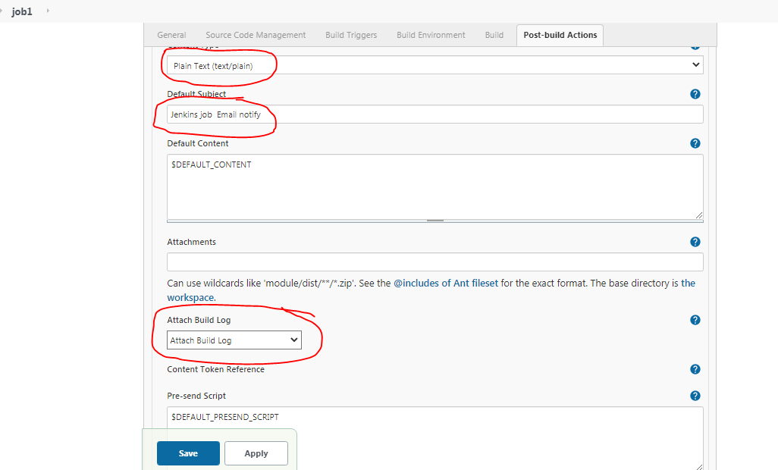

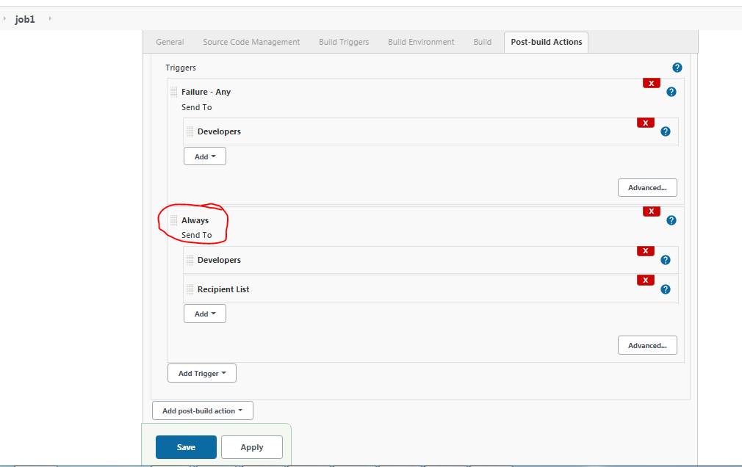

**Job1 build now.**

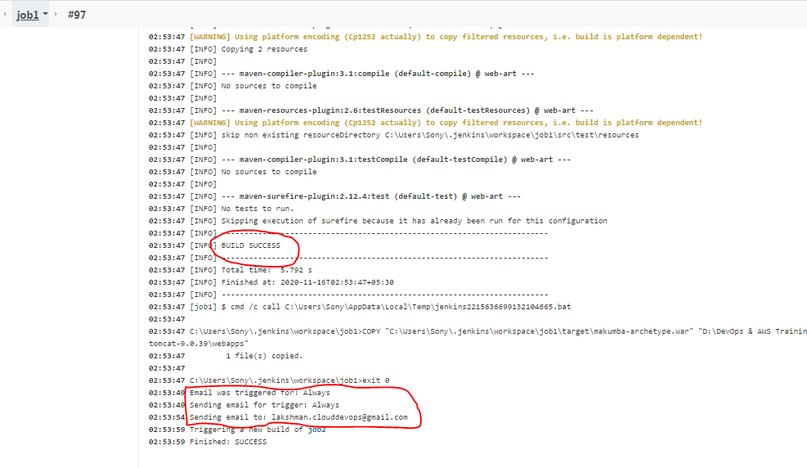

**Verify email**

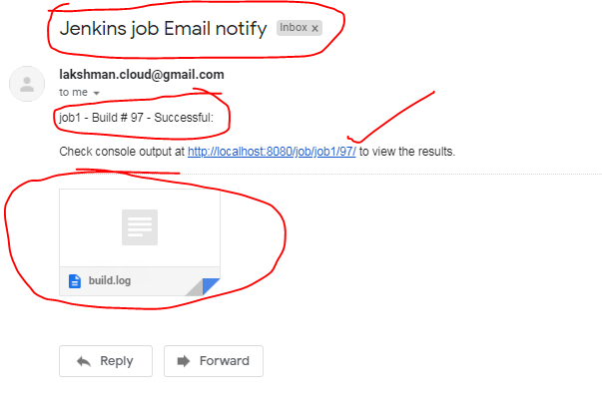

**Open log file**

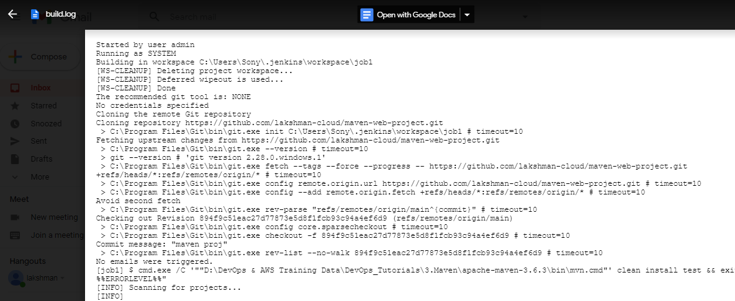

**Jenkins integration with Tomact in Linux:- goto bin and start the server.**

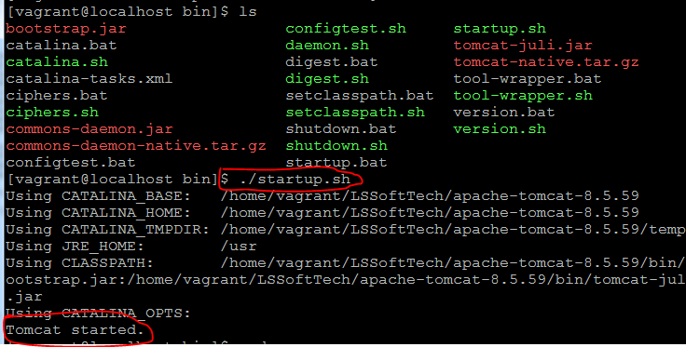

**Take hostname**

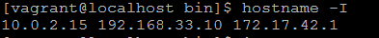

**Iptables -F -> to enable the firewalls**

**[root@localhost conf]# netstat -an|grep 8585 (check 8585 port is listening)**

**tcp6 0 0 :::8585 :::* LISTEN**

[**http://192.168.33.10:8484/**](http://192.168.33.10:8484/)

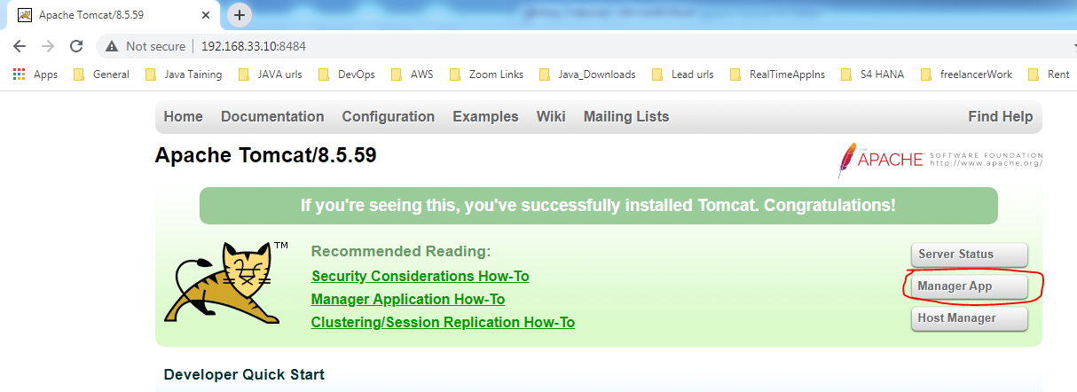

**Enter un/pwd: tomcat/tomcat**

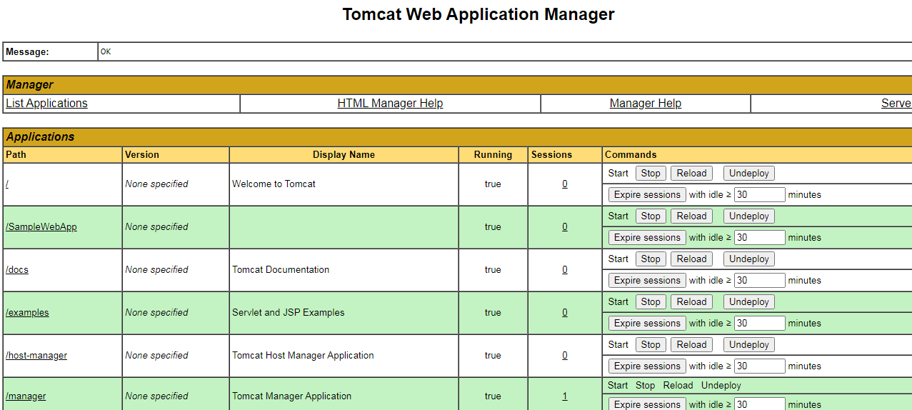

**Install plugin in Jenkins to deploy windows war file into linux tomcat server.**

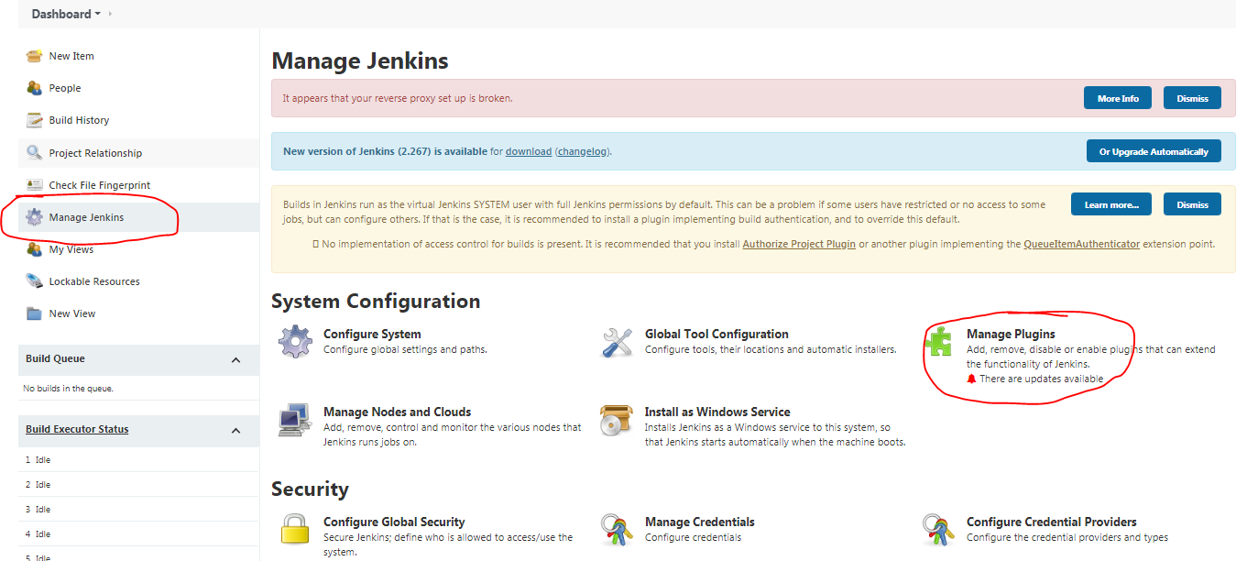

**Search: deploy to container**

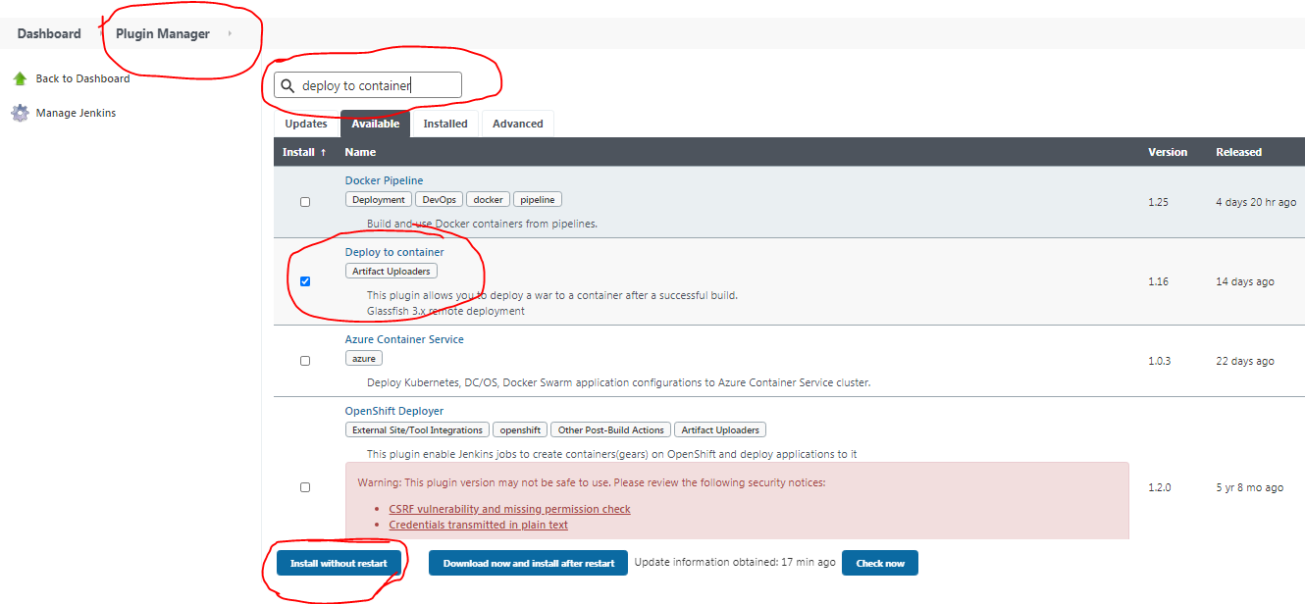

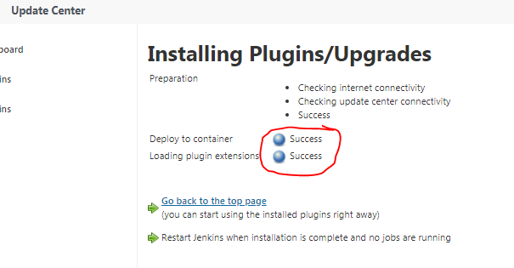

**Restart Jenkins (in console -> ctl+c will showtdown and again start)**

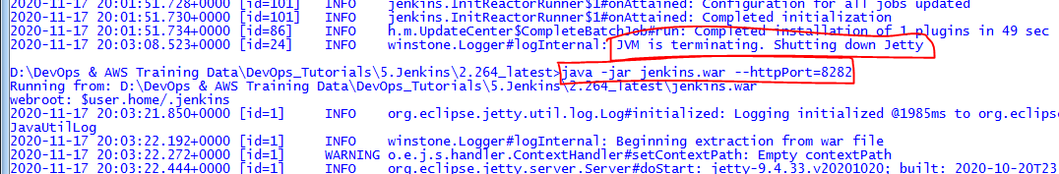

**Refresh Jenkins url:** [**http://localhost:8282/**](http://localhost:8282/)

**Un/pwd: admin/admin@123**

**Goto job1**

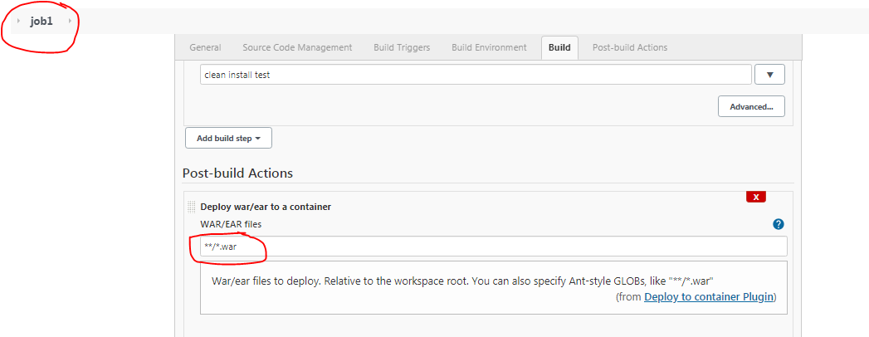

**Select tomcat8.x remote and add tomcat credentials.**

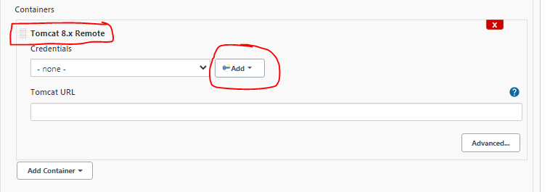

**Provide linux tomcat server un/pwd: tomcat/tomcat**

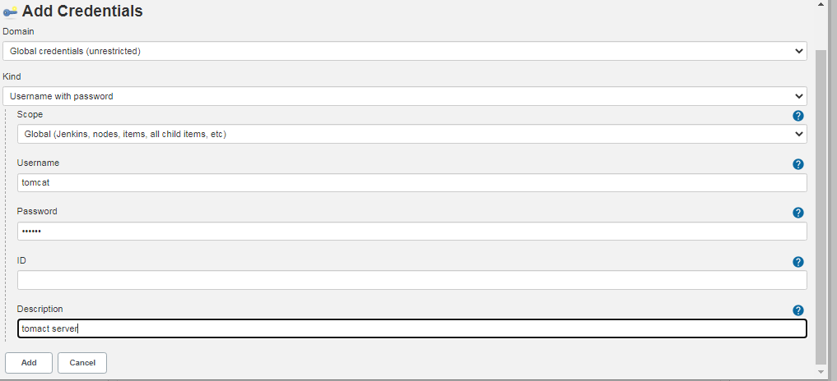

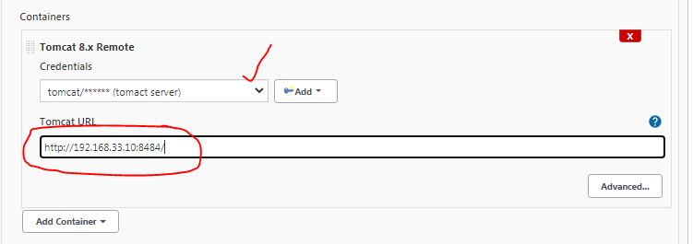

**Save**

**Buid the job1**

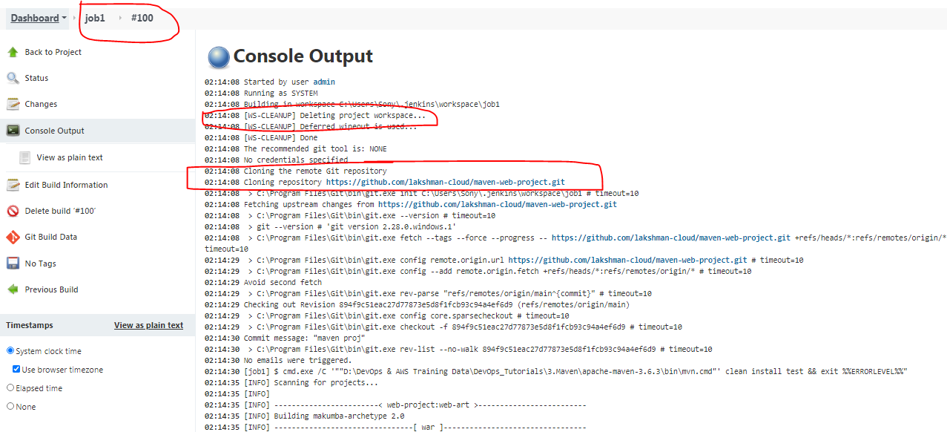

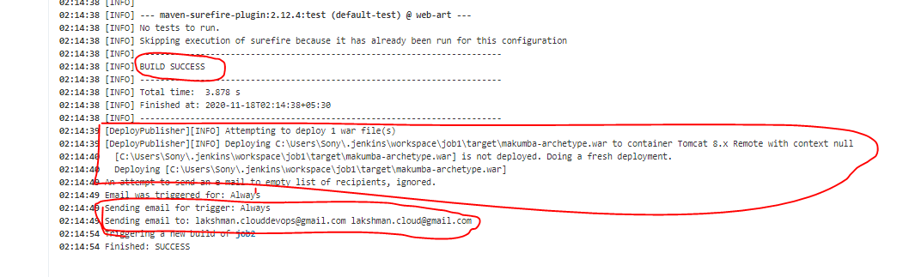

**Deployed into tomcat server.**

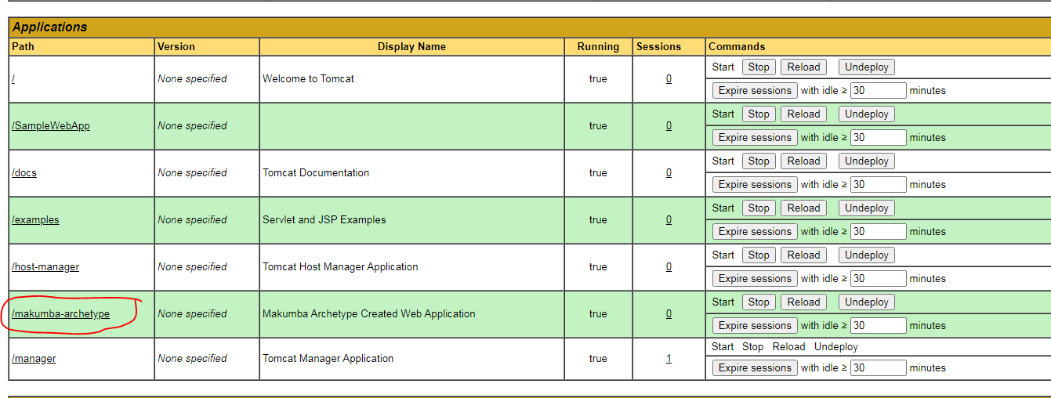

**Open email.**

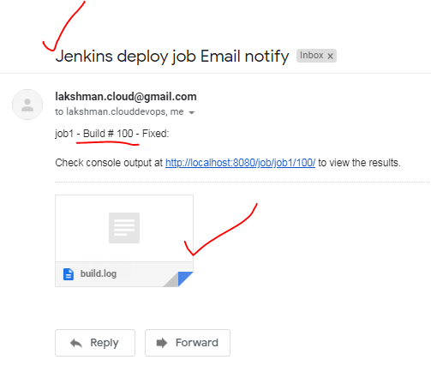

[**Role-based Authorization Strategy**](https://plugins.jenkins.io/role-strategy) plugin install

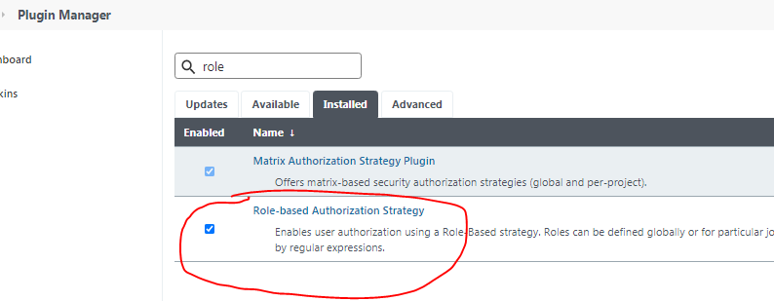

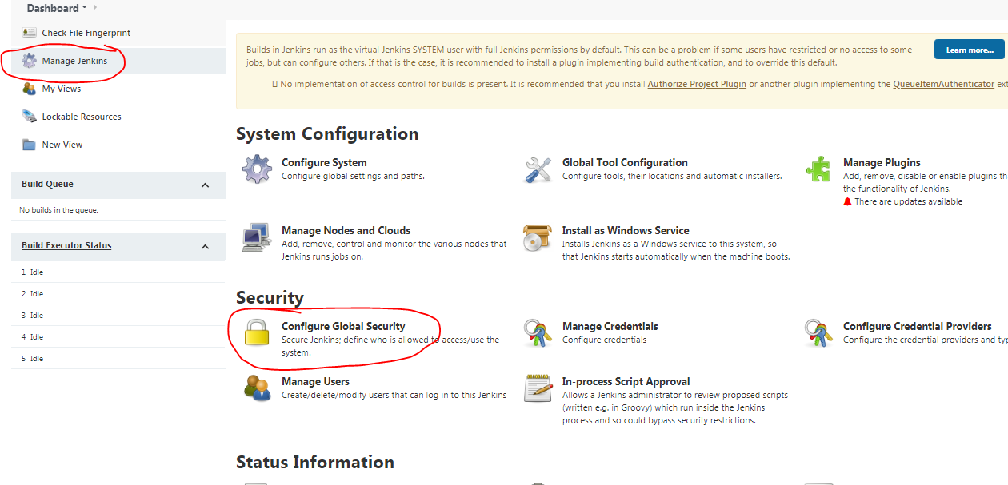

**Goto job1 and select Role-Based Strategy**

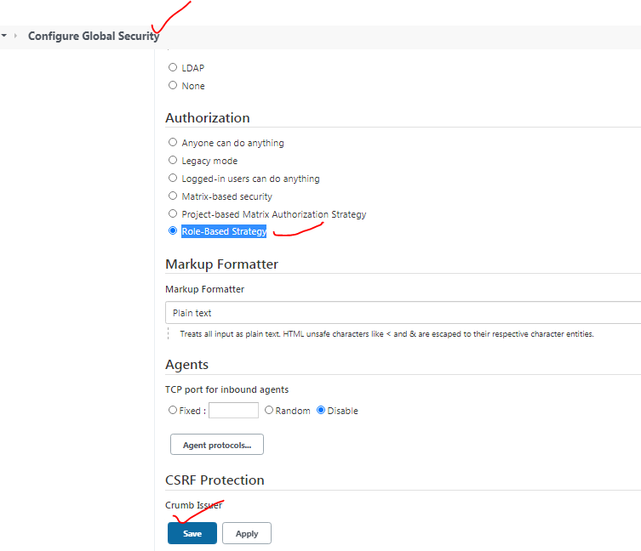

**Manage and Assign Roles option will appear.**

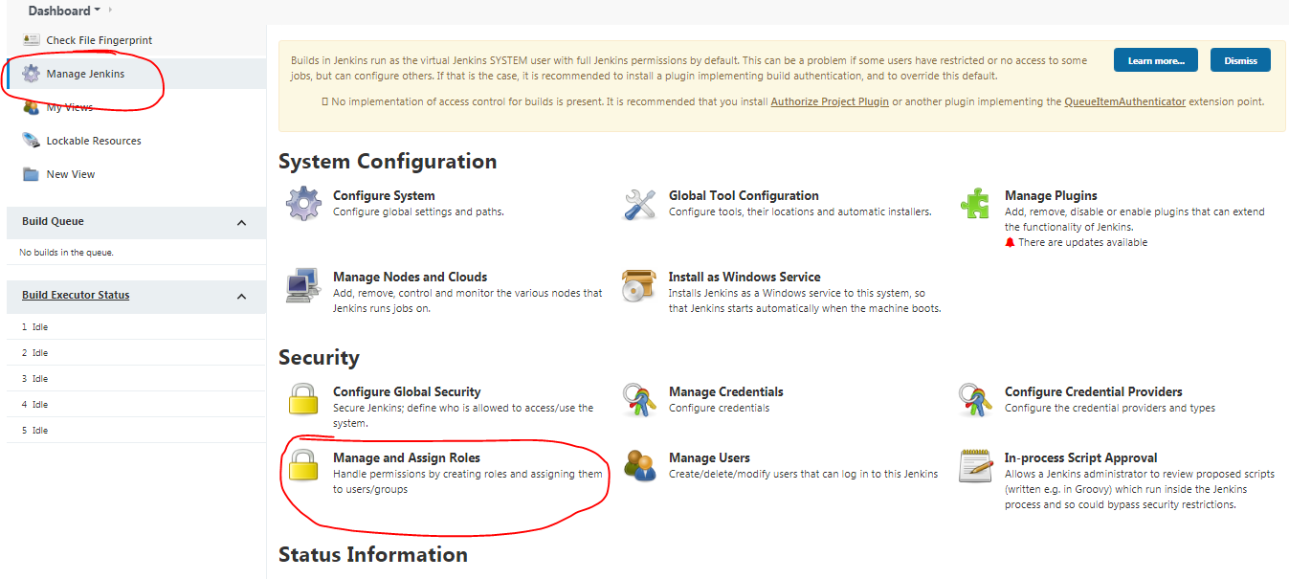

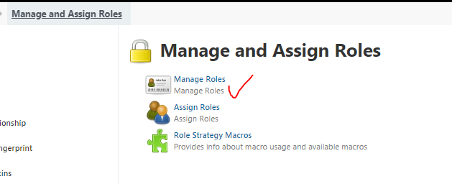

**Created build, deploy, create roles for 3 teams**

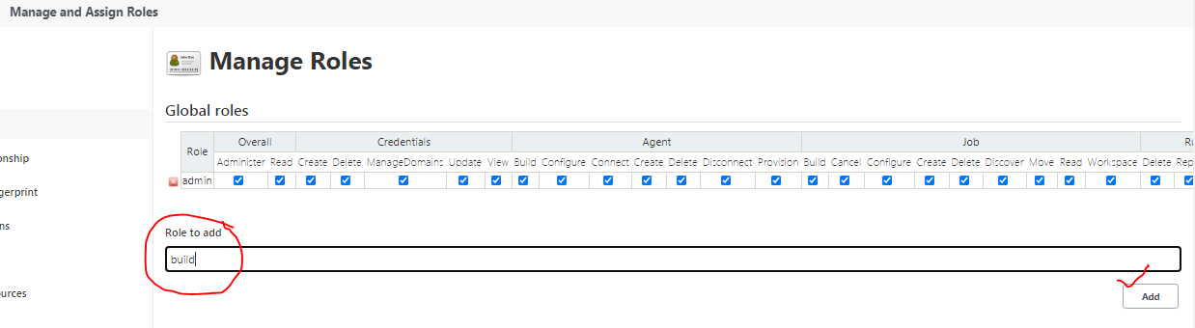

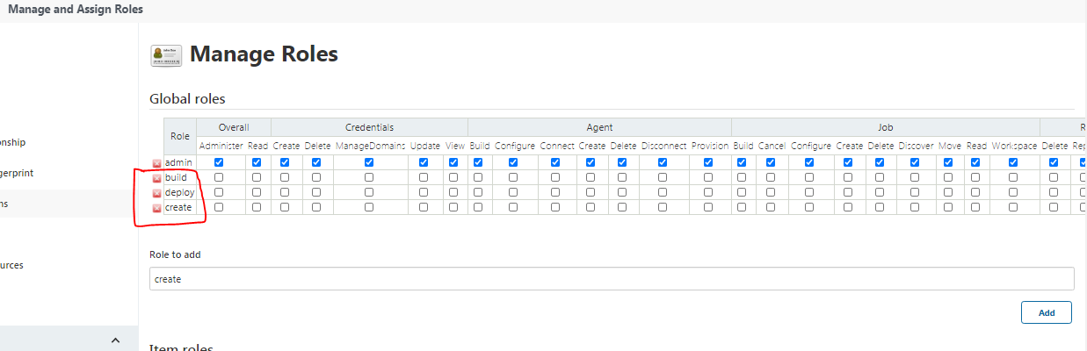

**Provide permission**

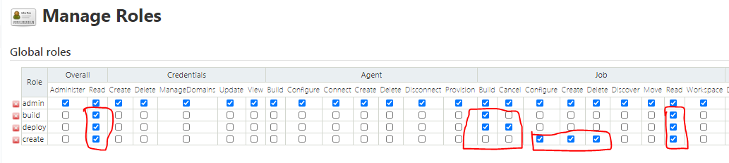

**Create 4 users**

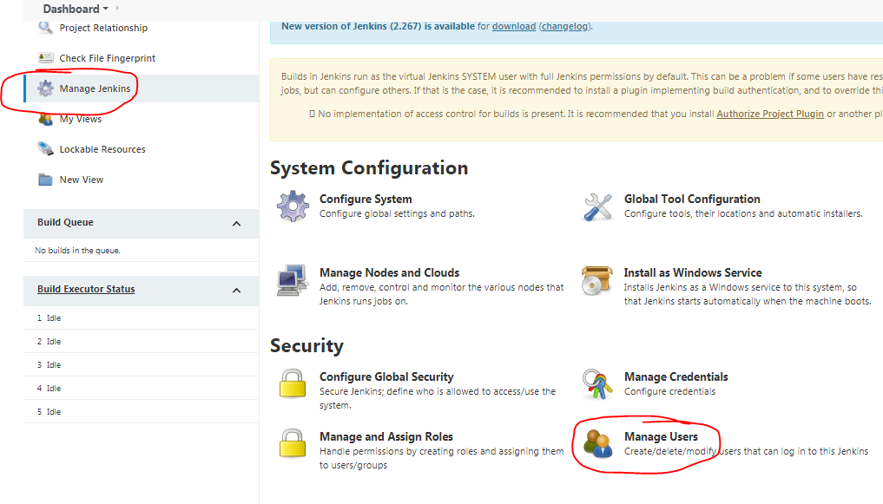

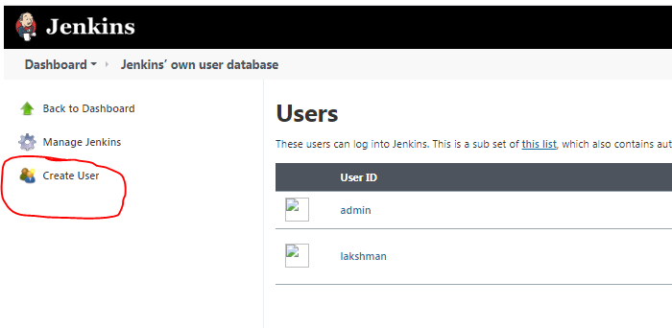

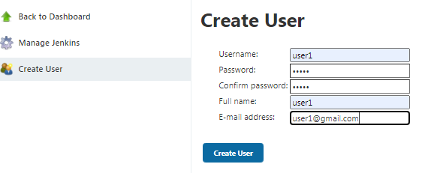

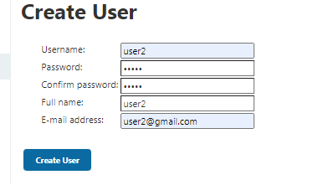

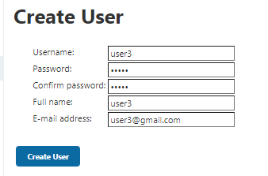

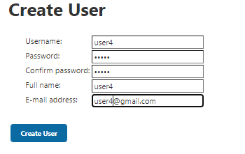

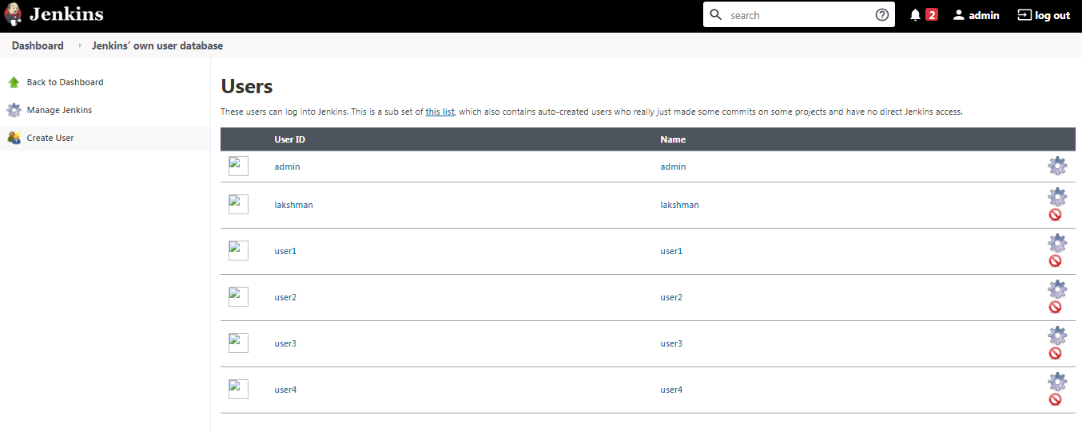

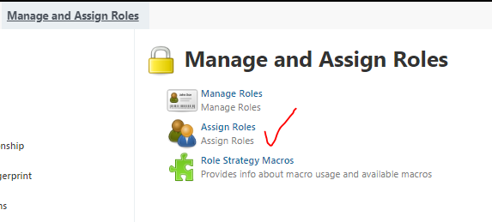

**Add 4 users**

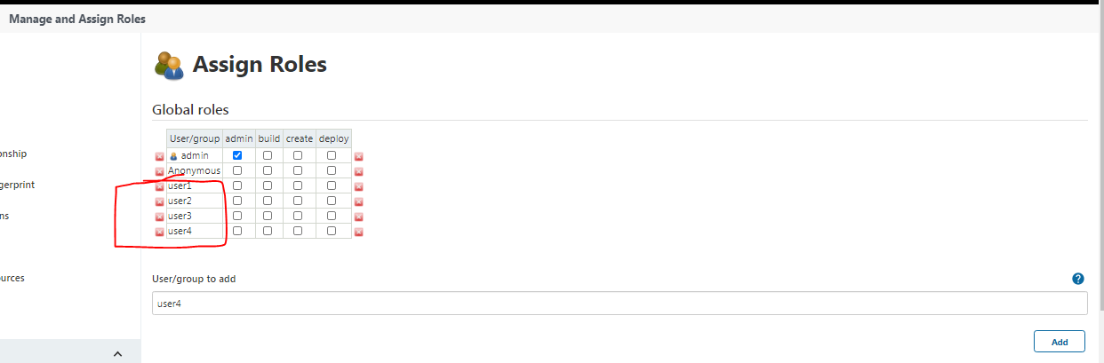

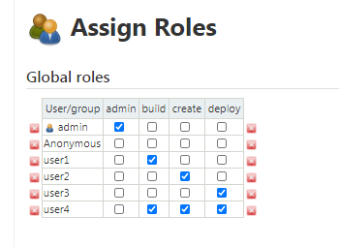



**Login user1 –build role ->read,build**

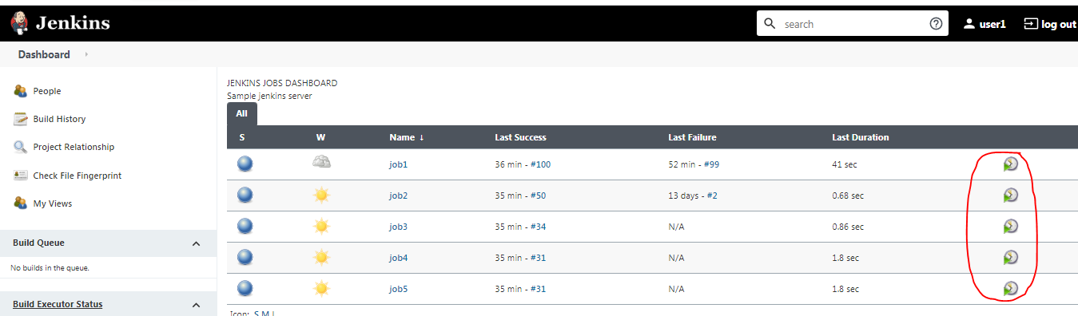

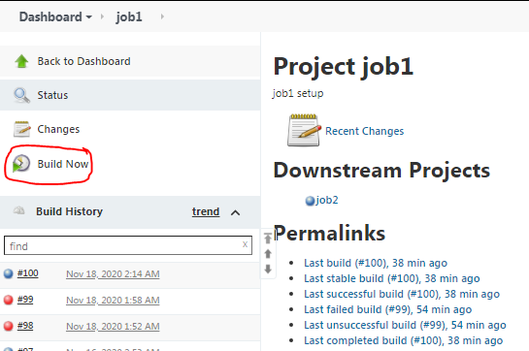

**Login user2 –create role -> configure, delete jobs, cancel(while building the job).**

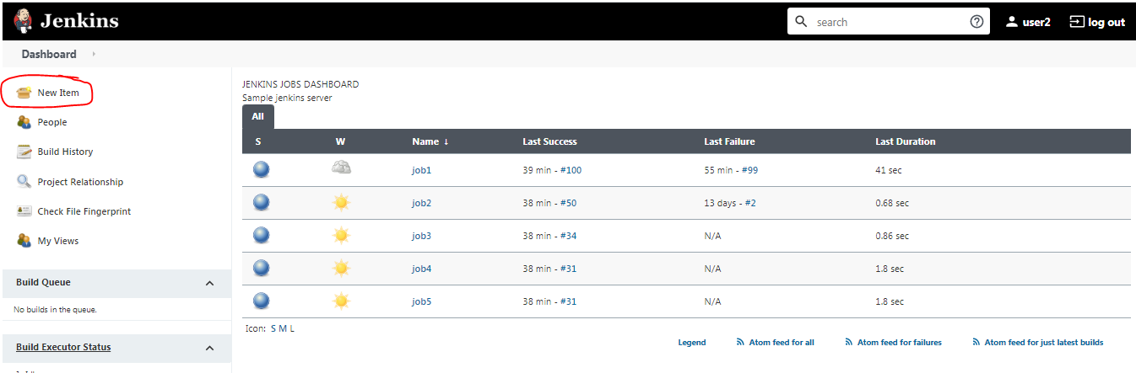

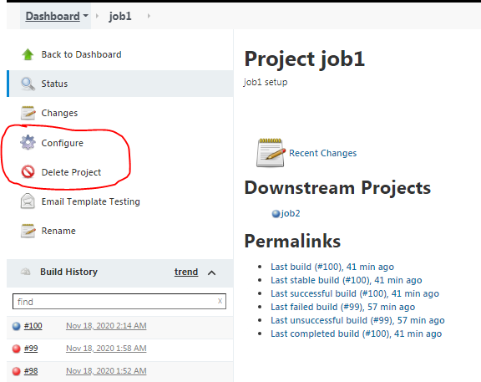

**Login user3 –deploy role ->build , cancel(while building the job).**

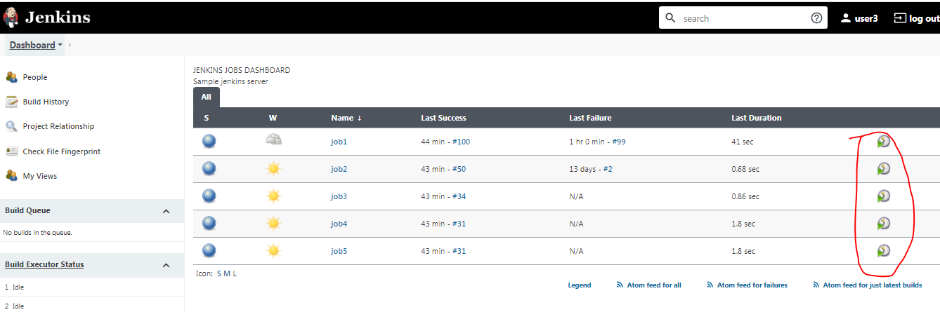

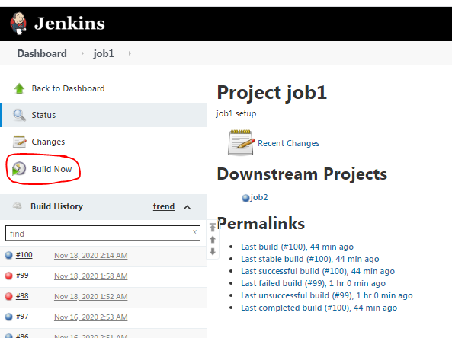

**Login user4->build ,deploy,create permissions.**

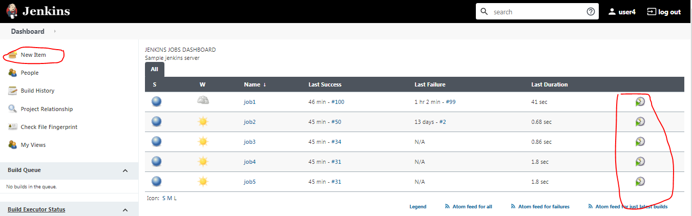

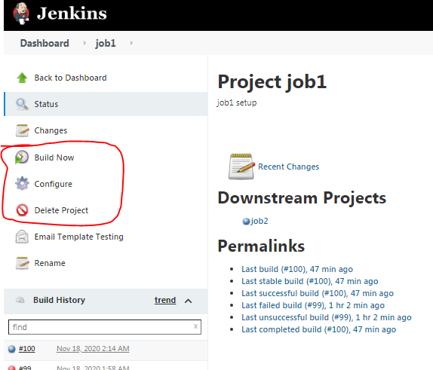

**New Veiw:-**

**Under All tab-> will show all jobs**

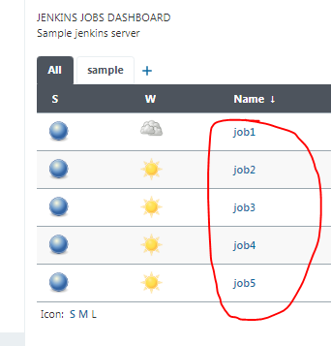

**Create new view tab**

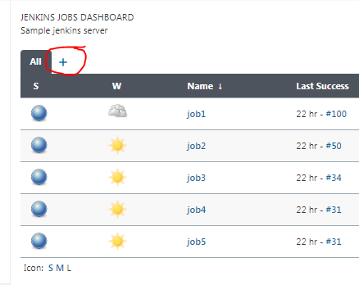

**Select List view option**

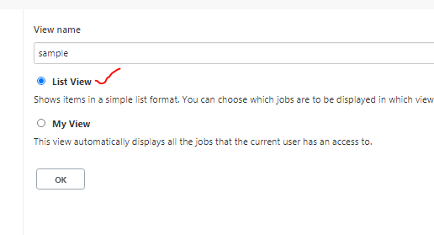

**select which jobs need to show under sample**

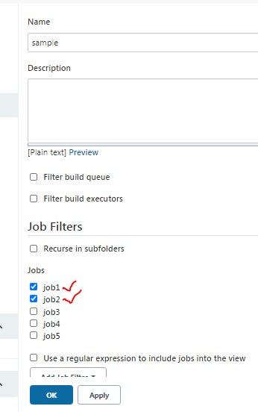

**Nested view plugin:- install plugin**

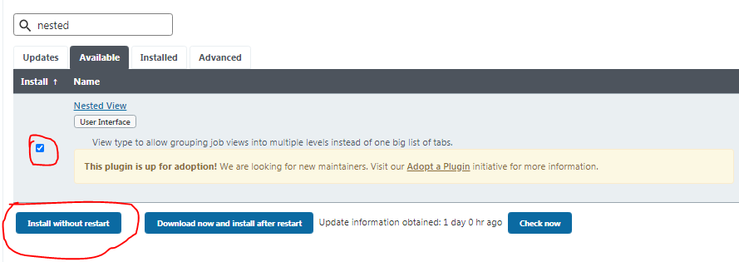

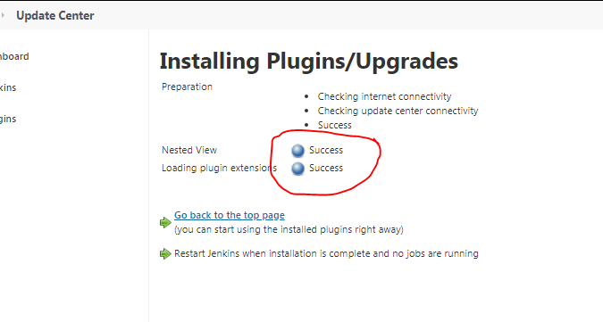

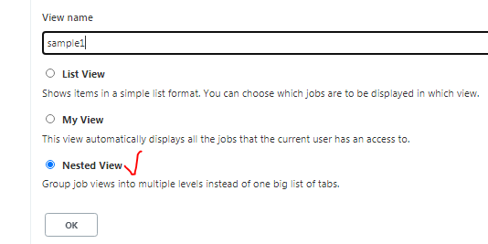

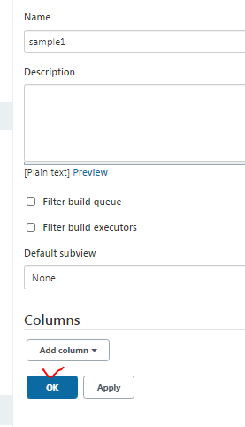

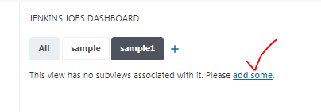

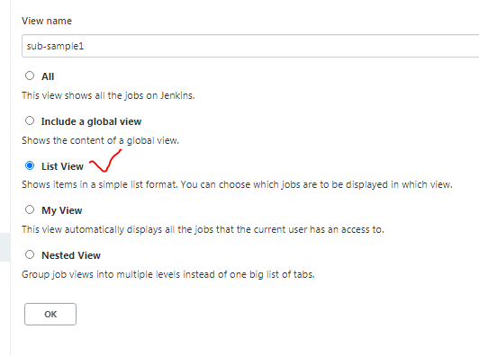

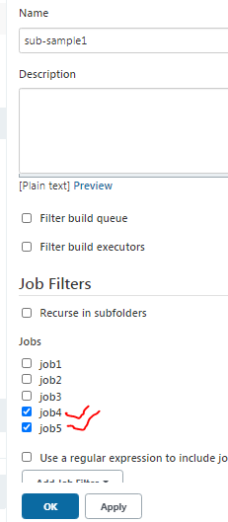

**Create parameterized job:-**

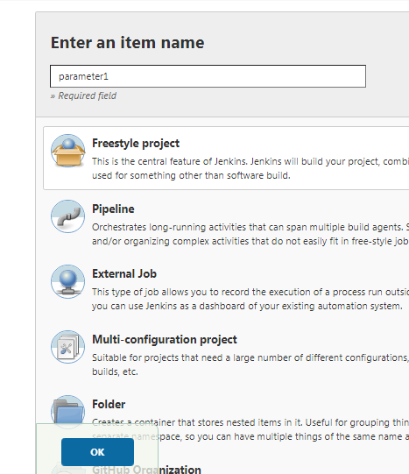

**Env, Github Release Version, Reason for build the job...etc**

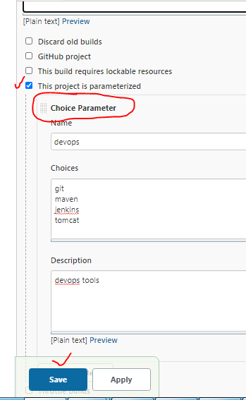

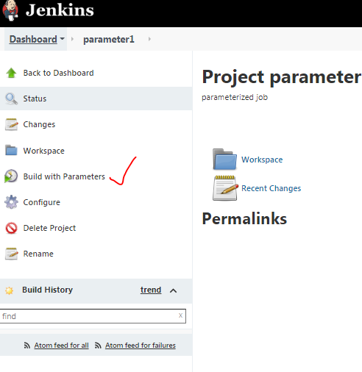

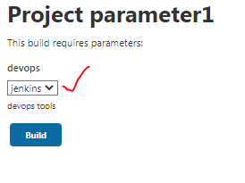

**Rebuilder param plugin:- last which options you have selected those same option will use .**

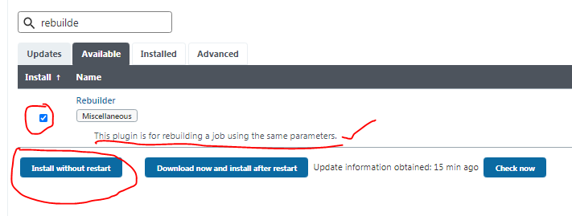

**Restart Jenkins .**

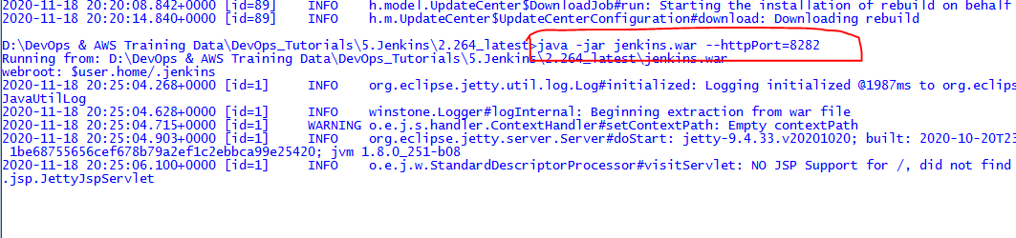

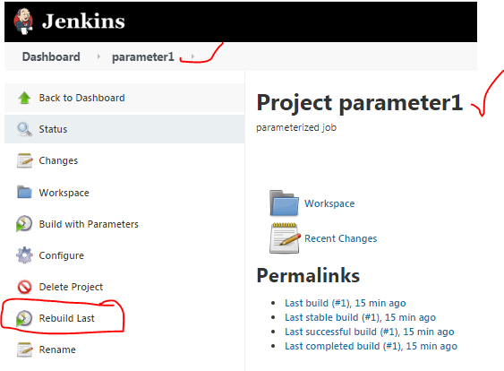

**Previously which i have selected that option will show to rebuild job.**

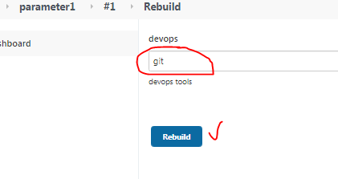

[disk-usage](https://plugins.jenkins.io/disk-usage) & [Metrics Disk Usage](https://plugins.jenkins.io/metrics-diskusage) plugins-> used disk usage of jobs.

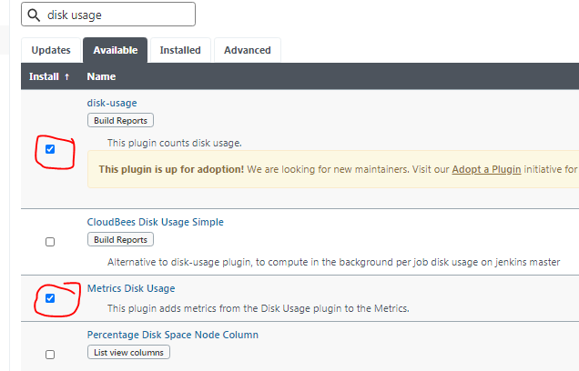

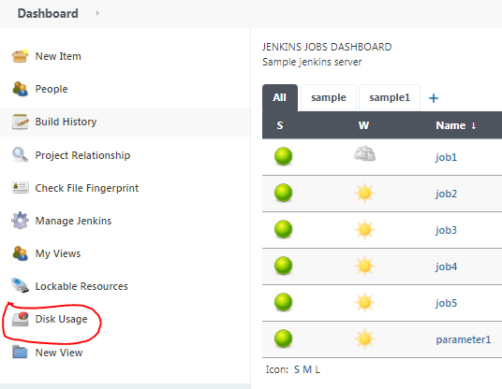

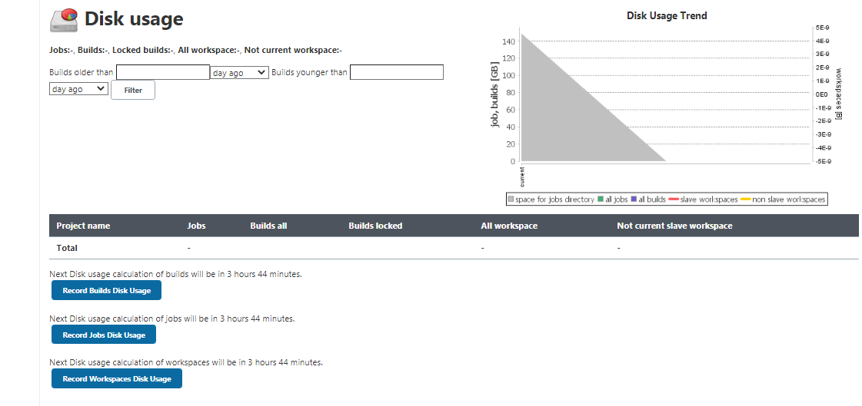

**Build some jobs after see disk usage.**

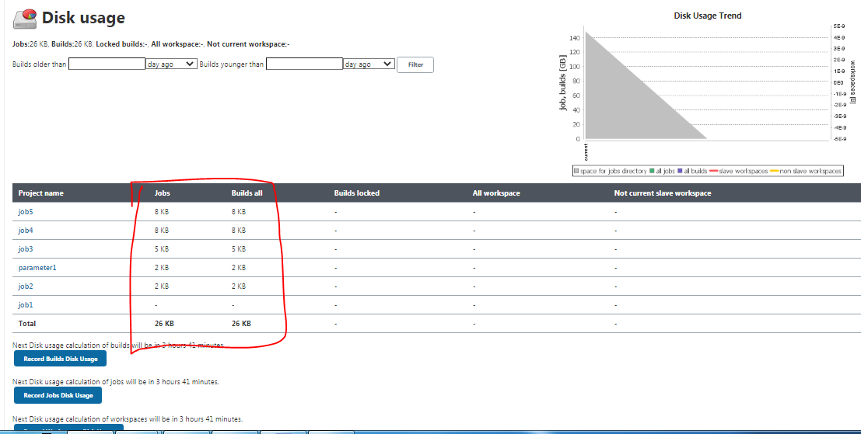

**Goto job2.**

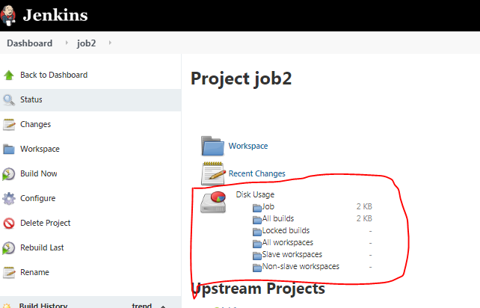

**Backup plugin -> for backup jobs**

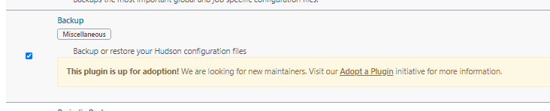

**Under manage Jenkins**

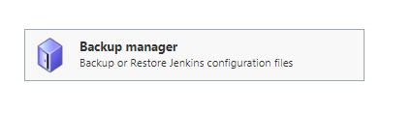

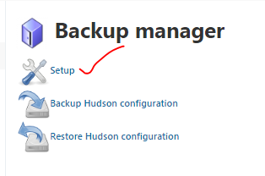

**Provide backup dir path.**

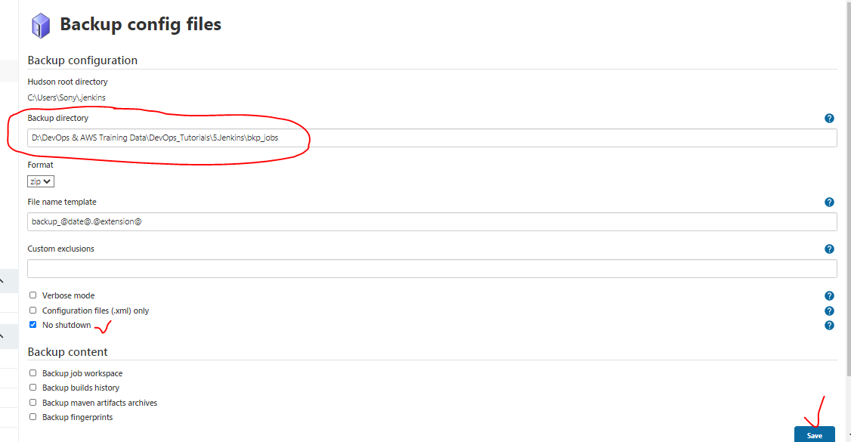

**Based on above backup path will done zip file of all jobs.**

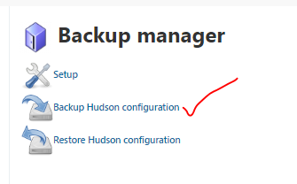

**It will start backup.-> backup done**

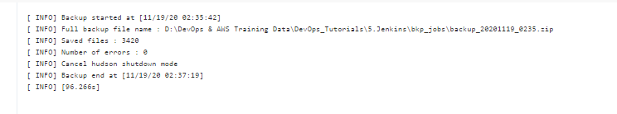

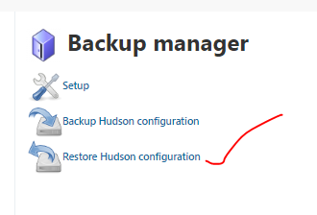

**Here will show all bkp jobs zip files, select and we can restore which one required.**

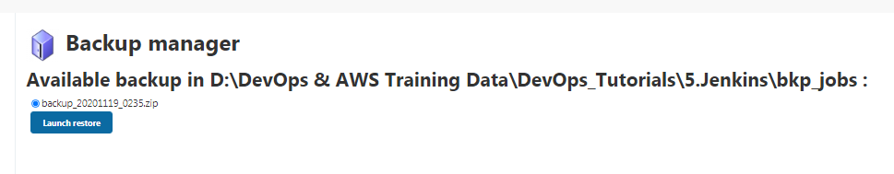

**How to change Jenkins home dir:-**

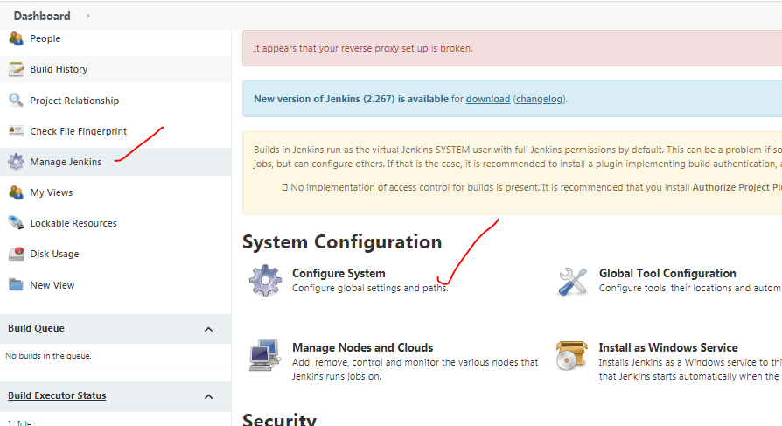

**Default Jenkins home dir will show.**

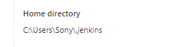

**Copy all Jenkins folder files paste into new folder (Jenkins_home)**

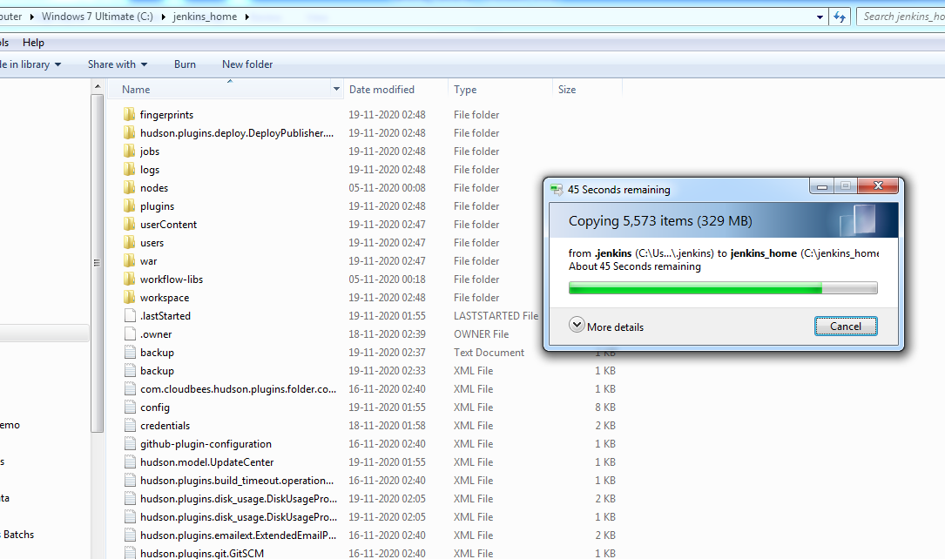

**Set user envrmnt path setup for JENKINS_HOME:-**

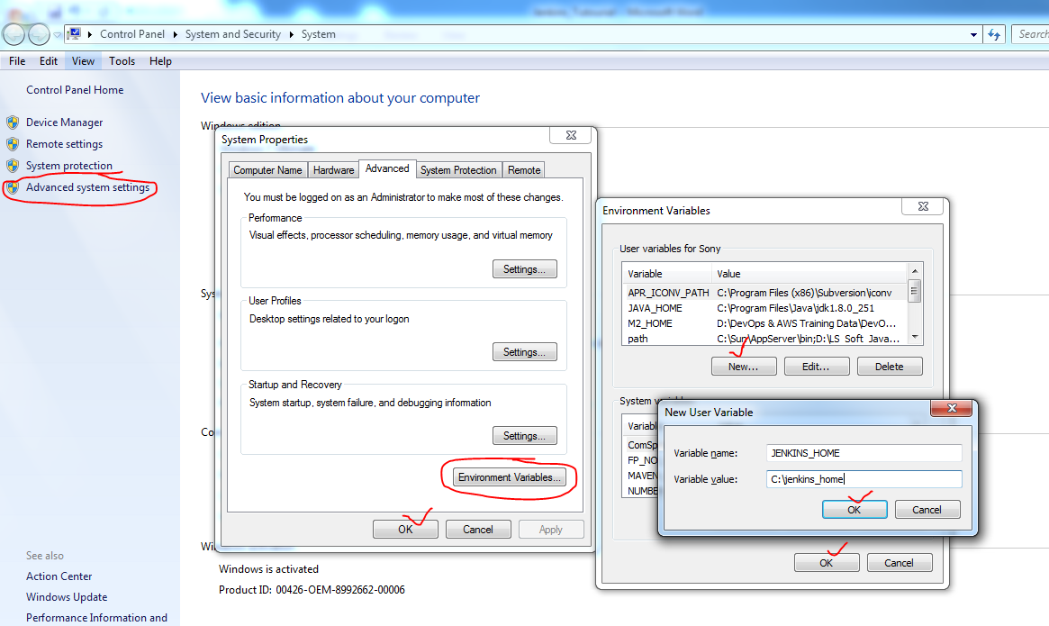

**Note:- remove old default Jenkins folder.**



**Restart the Jenkins. (close cmd prompt and open new cmd prompt) -> now pickup env setup path for Jenkins home dir.**

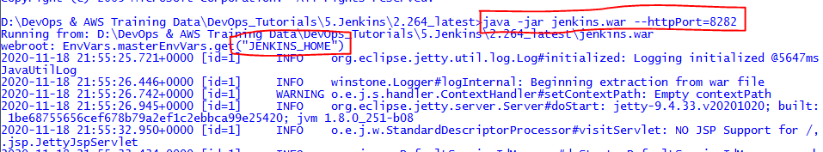

**Now verify home dir path.**

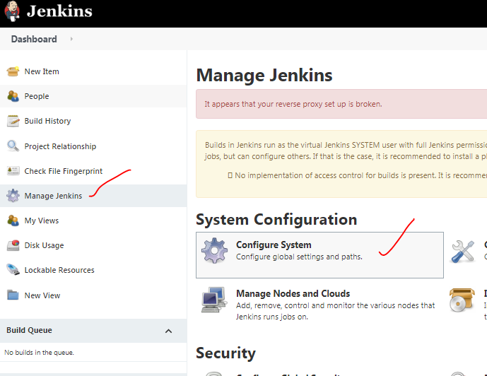

**User defined home dir is changed .**

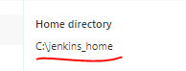

**Next build No Plugin:- If any latest build failed we can remove and set next build no, it will maintain next build number sequence .**

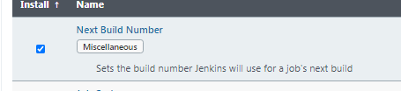

**I have changed some configuration for job2.**

**Build job2 -> job got failed.**

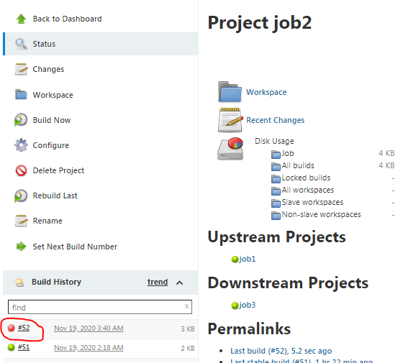

**Delete failed build.**

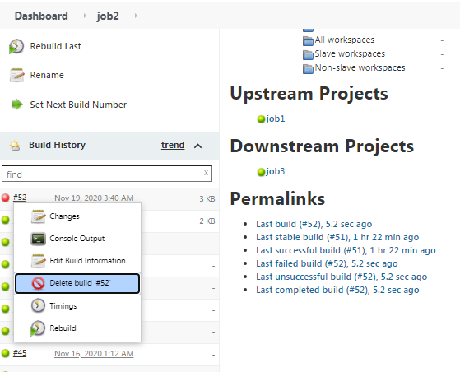

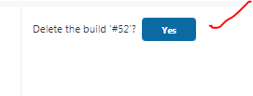

Changed to Next Build Number: 52

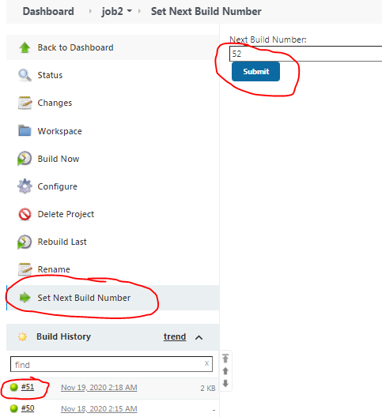

**Back to correct the job2 configuration and build it again-> it will take next build number as 52.**

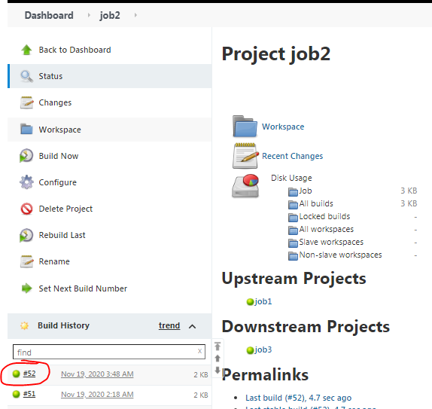

**Manage Nodes(linux):- slave/agent/nodes all are same.**

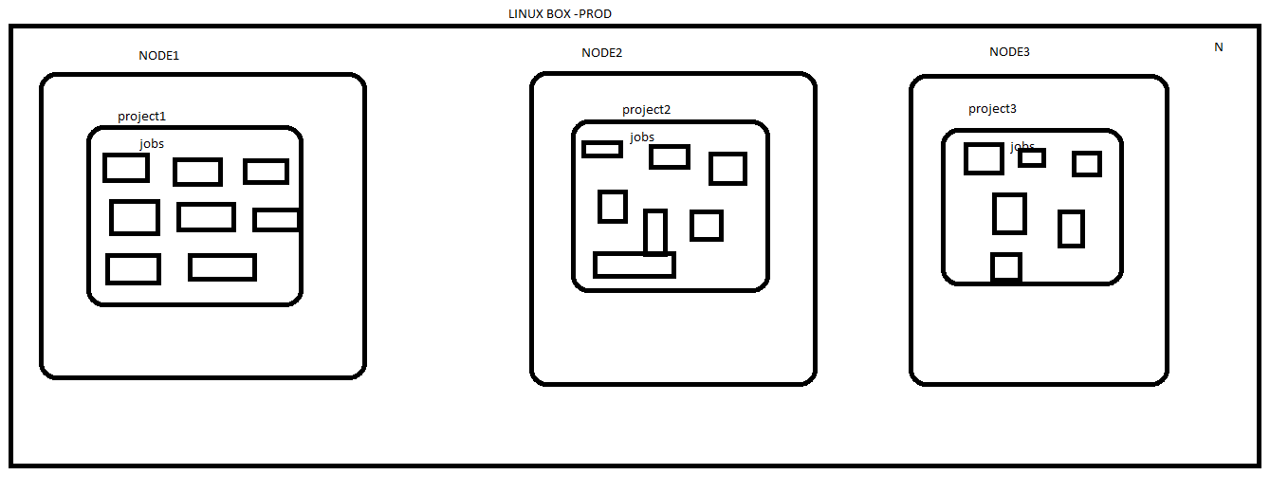

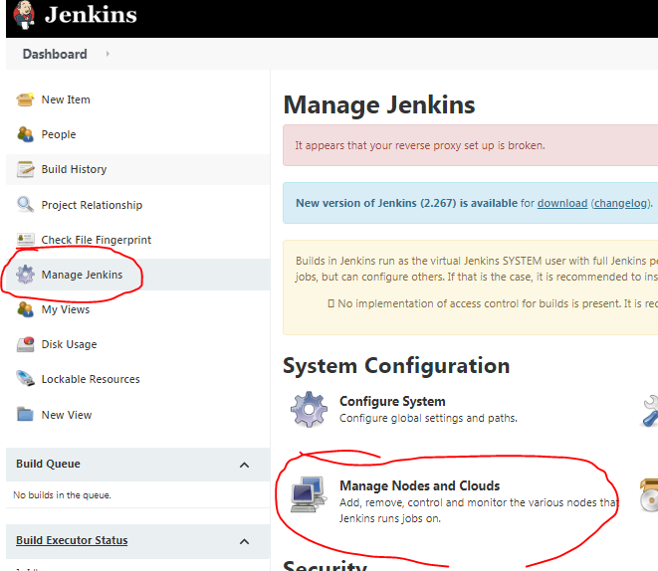

By default master node is available.

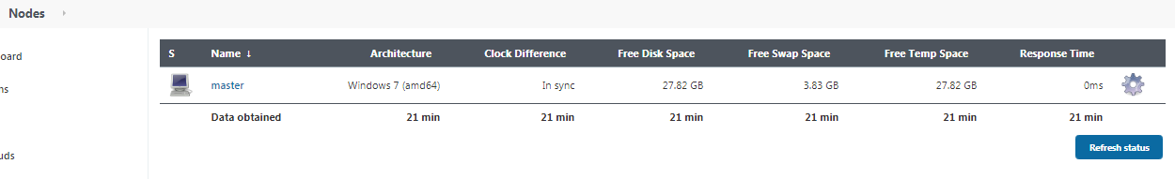

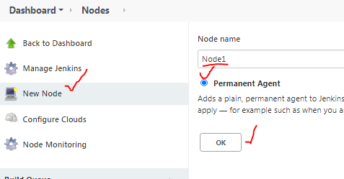

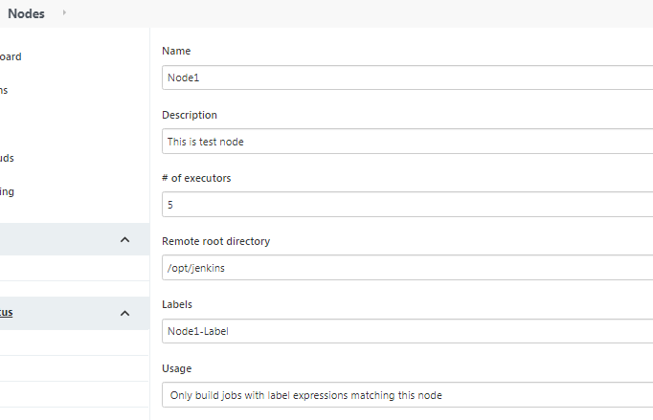

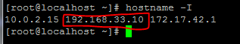

Un/Pwd: root/vagrant

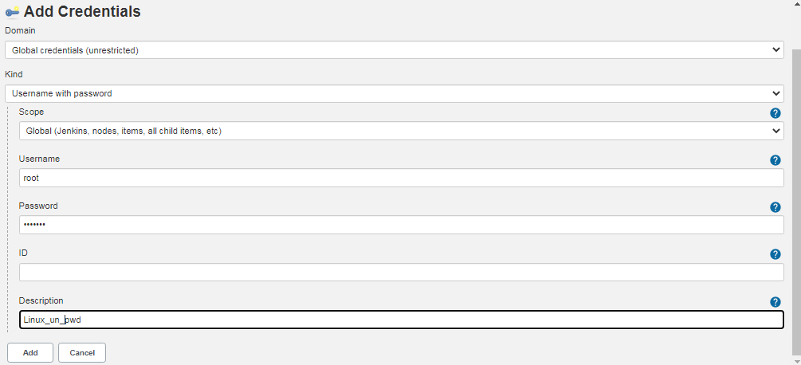

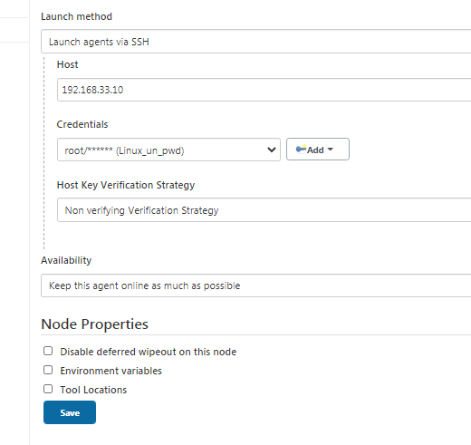

**Created Node1**

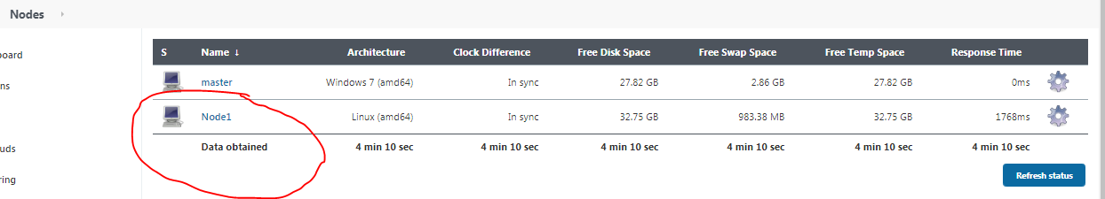

**In Linux box.**

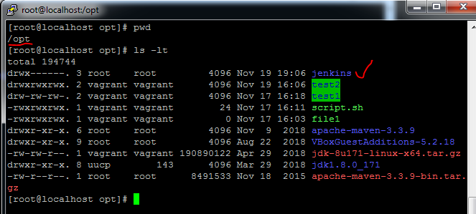

**Inside Jenkins dir.**

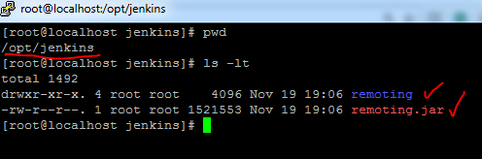

**Create one basic job(nothing any configurations)**

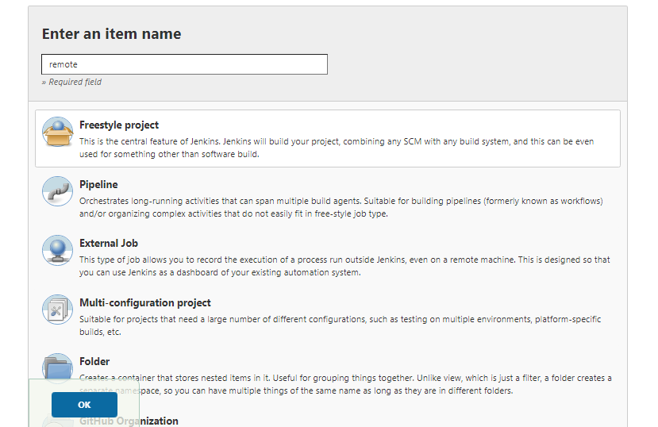

**Build Now remote job.**

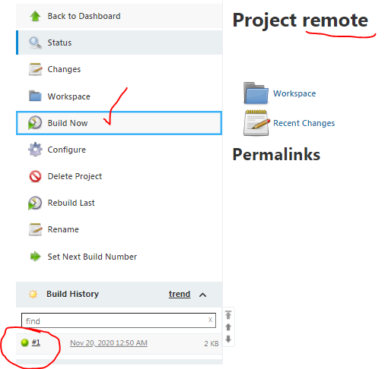

**This job run in normal under path.**

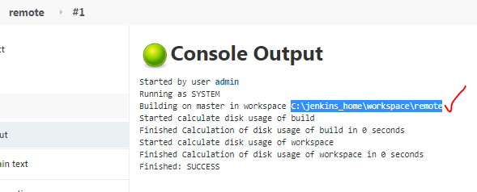

**Select Node1 label name in remote job, so that it will run under Node1 slave.**

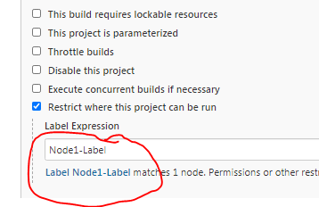

**echo “Hello DevOps Batch GM” >> DevOpsBatch.txt**

**ls -lt**

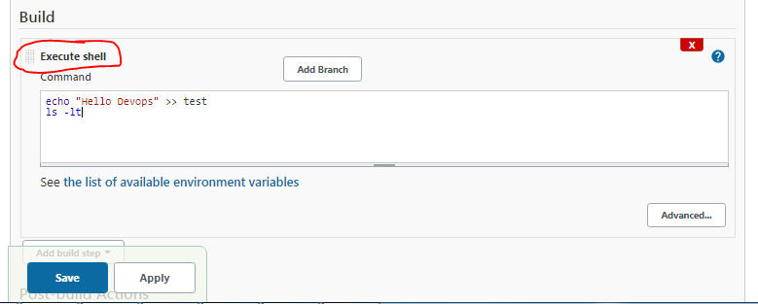

**Build now.**

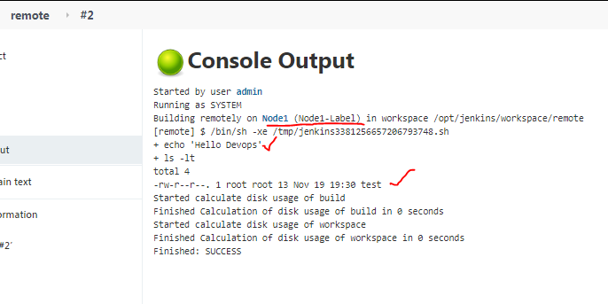

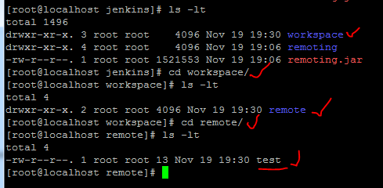

**Provide github url to remote job.**

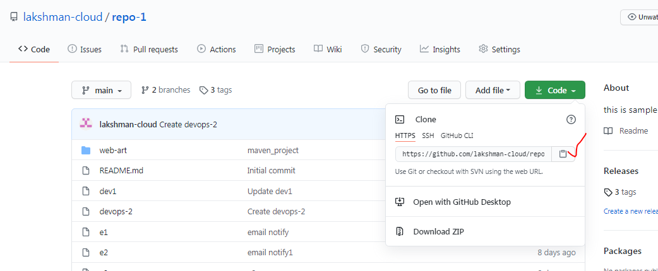

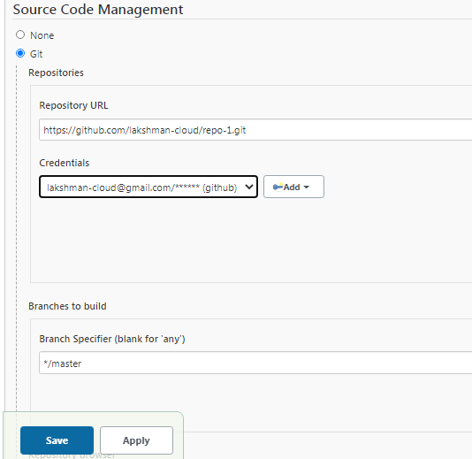

**Install git in linux box.**



**Configure linux git path into Node1 slave.**

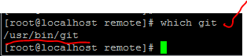

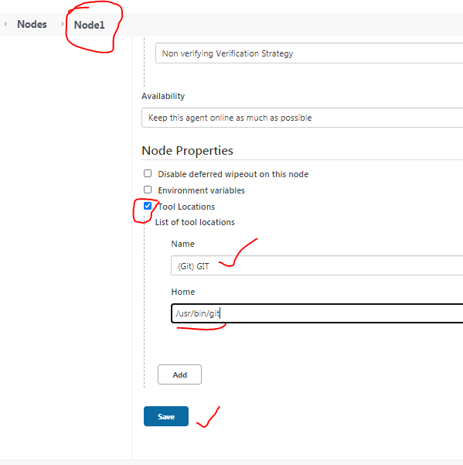

**Build Now remote job.**

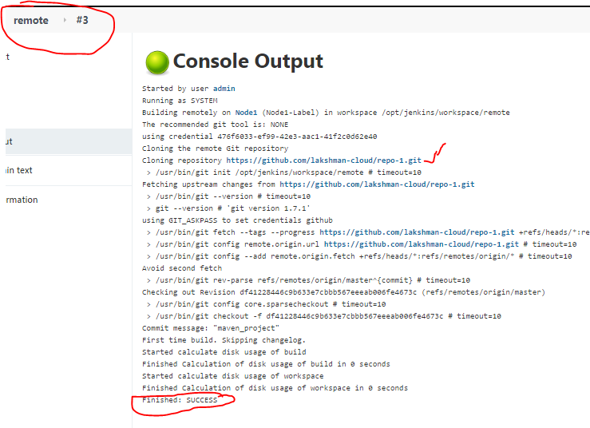

[**https://maven.apache.org/download.cgi**](https://maven.apache.org/download.cgi)

**Configure linux maven path into Node1 slave.**

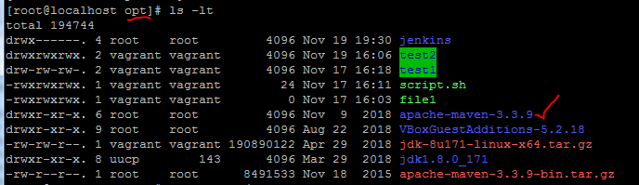

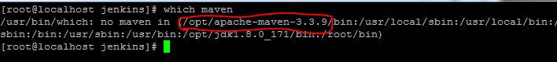

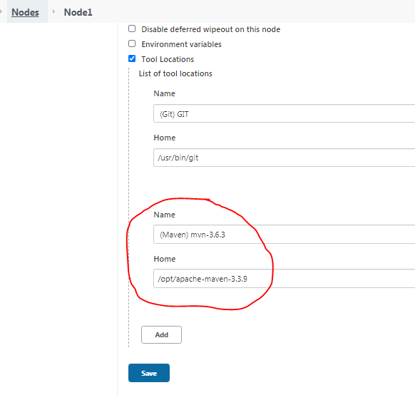

[**https://www.oracle.com/in/java/technologies/javase/javase-jdk8-downloads.html**](https://www.oracle.com/in/java/technologies/javase/javase-jdk8-downloads.html)

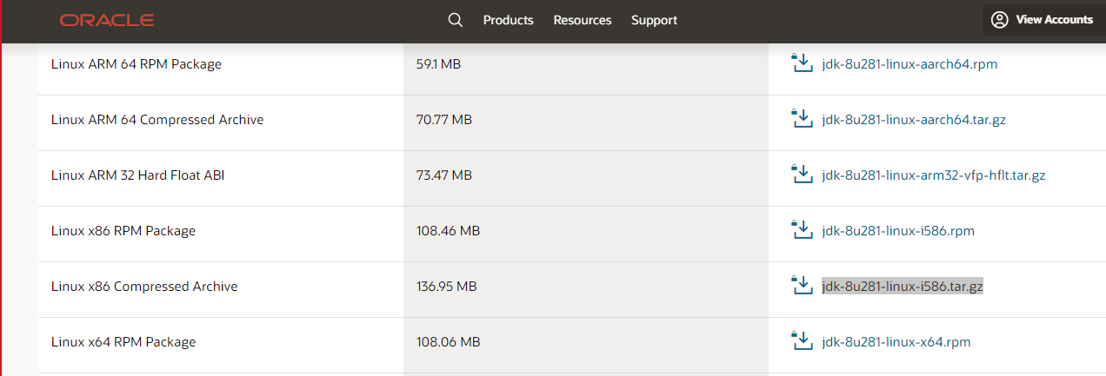

**Configure linux jdk path into Node1 slave.**



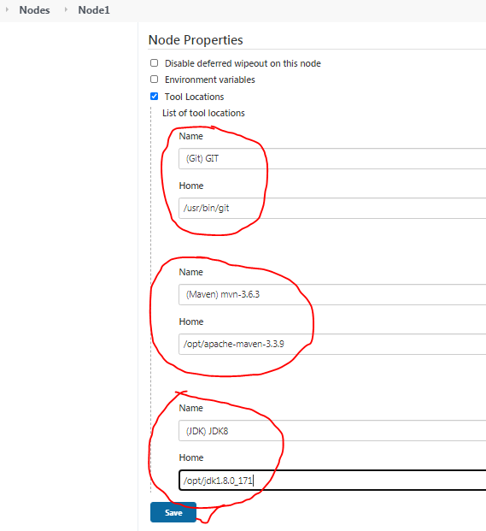

**Pass maven goals to remote job.**

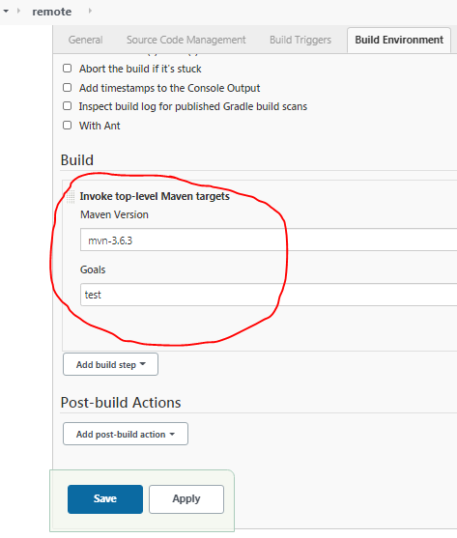

**Provide maven project git url to run maven goals.-> copy maven project github url**

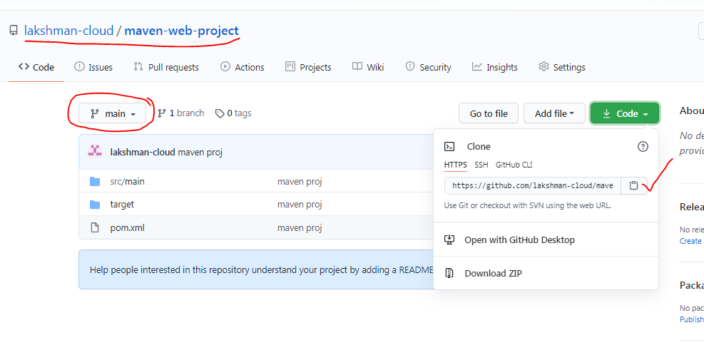

**Configure maven project github url to remote job.**

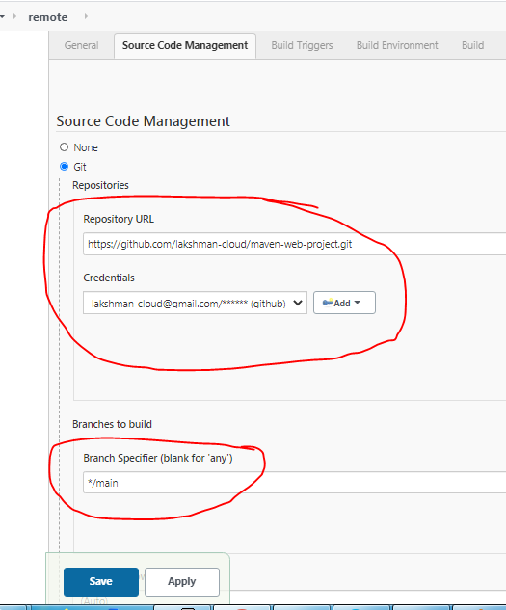

**Build Now remote job.**

**Build success-> downloaded all maven dependencies.**

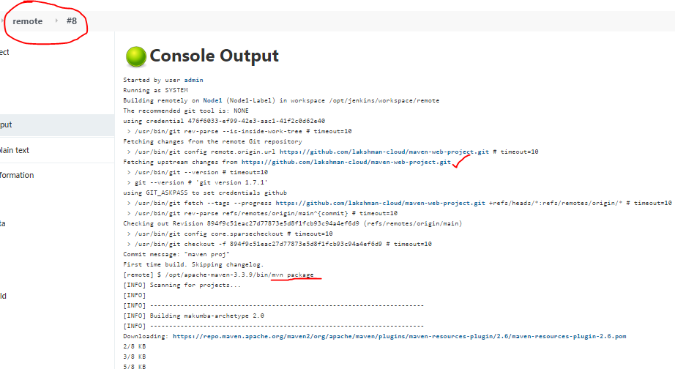

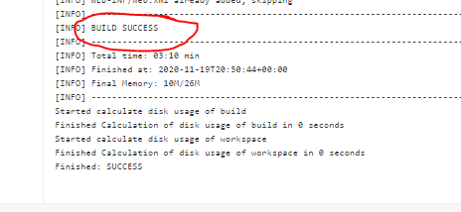

**Clone Workspace SCM Plugin:-**

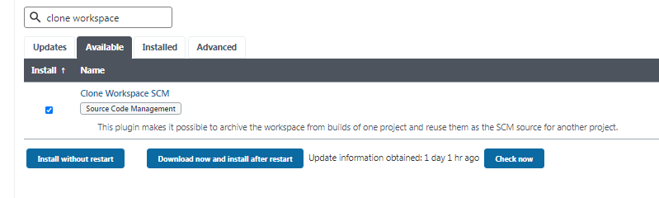

**Create 2 empty jobs.**

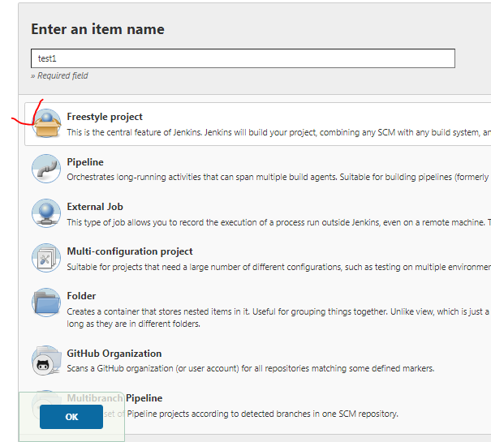

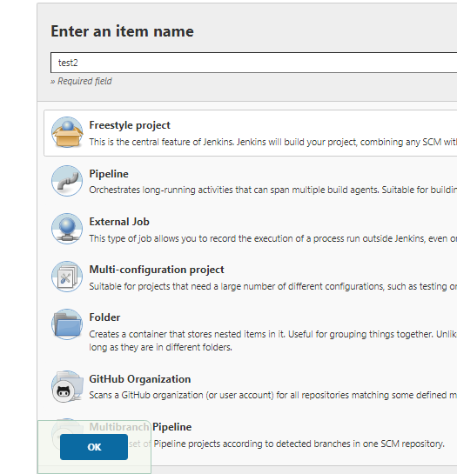

**file creation cmnd given in test1 job.**

**echo test1 file >> test1.txt**

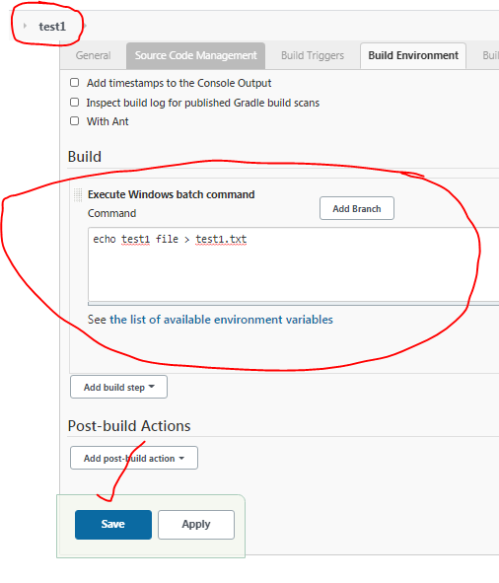

**Build test1 job.**

**Build success.**

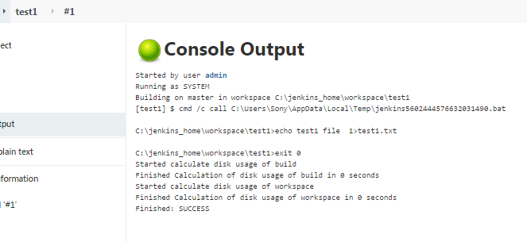

**In workspace test1.txt file created.**

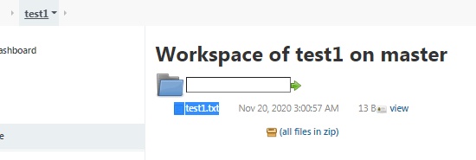

**Need to configure Which file you want to copy from test1 job to test2 job.**

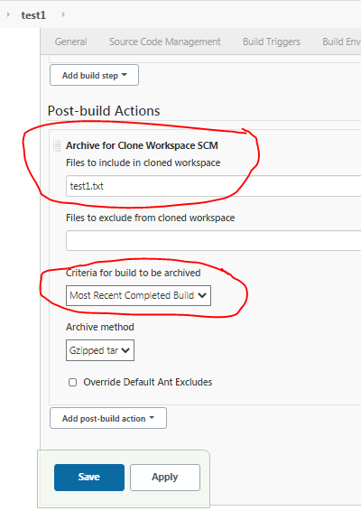

**We selected most recent successful build option-> so need to build for latest build.**

**Build success.**

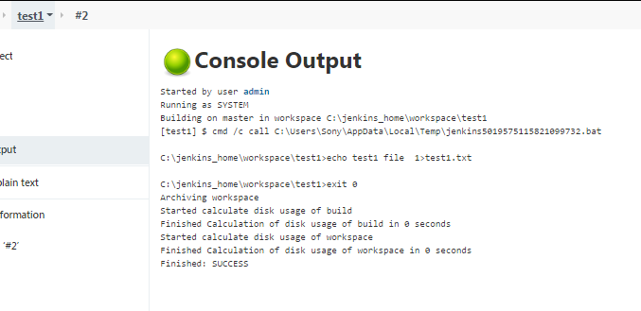

**Fresh job(test2), we need to select parent project as test1-> that code will use to build here(test2 job).**

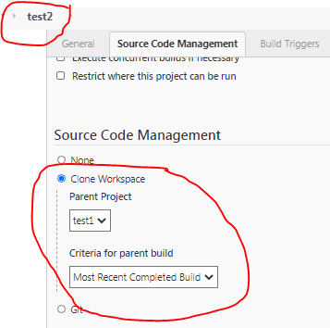

**Build Now ->1st build got success.**

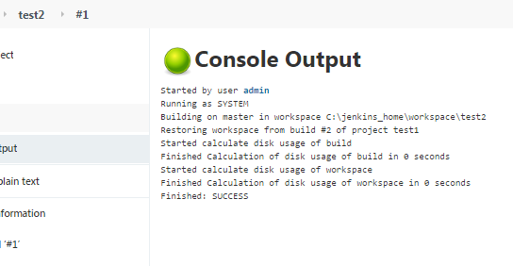

**Verify workspace-> code moved from test1 job(test1.txt) to test2 job.**

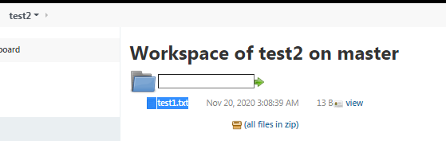

**Build pipeline plugin & Delivery pipeline:-**

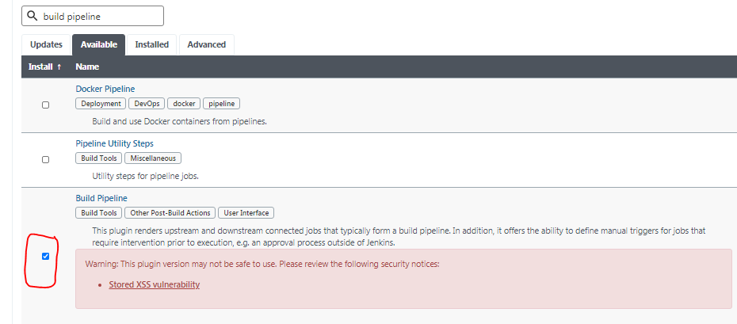

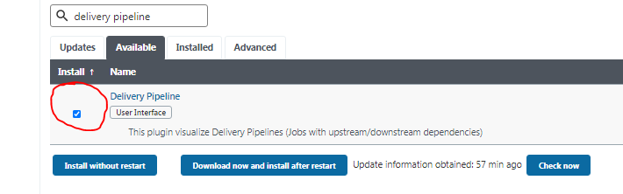

**Restart Jenkins server in cmd .**



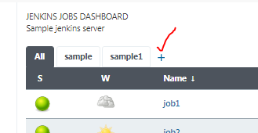

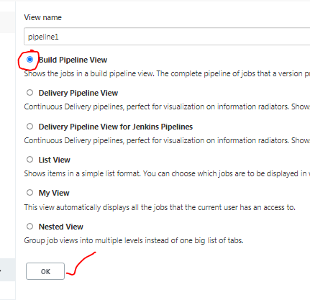

**Already upstream and downstream setup is available for job1 to job5, so need to select start job as job1.**

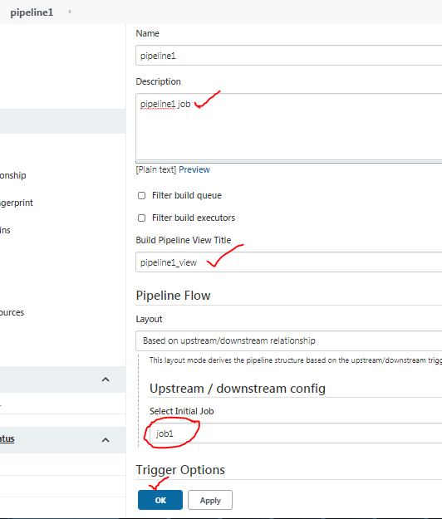

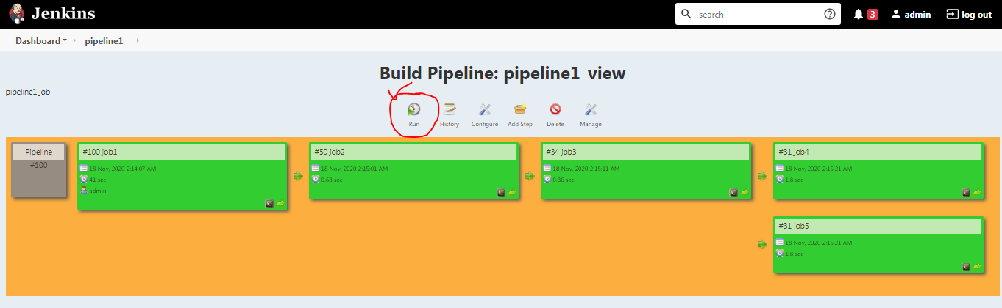

**Click run option to build the pipeline.**

**Started building ->yellow ,not build -> blue , build success –green, build failure-red.**

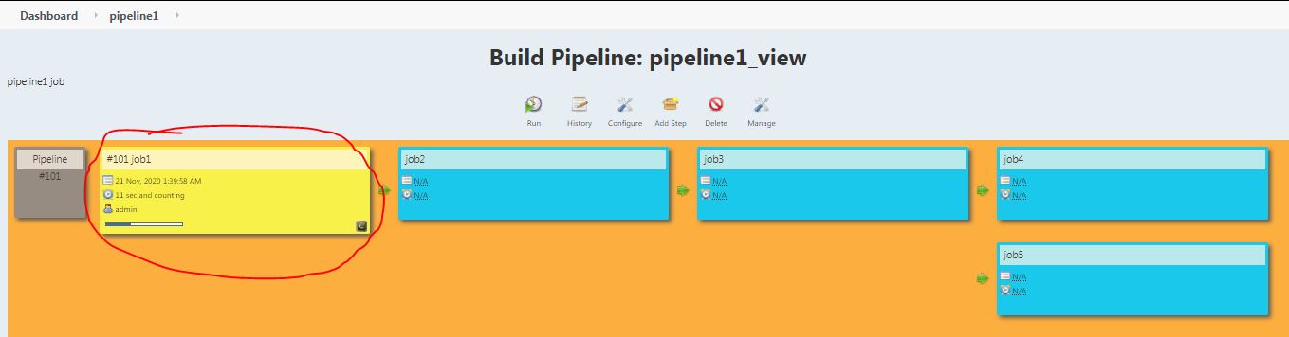

**Refresh the browser**

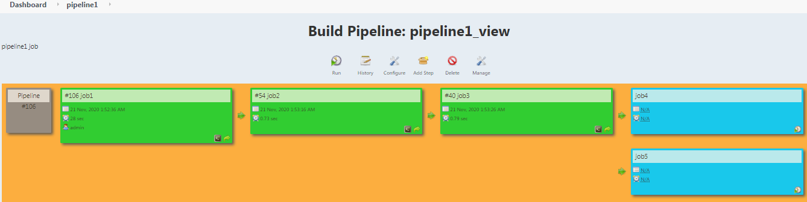

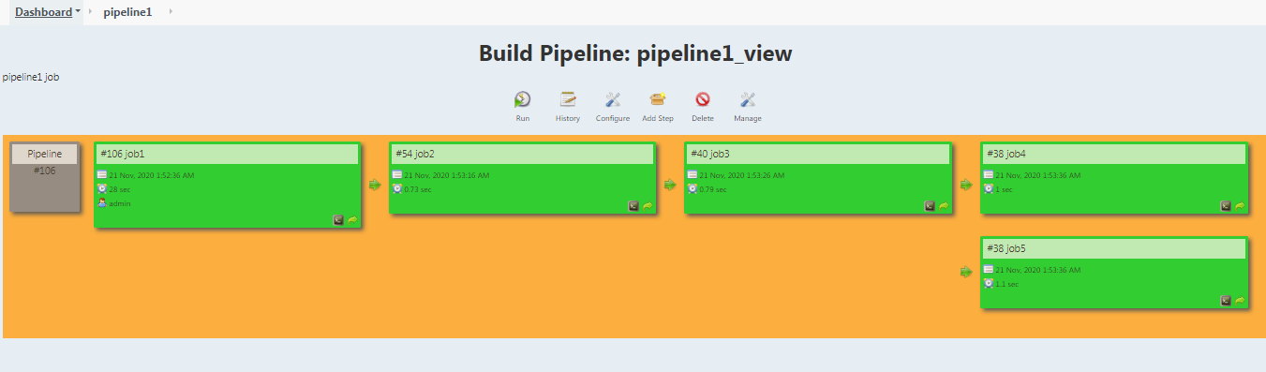

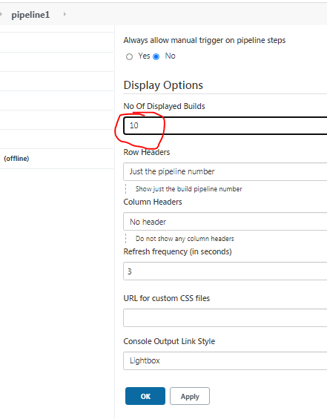

**10 builds started...**

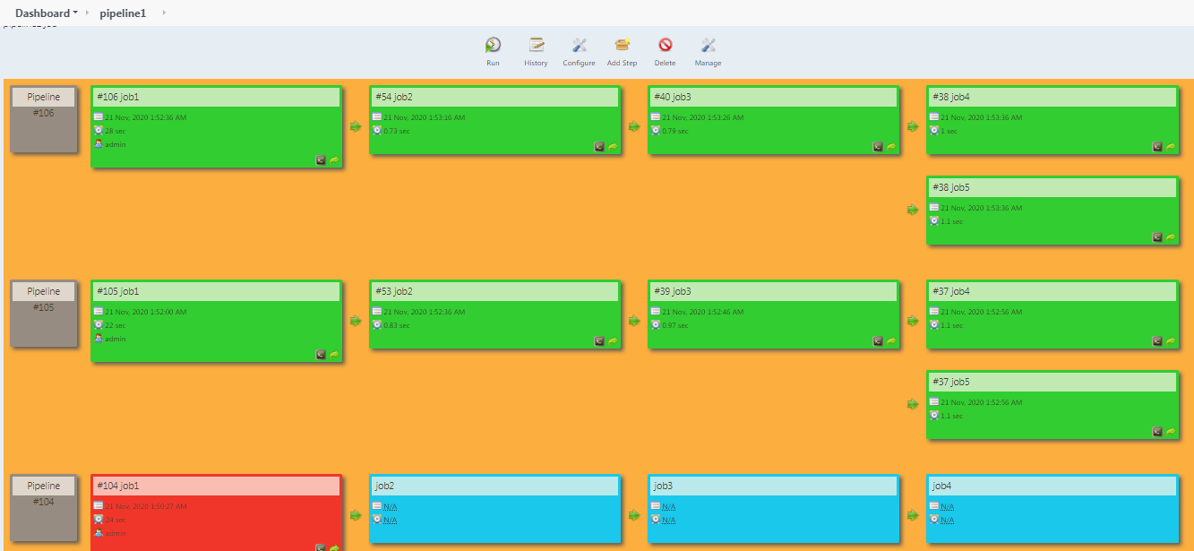

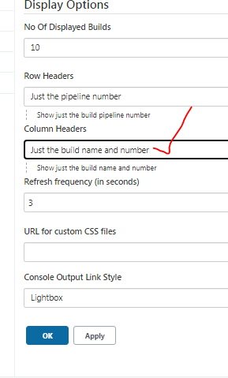

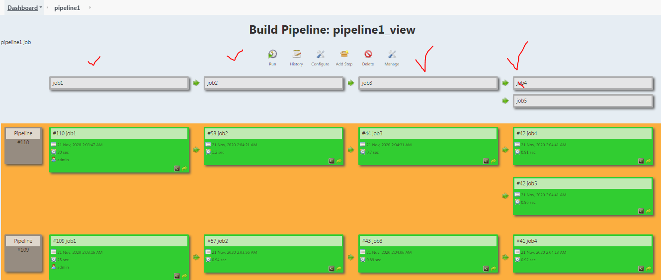

**Delivery pipeline:-**

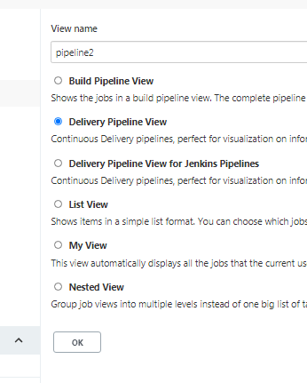

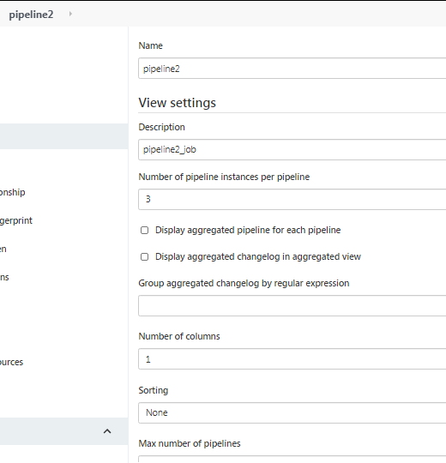

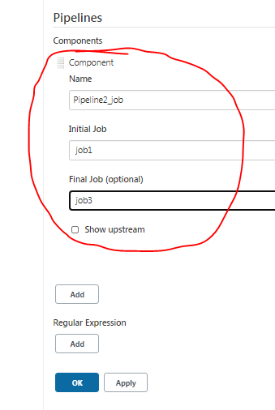

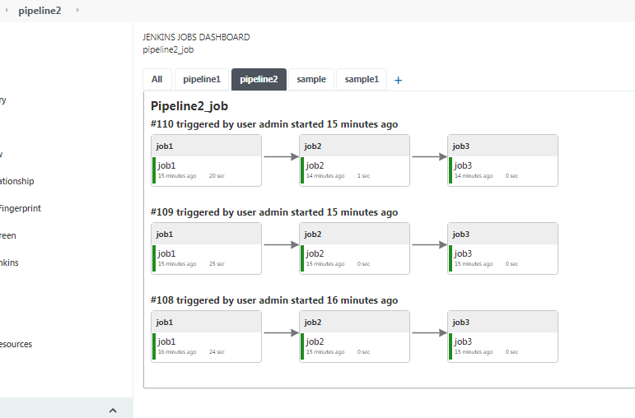

**Changed final job to job5**

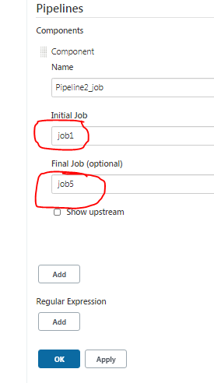

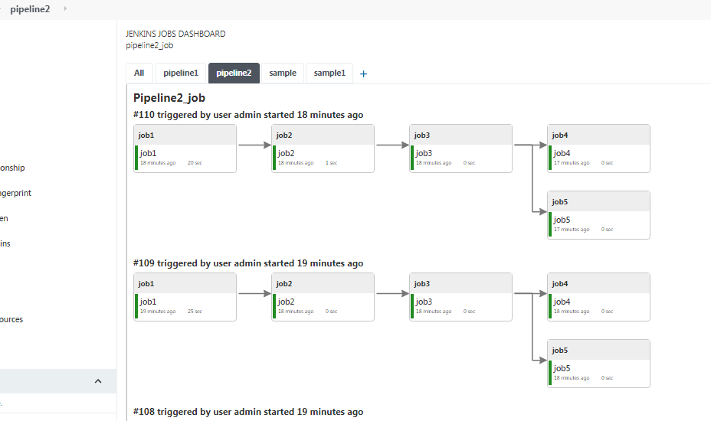

**Add some downstream job for job2.**

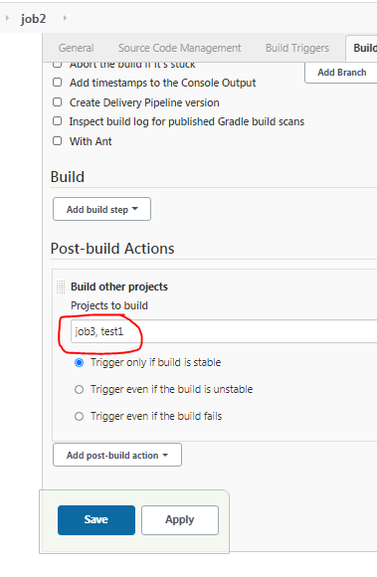

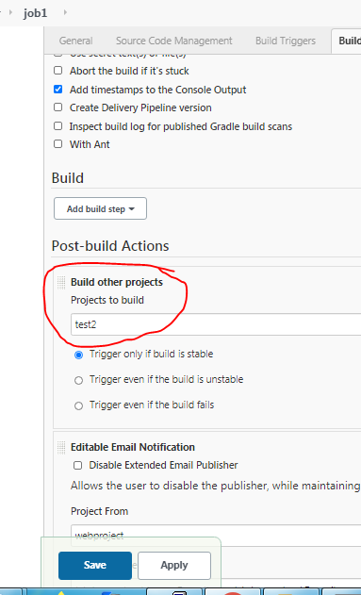

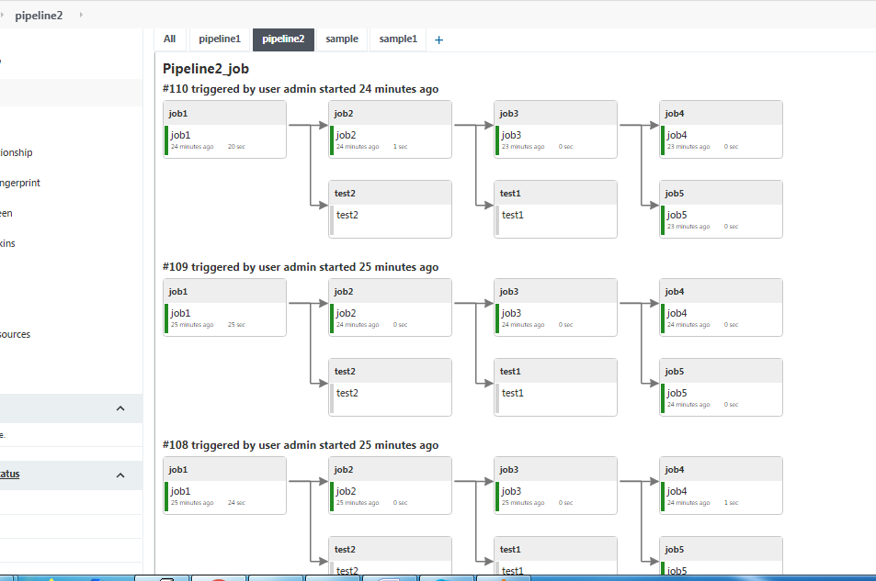

**Enable build and other options.**

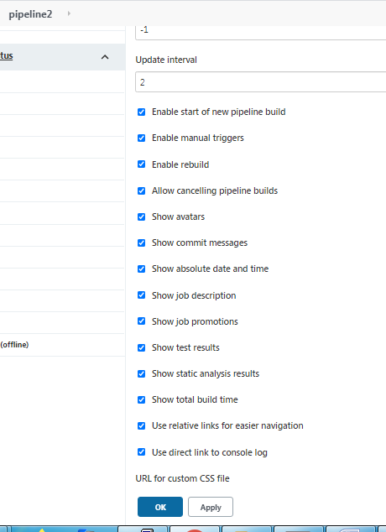

**Build option -> build it.**

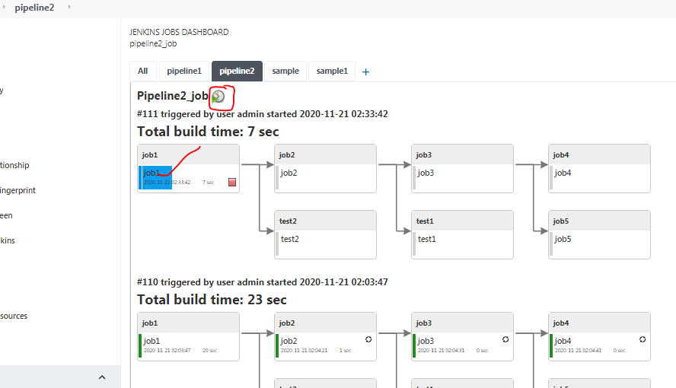

**Blue Ocean plugin-> Jenkins new look view.**

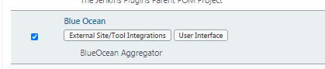

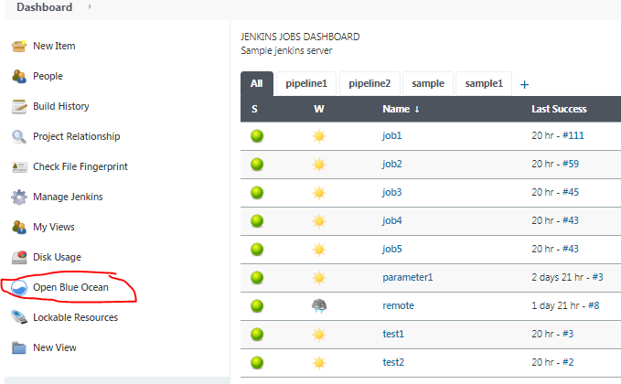

**Enter un/pwd.**

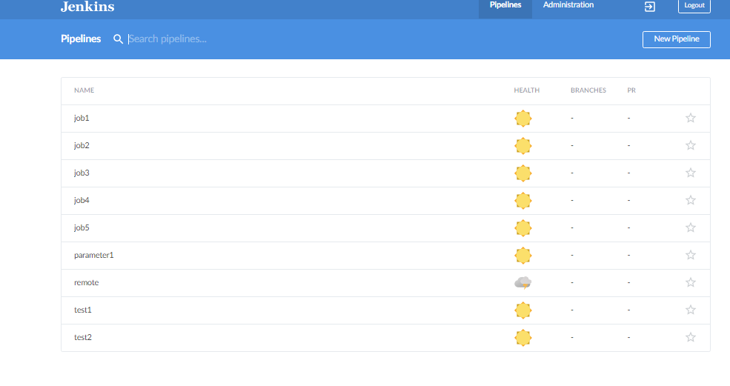

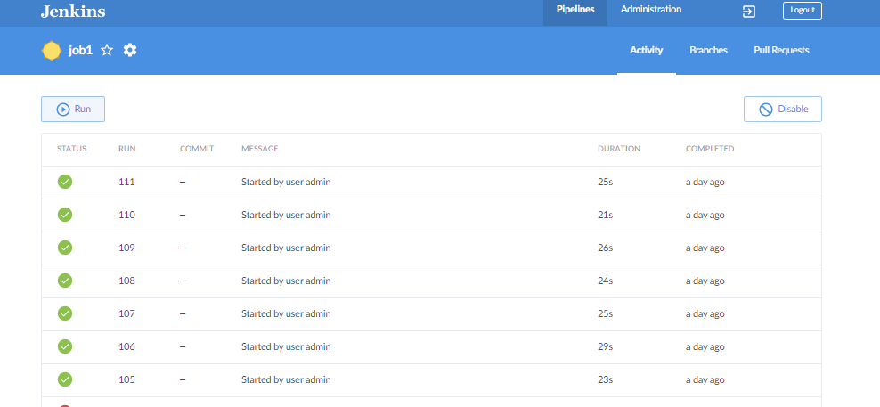

**How to run Jenkins in Linux machine:- open linux machine**

**Copy Jenkins war file into linux box using Winscp -> drag Jenkins file from left to right.**

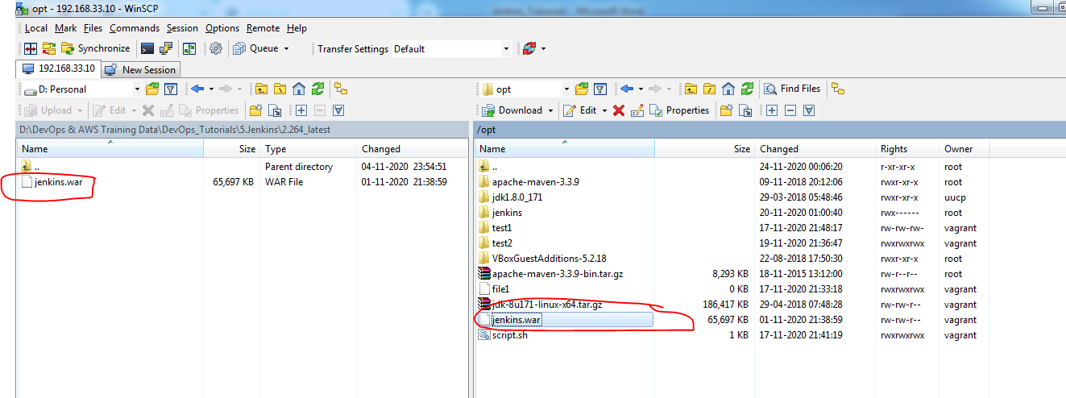

**OR**

**download Jenkins war file using wget** [**url:-**](url:-)[**https://updates.jenkins-ci.org/download/war/**](https://updates.jenkins-ci.org/download/war/)

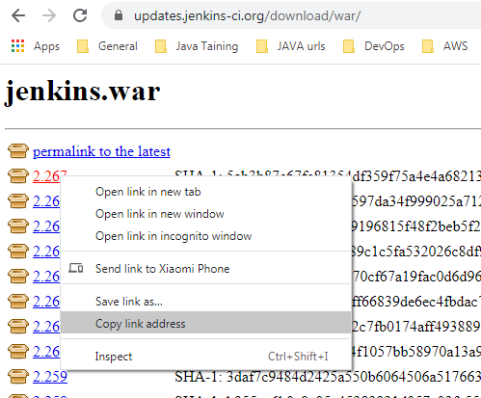

1. **Goto Jenkins.war dir and run the cmnd->java –jar jenkins.war --httpPort=8282**

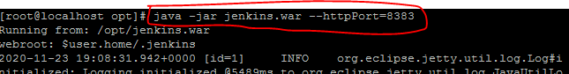

**Get IP address and check iptables:-**

**[root@localhost ~]# netstat –ntlp -> to show open ports**

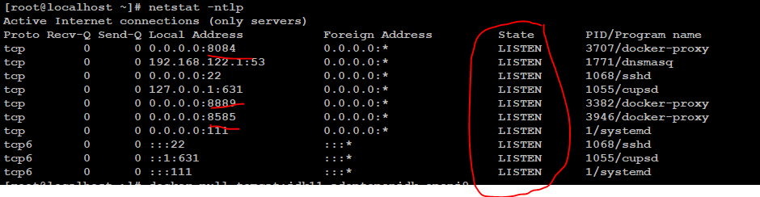

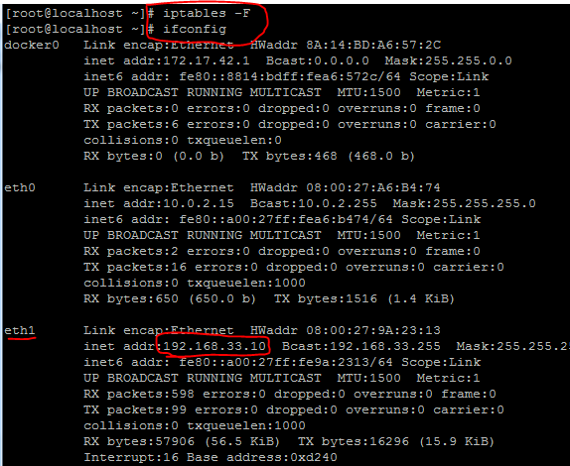

**Open in brower :-** [**http://192.168.33.10:8383/**](http://192.168.33.10:8383/)

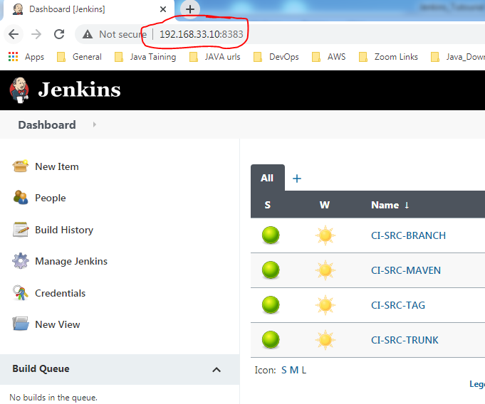

**=================================JENKINS END===============================**